Preliminary Conceptual Model - Causes of Haze in Breton Wilderness Area
(BRET1)

Regional sulfate and sulfate transported from the eastern United States are the major causes of haze in the Breton Wilderness Area.

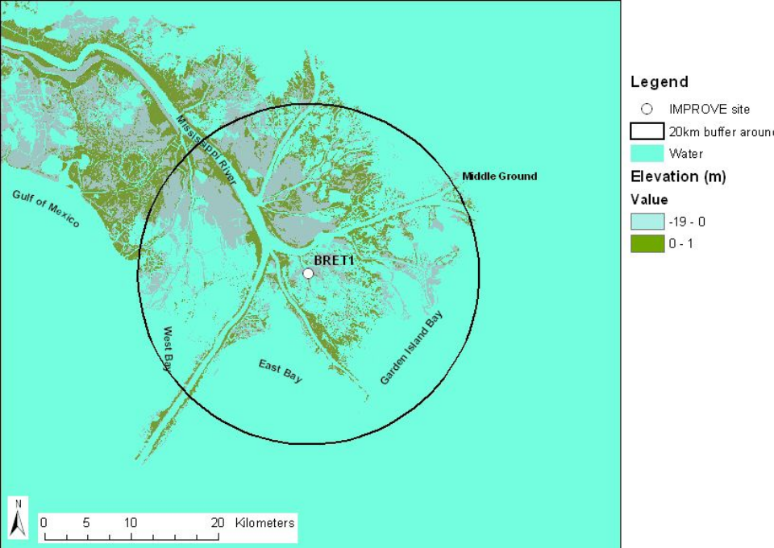
Figure 1. 20 Km terrain map

Breton Wilderness Area consists of 5,000 + acres on Breton Island, part of the Chandeleur Barrier Island chain located off the Mississippi River Delta of southern Louisiana. Ground cover is low sandy beaches on the Gulf of Mexico side, falling off on the mainland side into ponds, inlets, and salt-water marshes. The IMPROVE site representing Breton Wilderness Area is BRET1, located at the southeastern extreme of the Mississippi Delta, about 80 km (50 mi) south-southwest of the Wilderness, with Gulf Coast waters between. In Breton wilderness area during the sampling period of 9/2000 – 12/2002, the average PM_{2.5} mass concentration is 7.9 μg/m³. The average total light extinction coefficient (B_{ext}) is 76.2 Mm⁻¹ (Visual Range ~ 51.2 Km; Deciview ~ 20.3).. The average contributions of the major aerosol components to Breton haze (including Rayleigh scattering) are particulate sulfate 59.9%, nitrate 7.6%, organic matter (OMC) 8.0%, elemental carbon (light absorbing carbon, LAC) 4.2%, fine soil 0.8% and coarse mass (CM) 6.3%.

Sulfate is the dominant aerosol chemical component that contributes to regional haze in the Breton wilderness area. In the 20% worst days, it contributes in average ~ 67% to regional haze (more than 70% to the aerosol light extinction (excluding Rayleigh scattering)).
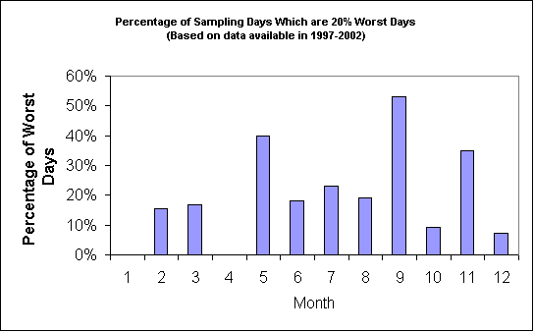
Figure 2. Percentage of sampling days that are 20% worst days in each month (based on data available from 2000-2002)
Figure 2 suggests that the highest occurrence of the 20% worst days happened in May and September, in which more than 40% of the sampling days are the 20% haziest days at Breton. As shown in Figure 3, sulfate is the largest aerosol contributor to haze throughout the year, especially from May to October during which the contribution of sulfate to haze is more than ~70% in the worst days. OMC and nitrate contribute ~15 - 20% in February and December during the 20% worst days.


Figure 3. Average contributions of major aerosol chemical components to light extinction during 20% worst days in each month (based on data available from 2000-2002)
Figure 4 indicates that the air transport patterns are quite different for 20% best and 20% worst days. During the 20% best days, air usually comes from southeast of the site. While during the 20% worst haze days, air most frequently comes from north.
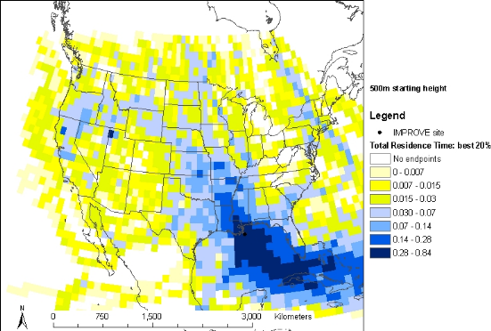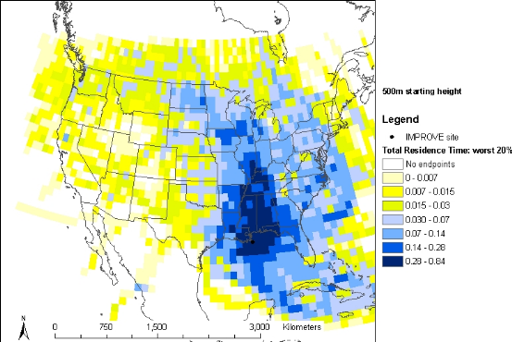
Figure 4. Normalized residence time for 20% best (left) and 20% worst (right) days (based on data from 2000-2002, air mostly transported from the blue area under the given sampling days)

The nearest major population centers are New Orleans, 120 km (75 mi) west of the Wilderness and Baton Rouge about 200 km (125 mi) west of the Wilderness. Industrial sources in the region include those associated with the petroleum industry including offshore drilling and refineries in southern Louisiana (Baton Rouge) and the Texas Gulf Coast, 300 to 400 km (200 – 250 mi) west. Figure 5 illustrates the major SO₂ source regions in the area. As Figure 6 indicates, the possible important source regions that contribute to the regional haze at Breton wilderness area include land-based sources to the north and west, and offshore sources to south and west. SO₂ may also transports from the northeastern United States and causes haze in the region.

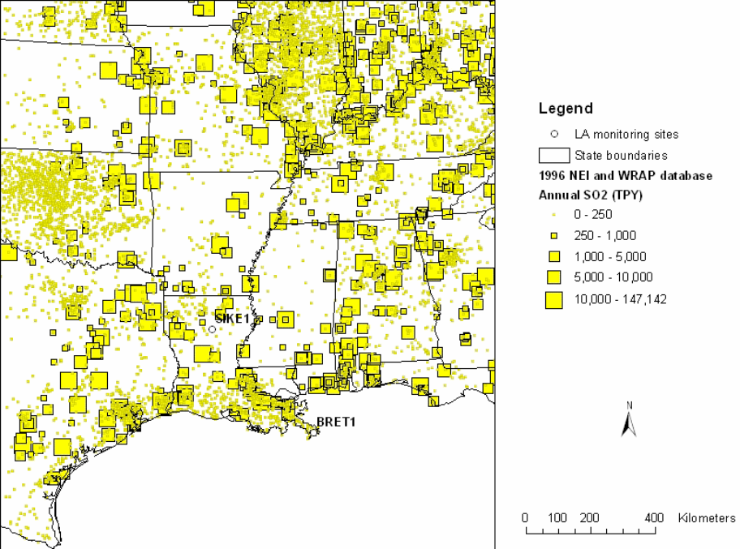

Figure 5. SO₂ sources based on 1996 NEI and WRAP database

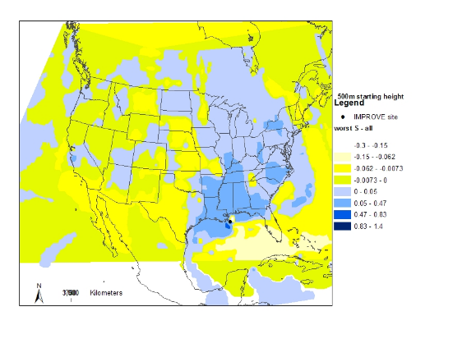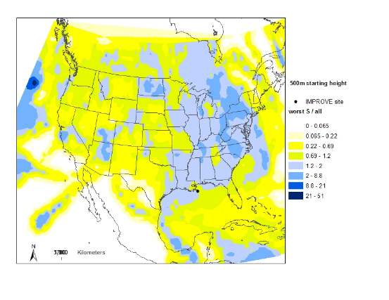
Figure 6. Difference (left) and ratio (right) of normalized residence time in 20% worst sulfate days and all days during 2000-2002 (possible important source regions are shown up as blue in the maps)

Because of the small diurnal temperature range of water and its aerodynamically smooth surface, mixing heights over water are relatively low with respect to those over land, with much less diurnal variation, and cycles that may during certain seasons be unrelated to and out of phase with the overland cycle. These features result in a potential for significant plume trapping effects at BRET1 and Breton Wilderness. Regionally, aerosol accumulation is more likely to occur during persistent subsidence inversion conditions associated with buildup and stagnation of synoptic high pressure ridges. Long-term data have shown the Gulf Coast region to be subject to frequent regional stagnation episodes. In the central Gulf Coast, stagnation conditions were found to exist 5 to 10 % of the time, mostly during extended summer (May-October), with the onset of the stagnation period occurring earlier (around May) in the Gulf Coast region than in southwestern states. So, regional SO₂ emissions together with the stagnation meteorology conditions during the extended summer are most likely responsible for the regional haze in the Breton wilderness area.

