Preliminary Conceptual Model - Causes of Haze in Cedar Bluff (CEBL1)

Due to the reason that a whole year of aerosol data is not available, no analysis about the 20% worst haze days can be done. Based on the data available from 6/2002-8/2003, sulfate transported from the east in the warm season, and regional nitrate in the cool season are believed to be the important causes of haze.

In Cedar Bluff, the average PM_{2.5} mass concentration during 6/2002-8/2003 is 7.7 μg/m³, and the average total light extinction coefficient (B_{ext}) is 61 Mm⁻¹ (Visual Range ~ 64 Km; Deciview ~ 18). Sulfate and nitrate are two of the largest contributors to haze, with an average contribution of 38% and 22%, respectively. Figure 2 indicates that sulfate in the summer and nitrate in the winter are the major causes of haze. Both sulfate and nitrate are important in the spring and fall. Figure 3 suggests that air usually transports from north and northwest in the winter. Southerly and easterly flows become important in the summer.
Figure 1. Average contributions of major aerosol chemical components to light extinction

Figure 2. Average contributions of major aerosol chemical components to light extinction in each month

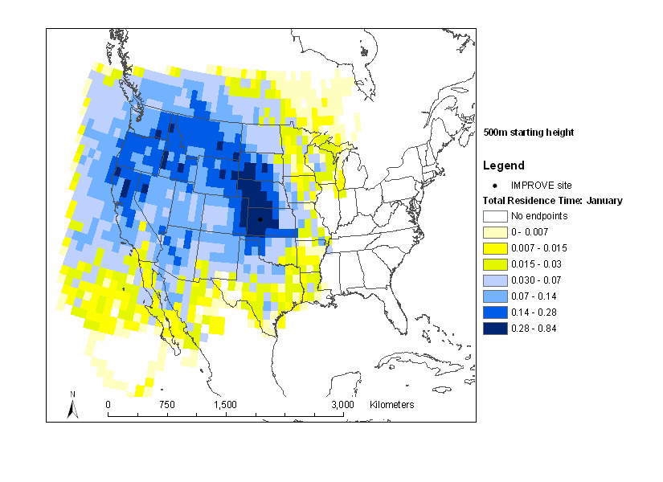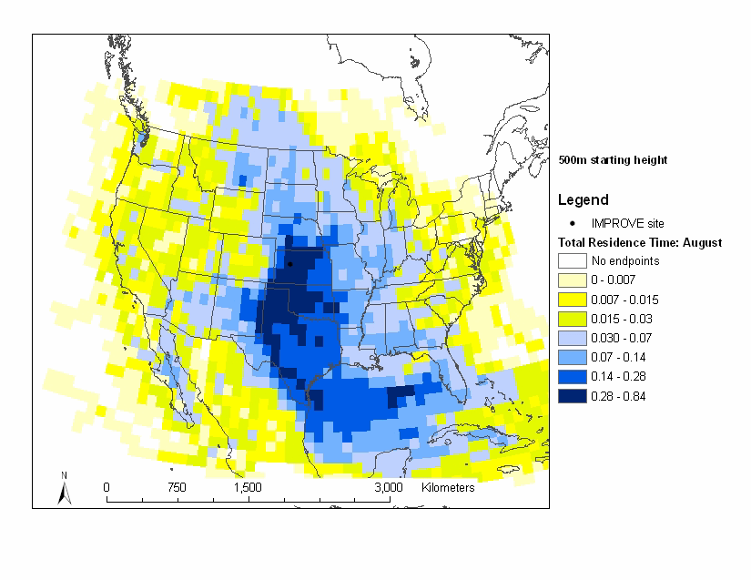
Figure 3. Normalized residence time in January (left) and August (right) (based on data from 2000-2002)

