Preliminary Conceptual Model - Causes of Haze in Great River Bluffs (GRRI1)

Due to the reason that a whole year of aerosol data is not available, no analysis about the 20% worst haze days can be done. Based on the data available from 6/2002-8/2003, sulfate transported from the eastern US such as the Ohio Valley in the warm season, and regional nitrate in the cool season are the major causes of haze.

In Great River Bluffs, the average PM_{2.5} mass concentration during 6/2002-8/2003 is 9 μg/m³, and the average total light extinction coefficient (B_{ext}) is 82 Mm⁻¹ (Visual Range ~ 48 Km; Deciview ~ 21). Sulfate and nitrate are two of the largest contributors to haze, with an average contribution of 40% and 28%, respectively. Figure 2 indicates sulfate is the biggest contributor to haze in the warm season, and nitrate is the biggest in the cool season. As shown in Figure 3, air usually transports from north and northwest in the winter. Southerly and easterly flows become important in the summer.

Figure 1. Average contributions of major aerosol chemical components to light extinction

Figure 2. Average contributions of major aerosol chemical components to light extinction in each month

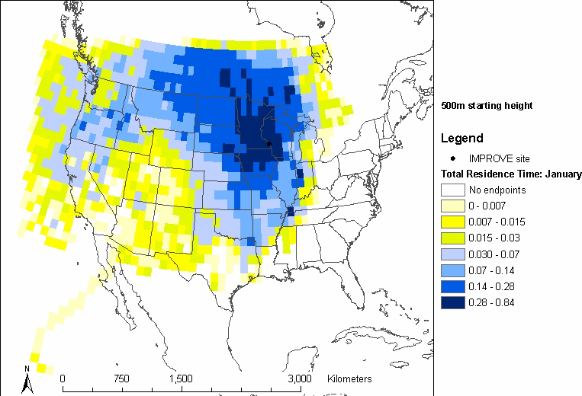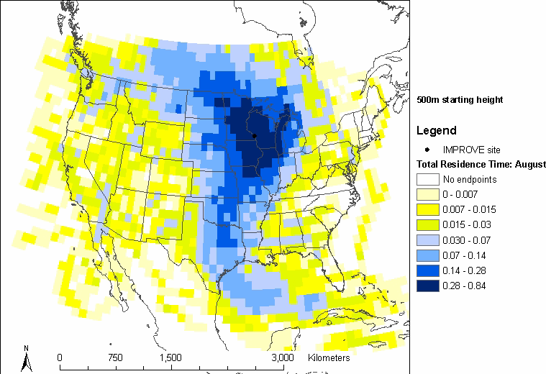
Figure 3. Normalized residence time in January (left) and August (right) (based on data from 2000-2002)

