Preliminary Conceptual Model - Causes of Haze in Hercules-Glades Wilderness Area
(HEGL1)

Sulfate transported from the eastern United States is the major cause of haze at the Hercules-Glades Wilderness Area.

The HEGL1 IMPROVE site is located in south central Missouri, 22 km east of the town of Forsyth. The site elevation is 425 m (1,394 ft). HEGL1 lies 700 m east of Hercules Glades Wilderness, a part of Mark Twain National Forest. Surrounding terrain is hilly (low hills of height ~ 100 m) and groundcover is predominantly forest and pasture. The HEGL1 IMPROVE site is in a well exposed location with respect to surrounding terrain features and aerosol data collected there should be very representative of aerosol concentrations and composition in this region of south central Missouri. The average PM_{2.5} mass concentration during the years 2001-2002 is 9.9 μg/m³, and the average total light extinction coefficient (B_{ext}) is 80 Mm⁻¹ (Visual Range ~ 49 Km; Deciview ~ 21). Sulfate is the largest contributor to haze, with an average contribution of ~ 53%.

Figure 1. 20 Km terrain map

Figure 3 suggests that the highest occurrence of the 20% worst days happened in the summer, in which ~40% of the sampling days are the 20% haziest days at Hercules-Glades. As shown in Figure 4, sulfate is the largest aerosol contributor to haze the whole year except January, March and December, with a contribution from ~ 40% to as high as ~ 80% in the summer in the 20% worst days. In January, March and December, nitrate is the largest aerosol contributor to haze, and its contribution is about 45% in the worst days.

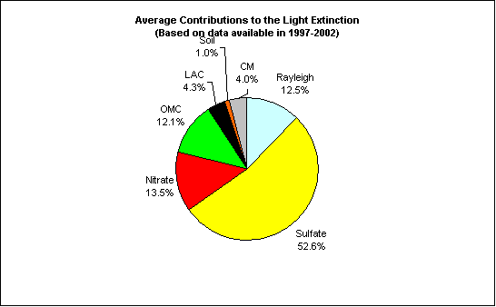
Figure 2. Average contributions of major aerosol chemical components to light extinction (Based on data available from 2001-2002)

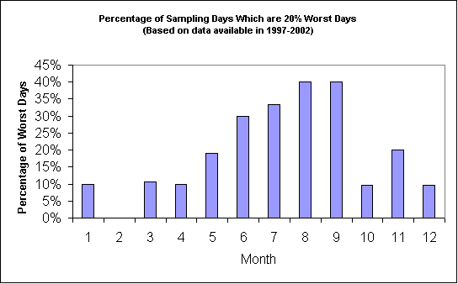
Figure 3. Percentage of sampling days that are 20% worst days in each month (Based on data available from 2001-2002)
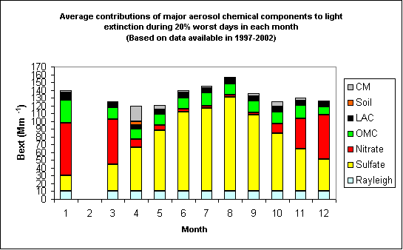
Figure 4. Average contributions of major aerosol chemical components to light extinction during 20% worst days in each month (Based on data available from 2001-2002)
As shown in Figure 5, prevailing transport wind directions in the Midwest are predominantly from the south, especially in the summer, a consequence of the semi-permanent Bermuda High of the eastern Atlantic coast that brings maritime tropical air into the Midwest from the direction of the Gulf of Mexico. In the winter and spring this pattern is modified by continental high pressure over the western states, the Great Basin High, that results in a higher frequency of northerly flow from the direction of the Canadian interior and the western U.S., bringing with it colder continental air masses that can at times override the tropical air in the upper Mississippi Valley creating instability and at times tornados. Figure 6 indicates that northerly to northwesterly flow usually bring clean air to the site, while southerly and easterly flows are more frequently associated with the 20% worst haze days. As shown in Figure 7, most of the 20% worst sulfate days are associated with flows from the eastern United States.
Figure 5. Normalized residence time in January (left) and August (right) (based on data from 2000-2002)

Figure 6. Normalized residence time in 20% best (left) and worst (right) days (based on data from 2000-2002)

Figure 7. Difference (left) and ratio (right) of normalized residence time in 20% worst sulfate days and all days during 2001-2002 (possible important source regions are shown up as blue in the maps)

