Preliminary Conceptual Model - Causes of Haze in Mingo Wilderness Area
(MING1)

Sulfate transported from the eastern United States is the major cause of haze at the Mingo Wilderness Area.

The Mingo Wilderness occupies 7,730 acres on the western half of the Mingo National Wildlife Refuge in southeastern Missouri. Terrain is marshy flatlands, surrounded by low hills. The MING1 IMPROVE site is located ~3 km northeast of the town Puxico near the southeastern corned of the Wildlife Refuge. The site elevation is 112 m (367 ft). Surrounding terrain is hilly and groundcover is predominantly forest and lakes. The average PM_{2.5} mass concentration during the years 7/2000 - 12/2002 is 12.5 μg/m³, and the average total light extinction coefficient (B_{ext}) is 95 Mm⁻¹ (Visual Range ~ 41 Km; Deciview ~ 22). Sulfate is the largest contributor to haze, with an average contribution of ~ 49%.
Figure 1. 20 Km terrain map

Figure 3 suggests that the highest occurrence of the 20% worst days happened in the summer and January, in which ~30 - 40% of the sampling days are the 20% haziest days at Mingo. As shown in Figure 4, Sulfate is the largest aerosol contributor to haze the whole year except January, March, April and December, with a contribution from ~ 35% to as high as ~ 70 - 80% in the summer on the 20% worst days. In January, March, April and December, nitrate is the largest aerosol contributor to haze, and its contribution is about 40-60% on the worst days.

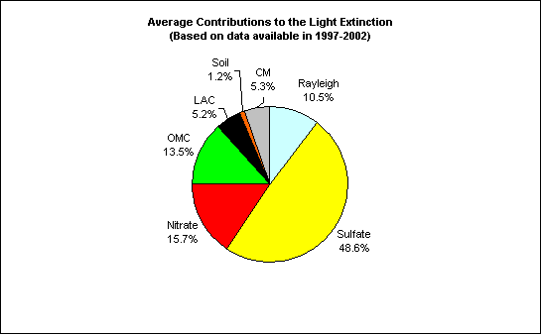
Figure 2. Average contributions of major aerosol chemical components to light extinction (Based on data available from 2000-2002)

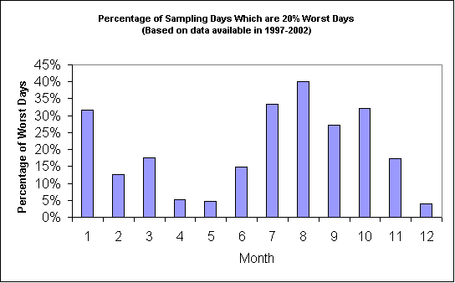
Figure 3. Percentage of sampling days that are 20% worst days in each month (Based on data available from 2000-2002)
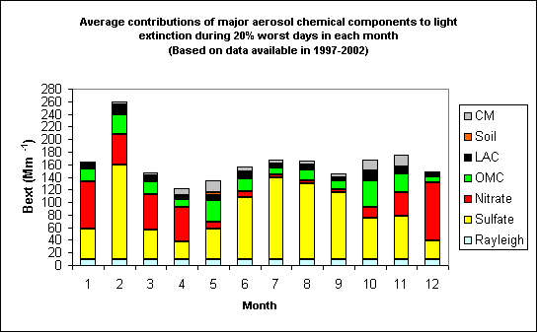
Figure 4. Average contributions of major aerosol chemical components to light extinction during 20% worst days in each month (Based on data available from 2000-2002)
As shown in Figure 5, prevailing transport wind directions in MING1 are predominantly from the west in winter and from the south and east in the summer. Figure 6 indicates that northerly to northwesterly flow usually bring clean air to the site, while easterly flows are more frequently associated with the 20% worst haze days. As shown in Figure 7, most of the 20% worst sulfate days are associated with flows from the eastern United States.

Figure 5. Normalized residence time in January (left) and August (right) (based on data from 2000-2002)

Figure 6. Normalized residence time in 20% best (left) and worst (right) days (based on data from 2000-2002)

Figure 7. Difference (left) and ratio (right) of normalized residence time in 20% worst sulfate days and all days during 2000-2002 (possible important source regions are shown up as blue in the maps)

