Preliminary Conceptual Model - Causes of Haze in Upper Buffalo Wilderness Area
(UPBU1)

Sulfate transported from the eastern United States in the summer is the major cause of haze in the Upper Buffalo Wilderness Area in Arkansas. Sulfate in average contributes ~ 60% to regional haze during the 20% worst haze days observed at the site UPBU1 based on 6 years of IMPROVE data available from 1997 – 2002.

The Upper Buffalo Wilderness contains 10,819 acres around the headwaters of the Buffalo National River in northern Arkansas. Terrain is rugged steep valleys, with many caves, hollows, and bluffs. The UPBU1 IMPROVE site is located on hilltop at an elevation of 723 m (2,372 ft), 500 m east of the small town of Dee, 16.5 km east of Upper Buffalo Wilderness boundary and 4 km north of Hurricane Creek Wilderness boundary. As shown in Figure 2, the average PM_{2.5} mass concentration measured at UPBU1 during 1997 to 2002 is 9.5 μg/m³. The average total light extinction coefficient (B_{ext}) is 75.5 Mm⁻¹ (Visual Range ~ 52 Km; Deciview ~ 20.2). The average contributions of the major aerosol components to Upper Buffalo haze are particulate sulfate 50.6%, nitrate 13.1%, organic matter (OMC) 12.7%, elemental carbon (light absorbing carbon, LAC) 4.2%, fine soil 1.1% and coarse mass (CM) 5.1%.

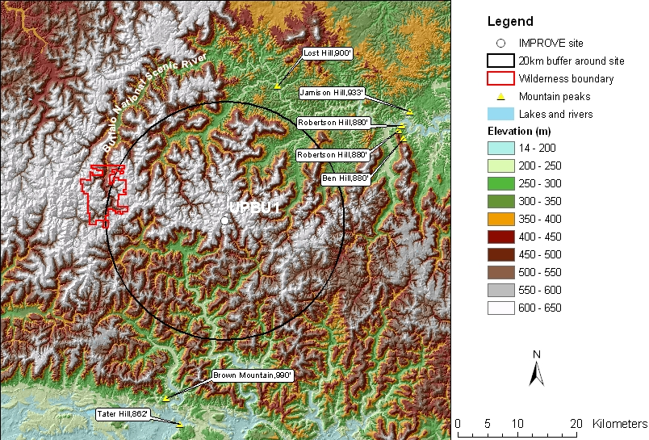
Figure 1. 20 Km terrain map

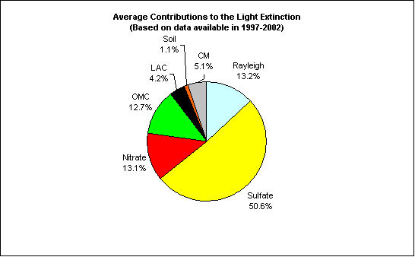
Figure 2. Average contributions of major aerosol chemical components to light extinction.

As Figure 3 and Figure 4 indicate, most of the 20% worst days happened in the summer season from July to September, and sulfate is the dominant aerosol component that contributes to the light extinction. Occasionally, nitrate may dominate aerosol light extinction and result in 20% worst days during the winter.

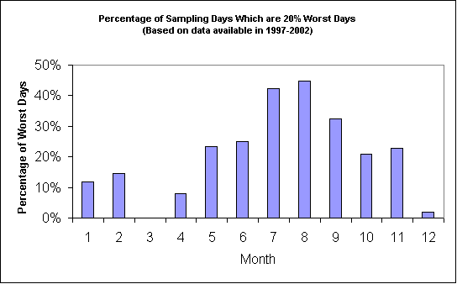
Figure 3. Percentage of sampling days that are 20% worst days in each month
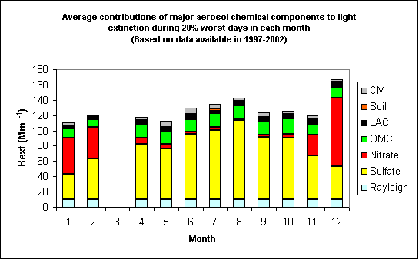
Figure 4. Average contributions of major aerosol chemical components to light extinction during 20% worst days in each month
Residence maps as shown in Figure 5 suggest air generally transported from north to north west or south of the site during the winter. In the summer, air flows from south to southwest, and eastern United States are dominant. Figure 6 and Figure 7 indicate that the eastern US is the major source region of the sulfate at the Upper Buffalo Wilderness Area.

Figure 5. Normalized residence time in January (left) and August (right) (based on data from 2000-2002)

Figure 6. Difference (left) and ratio (right) of normalized residence time in 20% worst sulfate days and all days during 2000-2002 (possible important source regions are shown up as blue in the maps)

Figure 7. SO₂ sources based on 1996 NEI and WRAP database

