Preliminary Conceptual Model - Causes of Haze in Voyageurs National Park
(VOYA2)

Sulfate transported from south to southeast of the site, local and regional nitrate in the winter, and emissions from prescribed burns or from wild land fire in the early summer are the major causes of haze at the Voyageurs National Park.

VOYA2 is located on an exposed hill-top and lakes are within 2 km of the site, with good exposure to regional scale transport winds. The average PM_{2.5} mass concentration during the years 2001-2002 is 4.4 μg/m³, and the average total light extinction coefficient (B_{ext}) is 36.9 Mm⁻¹ (Visual Range ~ 106 Km; Deciview ~ 13.1). Sulfate is the largest contributor to haze, with a contribution of 32%.

Figure 1. 20 Km terrain map

Figure 3 suggests that the highest occurrence of the 20% worst days happened in January, in which ~40% of the sampling days are the 20% haziest days at Voyageurs National Park. As shown in Figure 4, nitrate is the largest aerosol contributor to haze in the winter, with a contribution of about 50% in the 20% worst days in January and December. Sulfate contributes from ~ 20 - 30% in the cold season to ~ 40 - 50% in the summer. Relatively high OC/EC contributions (30% - 40%) are found in June and July. The area is largely forested, and there may be frequent emissions from prescribed burns or from wild land fire during hot and dry periods.

Figure 2. Average contributions of major aerosol chemical components to light extinction (Based on data available from 2001-2002)

Figure 3. Percentage of sampling days that are 20% worst days in each month (Based on data available from 2001-2002)
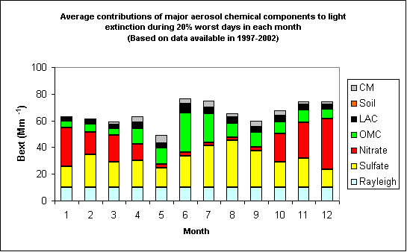
Figure 4. Average contributions of major aerosol chemical components to light extinction during 20% worst days in each month (Based on data available from 2001-2002)
Figure 5 shows main flow direction from the north to northwest in the winter. Southerly flows become important during the warn season. Figure 6 indicates that northerly flow from Canada usually bring clean air to the site, while southerly flows are more frequently associated with the 20% worst haze days. As shown in Figure 7, most of the 20% worst sulfate days are associated with air flows from south to southeast of the site.

Figure 8 indicates high density of NOx emissions in the central United States. Low temperature and high humidity in the winter favor the partition of NOx to the particulate phase. Moreover, temperature inversions occur 90 % of winter mornings in northern Minnesota, which traps air pollutants and result in 20% worst haze days in the winter.

Figure 5. Normalized residence time in January (left) and August (right) (based on data from 2000-2002)

Figure 6. Normalized residence time in 20% best (left) and worst (right) days (based on data from 2000-2002)

Figure 7. Difference (left) and ratio (right) of normalized residence time in 20% worst sulfate days and all days during 2001-2002 (possible important source regions are shown up as blue in the maps)

Figure 8. Regional NOx emissions

