Preliminary Conceptual Model - Causes of Haze in Wichita Mountains Wilderness Area
(WIMO1)

Sulfate transported from Texas and the eastern United States are the major causes of haze at the Wichita Mountains Wilderness Area.

The Wichita Mountains IMPROVE site is in a broad drainage in the Wichita Mountains. It is located on the lower slopes of Elk Mountain at an elevation of 518 m (1,699 ft). Valley bottom elevations in the vicinity are near 500 m (1,640 ft). Mountain summit elevations south of the drainage are near 650 to 680 m (2,130 to 2,230 ft). To the north terrain rises to 650 to 700 m (2,130 to 2,300 ft) at distances ~ 3 to 5 km (2 to 3 mi). The terrain is thus a generally WNW to ESE oriented valley, draining to the WSW toward the town of Lawton. Ground cover is predominantly grassland, with scattered patches of forest. The average PM_{2.5} mass concentration during the years 2001-2002 is 7.5 μg/m³, and the average total light extinction coefficient (B_{ext}) is 57 Mm⁻¹ (Visual Range ~ 68 Km; Deciview ~ 17). Sulfate is the largest contributor to haze, with an average contribution of ~ 43%.

Figure 1. 20 Km terrain map

Figure 3 suggests that the highest occurrence of the 20% worst days happened in April, May, August and September, in which ~35% of the sampling days are the 20% haziest days at Wichita Mountains. As shown in Figure 4, Sulfate is the largest aerosol contributor to haze the whole year except January, with a contribution of about 35 - 65% in the 20% worst days. Nitrate dominates light extinction in January, and contributes ~ 44% to haze in the 20% worst days.

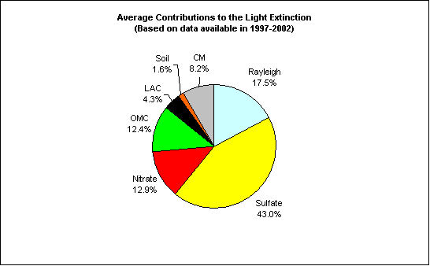
Figure 2. Average contributions of major aerosol chemical components to light extinction (Based on data available from 2001-2002)

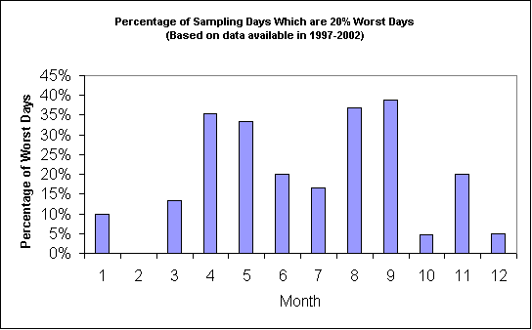
Figure 3. Percentage of sampling days that are 20% worst days in each month (Based on data available from 2001-2002)
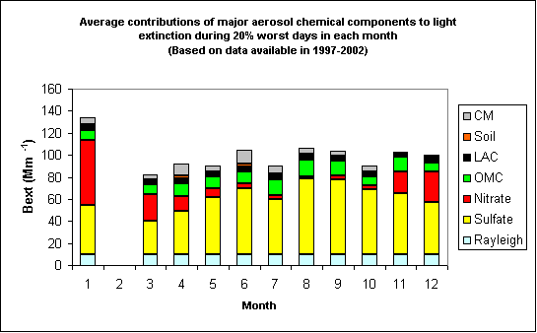
Figure 4. Average contributions of major aerosol chemical components to light extinction during 20% worst days in each month (Based on data available from 2001-2002)
As shown in Figure 5, prevailing transport wind directions in WIMO1 are predominantly from the west in winter and from the south and east in the summer. Figure 6 indicates that northerly to northwesterly flow usually bring clean air to the site, while southerly and easterly flows are more frequently associated with the 20% worst haze days. As shown in Figure 7, most of the 20% worst sulfate days are associated with flows from southeastern Texas and the eastern United States.

Figure 5. Normalized residence time in January (left) and August (right) (based on data from 2000-2002)

Figure 6. Normalized residence time in 20% best (left) and worst (right) days (based on data from 2000-2002)

Figure 7. Difference (left) and ratio (right) of normalized residence time in 20% worst sulfate days and all days during 2001-2002 (possible important source regions are shown up as blue in the maps)

