Haze Episode Assessment

Episode Name: Forest Fire episode

Episode Characteristics:

Aerosol Composition at affected sites:

Carbonate particles are the major contributors (contribution > ~ 50%) to the aerosol light extinction during the forest fire episode. OC concentrations are much higher (more than 50%) than typical in the sites that influenced by the forest fire. Usually, more OC than EC is emitted by forest fire compared with other anthropogenic sources, resulting in a relatively higher OC/EC during the forest fire period. Potassium concentration, which usually comes from the biomass burning, is also higher during the forest fire episode. Correlations can be found between OC and K concentrations in the sites that predominantly influenced by forest fires. But the detailed aerosol composition depends largely on the type of the vegetation burned and the burning conditions.

Spatial scale, regionality and seasonality:

Forest fire can be regional phenomenon – one fire can influence multiple sites, and one site may be influenced by multiple fire events. It usually happens in the Summer time from June to August.

Frequency and duration:

The frequency of the forest fire events varies from year to year. The following figure summarizes the total area burned in the U.S. by wildfire each year. The duration of the influence of forest fire also varies a lot, depending on the size of the fire and the meteorology conditions.
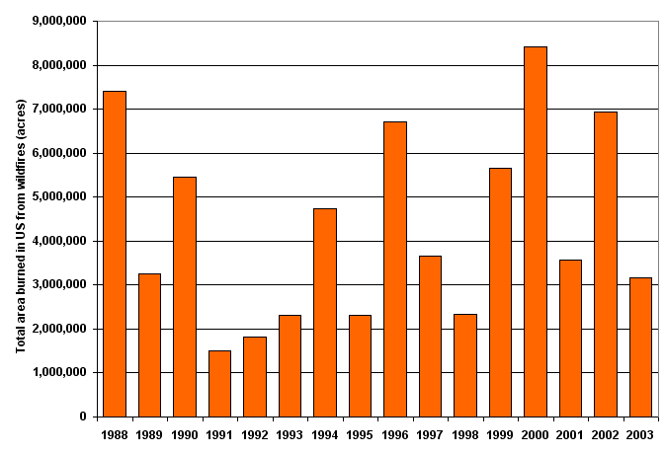

Dates of good Examples:

7/10/1999, 8/2/2000

Relationship to Meteorological Conditions:

Relatively higher temperature and lower RH are normally associated with the forest fire events.

Source Attribution Evidence:

Wildfire
Controlled fire
…

