

Report

Causes of Haze Assessment for US Fish and Wildlife Service Class I Areas in the Central and Eastern United States

Task 2. Aerosol Summary

Sub-Task. Summary of Clean Air Status and Trends Network (CASTNET) atmospheric and dry deposition data for the period 2000-2004

Prepared by
Mark Green
Ilias Kavouras
Dave DuBois
Jin Xu
Division of Atmospheric Sciences
Desert Research Institute
755 E. Flamingo Rd. Las Vegas, NV

Prepared for
Sandra V. Silva
Fish and Wildlife Service
Branch for Air Quality
7333 West Jefferson Avenue,
Lakewood, Colorado

August 2006
Table of Contents
A. Site locations and characteristics 7
B. Ambient concentrations and deposition 9
B.1 Beaufort, North Carolina 9
B.1.1 Ambient air 9
B.1.2 Dry Deposition 12
B.2 Cadiz, Kentucky 14
B.2.1 Ambient air 14
B.2.2 Dry Deposition 16
B.3 Candor, North Carolina 19
B.3.1 Ambient air 19
B.3.2 Dry Deposition 21
B.4 Cherokee Nation, Oklahoma 24
B.4.1 Ambient air 24
B.4.2 Dry Deposition 26
B.5 Georgia Station, Georgia 29
B.5.1 Ambient air 29
B.5.2 Dry Deposition 31
B.6 Howland, Maine 34
B.6.1 Ambient air 34
B.6.2 Dry Deposition 36
B.7 Hoxeyville, Michigan 39
B.7.1 Ambient air 39
B.7.2 Dry Deposition 41
B.8 Indian River Lagoon, Florida 44
B.8.1 Ambient air 44
B.8.2 Dry Deposition 46
B.9 Sumatra, Florida 49
B.9.1 Ambient air 49
B.9.2 Dry Deposition 51
B.10 Washington Crossing, New Jersey 54
B.10.1 Ambient air 54
B.10.2 Dry Deposition 56

List of Tables
Table 1 FWS and CASTNET sites 8
Table 2. Descriptive statistics (in μg/m³) of atmospheric particulate ammonium, nitrate, sulfate and, sulfur dioxide and nitric acid in Beaufort, NC for 2000-2004 periods 9
Table 3 Annual and quarterly variation of regression coefficients of atmospheric NH4 (as dependent variable) and the sum of NO3 and SO4 (as independent variable). 11
Table 4 Descriptive statistics (g/ha) of dry deposition rate of ammonium, nitrate, sulfate and, sulfur dioxide and nitric acid in Beaufort, NC for 2000-2004 periods and total nitrogen and sulfur deposition (kg/ha) for the entire period 12
Table 5 Descriptive statistics (in μg/m³) of atmospheric particulate ammonium, nitrate, sulfate and, sulfur dioxide and nitric acid in Cadiz KY for 2000-2004 periods 14
Table 6 Annual and quarterly variation of regression coefficients of atmospheric NH4 (as dependent variable) and the sum of NO3 and SO4 (as independent variable). 16
Table 7 Descriptive statistics (g/ha) of dry deposition of ammonium, nitrate, sulfate and, sulfur dioxide and nitric acid in Cadiz, KY for 2000-2004 periods and total nitrogen and sulfur deposition (kg/ha) for the entire period 17
Table 8 Descriptive statistics (in μg/m³) of atmospheric particulate ammonium, nitrate, sulfate and, sulfur dioxide and nitric acid in Candor NC for 2000-2004 periods 19
Table 9 Annual and quarterly variation of regression coefficients of atmospheric NH4 (as dependent variable) and the sum of NO3 and SO4 (as independent variable). 21
Table 10 Descriptive statistics (g/ha) of dry deposition of ammonium, nitrate, sulfate and, sulfur dioxide and nitric acid in Beaufort, NC for 2000-2004 periods and total nitrogen and sulfur deposition (kg/ha) for the entire period 22
Table 11 Descriptive statistics (in μg/m³) of atmospheric particulate ammonium, nitrate, sulfate and, sulfur dioxide and nitric acid in Candor NC for 2000-2004 periods 24
Table 12 Annual and quarterly variation of regression coefficients of atmospheric NH4 (as dependent variable) and the sum of NO3 and SO4 (as independent variable). 26
Table 13 Descriptive statistics (g/ha) of dry deposition of ammonium, nitrate, sulfate and, sulfur dioxide and nitric acid in Beaufort, NC for 2000-2004 periods and total nitrogen and sulfur deposition (kg/ha) for the entire period 27
Table 14 Descriptive statistics (in μg/m³) of atmospheric particulate ammonium, nitrate, sulfate and, sulfur dioxide and nitric acid in Georgia Station for 2000-2004 periods 29
Table 15 Annual and quarterly variation of regression coefficients of atmospheric NH4 (as dependent variable) and the sum of NO3 and SO4 (as independent variable). 31
Table 16 Descriptive statistics (g/ha) of dry deposition of ammonium, nitrate, sulfate and, sulfur dioxide and nitric acid in Georgia Station for 2000-2004 periods and total nitrogen and sulfur deposition (kg/ha) for the entire period 32
Table 17 Descriptive statistics (in μg/m³) of atmospheric particulate ammonium, nitrate, sulfate and, sulfur dioxide and nitric acid in Howland for 2000-2004 periods 34
Table 18 Annual and quarterly variation of regression coefficients of atmospheric NH4 (as dependent variable) and the sum of NO3 and SO4 (as independent variable). 36
Table 19 Descriptive statistics (g/ha) of dry deposition of ammonium, nitrate, sulfate and, sulfur dioxide and nitric acid in Howland for 2000-2004 periods and total nitrogen and sulfur deposition (kg/ha) for the entire period 37
Table 20 Descriptive statistics (in μg/m³) of atmospheric particulate ammonium, nitrate, sulfate and, sulfur dioxide and nitric acid in Hoxeyville for 2000-2004 periods 39
Table 21 Annual and quarterly variation of regression coefficients of atmospheric NH4 (as dependent variable) and the sum of NO3 and SO4 (as independent variable). 41
Table 22 Descriptive statistics (g/ha) of dry deposition of ammonium, nitrate, sulfate and, sulfur dioxide and nitric acid in Hoxeyville for 2000-2004 periods and total nitrogen and sulfur deposition (kg/ha) for the entire period 42
Table 23 Descriptive statistics (in μg/m³) of atmospheric particulate ammonium, nitrate, sulfate and, sulfur dioxide and nitric acid in Indian River Lagoon for 2000-2004 periods 44
Table 24 Annual and quarterly variation of regression coefficients of atmospheric NH4 (as dependent variable) and the sum of NO3 and SO4 (as independent variable). 46
Table 25 Descriptive statistics (g/ha) of dry deposition of ammonium, nitrate, sulfate and, sulfur dioxide and nitric acid in Indian River Lagoon for 2000-2004 periods and total nitrogen and sulfur deposition (kg/ha) for the entire period 47
Table 26 Descriptive statistics (in μg/m³) of atmospheric particulate ammonium, nitrate, sulfate and, sulfur dioxide and nitric acid in Sumatra for 2000-2004 periods 49
Table 27 Annual and quarterly variation of regression coefficients of atmospheric NH4 (as dependent variable) and the sum of NO3 and SO4 (as independent variable). 51
Table 28 Descriptive statistics (g/ha) of dry deposition of ammonium, nitrate, sulfate and, sulfur dioxide and nitric acid in Sumatra for 2000-2004 periods and total nitrogen and sulfur deposition (kg/ha) for the entire period 52
Table 29 Descriptive statistics (in μg/m³) of atmospheric particulate ammonium, nitrate, sulfate and, sulfur dioxide and nitric acid in Washington Crossing for 2000-2004 periods 54
Table 30 Annual and quarterly variation of regression coefficients of atmospheric NH4 (as dependent variable) and the sum of NO3 and SO4 (as independent variable). 56
Table 31 Descriptive statistics (g/ha) of dry deposition of ammonium, nitrate, sulfate and, sulfur dioxide and nitric acid in Washington Crossing for 2000-2004 periods and total nitrogen and sulfur deposition (kg/ha) for the entire period 57

List of Figures
Figure 1 Map showing the location of Fish and Wildlife Service sites (yellow circles) and CASTNET sites (white circles) 7
Figure 2 Location of CASTNET Beaufort and FWS Swanquarter sites. 9
Figure 3 Mean annual concentrations of particulate ammonium (NH4), nitrate (NO3) and sulfate (SO4) and gaseous nitric acid (HNO3) and sulfur dioxide (SO2) 10
Figure 4 Mean quarterly concentrations of particulate ammonium (NH4), nitrate (NO3) and sulfate (SO4) and gaseous nitric acid (HNO3) and sulfur dioxide (SO2) 10
Figure 5 Scatter plot of NH4 nano-equivalents per m³ vs. the sum of NO₃ and SO₄ nano-equivalents per m³ 11
Figure 6 Annual dry deposition of ammonium (NH4), nitrate (NO3), sulfate (SO4), nitric acid (HNO3) and sulfur dioxide (SO2). 12
Figure 7 Quarterly dry deposition of ammonium (NH4), nitrate (NO3), sulfate (SO4), nitric acid (HNO3) and sulfur dioxide (SO2). 13
Figure 8 Total nitrogen and sulfur dry deposition at Beaufort during 2000-2004 13
Figure 9 Location of CASTNET Cadiz site with respect to FWS Mingo site. 14
Figure 10 Mean annual concentrations of particulate ammonium (NH4), nitrate (NO3) and sulfate (SO4) and gaseous nitric acid (HNO3) and sulfur dioxide (SO2) 15
Figure 11 Mean quarterly concentrations of particulate ammonium (NH4), nitrate (NO3) and sulfate (SO4) and gaseous nitric acid (HNO3) and sulfur dioxide (SO2) 15
Figure 12. Scatter plot of NH4 nanoequivalents per m³ vs. the sum of NO₃ and SO₄ nano-equivalents per m³ 16
Figure 13 Annual dry deposition of ammonium (NH4), nitrate (NO3), sulfate (SO4), nitric acid (HNO3) and sulfur dioxide (SO2). 17
Figure 14 Quarterly dry deposition of ammonium (NH4), nitrate (NO3), sulfate (SO4), nitric acid (HNO3) and sulfur dioxide (SO2). 18
Figure 15 Total nitrogen and sulfur dry deposition at Cadiz during 2000-2004 18
Figure 16 Location of CASTNET Candor and FWS Cape Romain sites. 19
Figure 17 Mean annual concentrations of particulate ammonium (NH4), nitrate (NO3) and sulfate (SO4) and gaseous nitric acid (HNO3) and sulfur dioxide (SO2) 20
Figure 18 Mean quarterly concentrations of particulate ammonium (NH4), nitrate (NO3) and sulfate (SO4) and gaseous nitric acid (HNO3) and sulfur dioxide (SO2) 20
Figure 19 Scatter plot of NH4 nanoequivalents per m3 vs. the sum of NO₃ and SO₄ nano-equivalents per m³ 21
Figure 20 Annual dry deposition of ammonium (NH4), nitrate (NO3), sulfate (SO4), nitric acid (HNO3) and sulfur dioxide (SO2). 22
Figure 21 Quarterly dry deposition of ammonium (NH4), nitrate (NO3), sulfate (SO4), nitric acid (HNO3) and sulfur dioxide (SO2). 23
Figure 22 Total nitrogen and sulfur dry deposition at Candor during 2000-2004 23
Figure 23 Location of CASTNET Cherokee Nation and FWS Wichita Mountain sites. 24
Figure 24 Mean annual concentrations of particulate ammonium (NH4), nitrate (NO3) and sulfate (SO4) and gaseous nitric acid (HNO3) and sulfur dioxide (SO2) 25
Figure 25 Mean quarterly concentrations of particulate ammonium (NH4), nitrate (NO3) and sulfate (SO4) and gaseous nitric acid (HNO3) and sulfur dioxide (SO2) 25
Figure 26 Scatter plot of NH4 nanoequivalents per m3 vs. the sum of NO₃ and SO₄ nano-equivalents per m³ 26
Figure 27 Annual dry deposition of ammonium (NH4), nitrate (NO3), sulfate (SO4), nitric acid (HNO3) and sulfur dioxide (SO2). 27
Figure 28 Quarterly dry deposition of ammonium (NH4), nitrate (NO3), sulfate (SO4), nitric acid (HNO3) and sulfur dioxide (SO2). 28
Figure 29 Total nitrogen and sulfur dry deposition at Cherokee Nation during 2000-2004 28
Figure 30 Location of CASTNET Georgia Station and FWS Wolf Island sites. 29
Figure 31 Mean annual concentrations of particulate ammonium (NH4), nitrate (NO3) and sulfate (SO4) and gaseous nitric acid (HNO3) and sulfur dioxide (SO2) 30
Figure 32 Mean quarterly concentrations of particulate ammonium (NH4), nitrate (NO3) and sulfate (SO4) and gaseous nitric acid (HNO3) and sulfur dioxide (SO2) 30
Figure 33 Scatter plot of NH4 nanoequivalents per m³ vs. the sum of NO₃ and SO₄ nano-equivalents per m³ 31
Figure 34 Annual dry deposition of ammonium (NH4), nitrate (NO3), sulfate (SO4), nitric acid (HNO3) and sulfur dioxide (SO2). 32
Figure 35 Quarterly dry deposition of ammonium (NH4), nitrate (NO3), sulfate (SO4), nitric acid (HNO3) and sulfur dioxide (SO2). 33
Figure 36 Total nitrogen and sulfur dry deposition at Georgia Station during 2000-2004 33
Figure 37 Location of CASTNET Howland and FWS Moosehorn sites. 34
Figure 38 Mean annual concentrations of particulate ammonium (NH4), nitrate (NO3) and sulfate (SO4) and gaseous nitric acid (HNO3) and sulfur dioxide (SO2) 35
Figure 39 Mean quarterly concentrations of particulate ammonium (NH4), nitrate (NO3) and sulfate (SO4) and gaseous nitric acid (HNO3) and sulfur dioxide (SO2) 35
Figure 40 Scatter plot of NH4 nanoequivalents per m³ vs. the sum of NO₃ and SO₄ nano-equivalents per m³ 36
Figure 41 Annual dry deposition of ammonium (NH4), nitrate (NO3), sulfate (SO4), nitric acid (HNO3) and sulfur dioxide (SO2). 37
Figure 42 Quarterly dry deposition of ammonium (NH4), nitrate (NO3), sulfate (SO4), nitric acid (HNO3) and sulfur dioxide (SO2). 38
Figure 43 Total nitrogen and sulfur dry deposition at Howland during 2000-2004 38
Figure 44 Location of CASTNET Hoxeyville and FWS Seney sites. 39
Figure 45 Mean annual concentrations of particulate ammonium (NH4), nitrate (NO3) and sulfate (SO4) and gaseous nitric acid (HNO3) and sulfur dioxide (SO2) 40
Figure 46 Mean quarterly concentrations of particulate ammonium (NH4), nitrate (NO3) and sulfate (SO4) and gaseous nitric acid (HNO3) and sulfur dioxide (SO2) 40
Figure 47 Scatter plot of NH4 nanoequivalents per m³ vs. the sum of NO₃ and SO₄ nano-equivalents per m³ 41
Figure 48 Annual dry deposition of ammonium (NH4), nitrate (NO3), sulfate (SO4), nitric acid (HNO3) and sulfur dioxide (SO2). 42
Figure 49 Quarterly dry deposition of ammonium (NH4), nitrate (NO3), sulfate (SO4), nitric acid (HNO3) and sulfur dioxide (SO2). 43
Figure 50 Total nitrogen and sulfur dry deposition at Hoxeyville during 2000-2004 43
Figure 51 Location of CASTNET Indian River Lagoon and FWS Chassahowitzka sites. 44
Figure 52 Mean annual concentrations of particulate ammonium (NH4), nitrate (NO3) and sulfate (SO4) and gaseous nitric acid (HNO3) and sulfur dioxide (SO2) 45
Figure 53 Mean quarterly concentrations of particulate ammonium (NH4), nitrate (NO3) and sulfate (SO4) and gaseous nitric acid (HNO3) and sulfur dioxide (SO2) 45
Figure 54 Scatter plot of NH4 nanoequivalents per m³ vs. the sum of NO₃ and SO₄ nano-equivalents per m³ 46
Figure 55 Annual dry deposition of ammonium (NH4), nitrate (NO3), sulfate (SO4), nitric acid (HNO3) and sulfur dioxide (SO2). 47
Figure 56 Quarterly dry deposition of ammonium (NH4), nitrate (NO3), sulfate (SO4), nitric acid (HNO3) and sulfur dioxide (SO2). 48
Figure 57 Total nitrogen and sulfur dry deposition at Indian River Lagoon during 2000-2004 48
Figure 58 Location of CASTNET Sumatra and FWS Breton, St.Marks and Okefenokee sites. 49
Figure 59 Mean annual concentrations of particulate ammonium (NH4), nitrate (NO3) and sulfate (SO4) and gaseous nitric acid (HNO3) and sulfur dioxide (SO2) 50
Figure 60 Mean quarterly concentrations of particulate ammonium (NH4), nitrate (NO3) and sulfate (SO4) and gaseous nitric acid (HNO3) and sulfur dioxide (SO2) 50
Figure 61 Scatter plot of NH4 nanoequivalents per m³ vs. the sum of NO₃ and SO₄ nano-equivalents per m³ 51
Figure 62 Annual dry deposition of ammonium (NH4), nitrate (NO3), sulfate (SO4), nitric acid (HNO3) and sulfur dioxide (SO2). 52
Figure 63 Quarterly dry deposition of ammonium (NH4), nitrate (NO3), sulfate (SO4), nitric acid (HNO3) and sulfur dioxide (SO2). 53
Figure 64 Total nitrogen and sulfur dry deposition at Sumatra during 2000-2004 53
Figure 65 Location of CASTNET Sumatra and FWS Breton, St.Marks and Okefenokee sites. 54
Figure 66 Mean annual concentrations of particulate ammonium (NH4), nitrate (NO3) and sulfate (SO4) and gaseous nitric acid (HNO3) and sulfur dioxide (SO2) 55
Figure 67 Mean quarterly concentrations of particulate ammonium (NH4), nitrate (NO3) and sulfate (SO4) and gaseous nitric acid (HNO3) and sulfur dioxide (SO2) 55
Figure 68 Scatter plot of NH4 nanoequivalents per m³ vs. the sum of NO₃ and SO₄ nano-equivalents per m³ 56
Figure 69 Annual dry deposition of ammonium (NH4), nitrate (NO3), sulfate (SO4), nitric acid (HNO3) and sulfur dioxide (SO2). 57
Figure 70 Quarterly dry deposition of ammonium (NH4), nitrate (NO3), sulfate (SO4), nitric acid (HNO3) and sulfur dioxide (SO2). 58
Figure 71 Total nitrogen and sulfur dry deposition at Washington Crosiing during 2000-2004 58

Site locations and characteristics

None of the twelve (12) FWS sites of the IMPROVE network included in this study is collocated with a CASTNET site. For this reason, a set of geographical criteria are developed to associate each FWS site with a CASTNET site. Initially, only CASTNET sites within 100 km away from the FWS site and difference in elevation of no more than 300 meters are considered. As a result, a CASTNET site is obtained for nine FWS sites with distance varied from 25 up to 88 km. For three sites (Breton LA, Wichita Mountain OK and Wolf Island GA) the nearest CASTNET site is chosen (Table 1). For three FWS sites (Breton LA, Okefenokke GA and St. Marks FL), CASTNET site Sumatra (in Florida) is chosen based on the geographical criteria. The background in maps is land cover data obtained from the AVHRR Global land Cover database covering all of North America.

Figure 1 Map showing the location of Fish and Wildlife Service sites (yellow circles) and CASTNET sites (white circles)

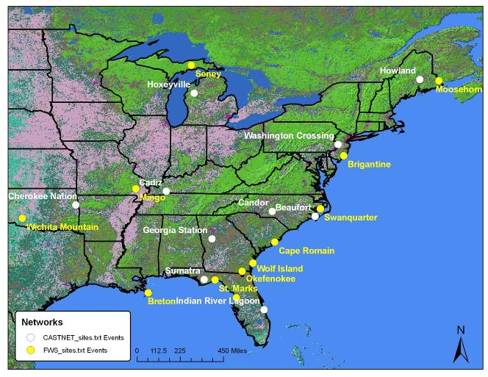

Table 1 FWS and CASTNET sites

Fish and Wildlife Service site | Coordinates, Elevation | CASTNET site | CoordinatesElevation | Distances  Km / m
Brigantine NJ | N39.46 W74.45 5 | Washington Crossing NJ | N40.31 W74.87 61 | 31 / 56
Chassahowitzka FL | N28.74 W82.55 4.3 | Indian River Lagoon FL | N27.84 W80.45 2 | 71 / 2
Breton LA | N29.12 W89.20 11 | Sumatra FL | N30.11 W84.94 14 | 131 / 3
Cape Romain SC | N32.94 W79.65 4.7 | Candor NC | N35.26 W79.83 198 | 80 / 193
St. Marks FL | N30.09 W84.16 7.7 | Sumatra Fl | N30.11 W84.94 14 | 25 / 6
Mingo KS | N36.97 W90.14 111.3 | Cadiz KY | N36.78 W87.85 189 | 64 / 78
Moosehorn ME | N45.13 W67.26 77.7 | Howland ME | N45.21 W68.70 72.7 | 35 / 9
Okefenokee GA | N30.74 W82.13 4.8 | Sumatra FL | N30.11 W84.94 14 | 88 / 34
Seney MI | N46.29 W85.95 214.5 | Hoxeyville MI | N44.18 W85.74 305 | 73 / 91
Swanquarter NC | N35.45 W76.20 2 | Beaufort NC | N34.88 W76.62 2 | 23 / 6
Wichita Mt OK | N34.73 98.71 8 | Cherokee Nation OK | N35.75 W94.67 299 | 119 / 294
Wolf Island GA | N31.35 W81.31 2 | Georgia Station GA | N33.18 W84.40 270 | 110 / 268

Ambient concentrations and deposition

Beaufort, North Carolina

Beaufort, North Carolina is used as a surrogate CASTNET site for FWS Swanquarter site in North Carolina. Figure 2 shows the locations of both sites at the end of Pamlico River.

Figure 2 Location of CASTNET Beaufort and FWS Swanquarter sites.
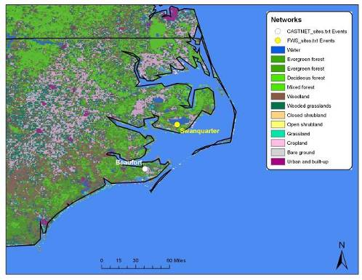

Ambient air

Ambient air concentration levels of particle-associated ammonium, nitrate, sulfate and gas-phase sulfur dioxide and nitric acid for Beaufort, NC during the 2000-2004 period are presented in Table 2.

Table 2 Descriptive statistics (in μg/m³) of atmospheric particulate ammonium, nitrate, sulfate and, sulfur dioxide and nitric acid in Beaufort, NC for 2000-2004 periods
 | Mean | Minimum | Maximum | Std Deviation
Aerosol
Ammonium (NH₄⁺) | 0.9 | 0.2 | 2.6 | 0.4
Nitrate (NO₃⁻) | 1.3 | 0.1 | 2.9 | 0.5
Sulfate (SO₄²⁻) | 3.9 | 0.9 | 9.9 | 1.6
Gas Phase
Sulfur dioxide (SO₂) | 3.0 | 0.4 | 14.1 | 2.4
Nitric Acid (HNO₃) | 1.1 | 0.1 | 4.2 | 0.7

Figure 3 Mean annual concentrations of particulate ammonium (NH4), nitrate (NO3) and sulfate (SO4) and gaseous nitric acid (HNO3) and sulfur dioxide (SO2)

As shown in Figure 3 concentrations of particulate components (ammonium, nitrate and sulfate) decreased from 2000 to 2003, while a slight increase is observed for 2004. A similar profile but with upward trends in atmospheric concentrations for sulfur dioxide and nitric acid starting in 2003 is plotted.

Figure 4 Mean quarterly concentrations of particulate ammonium (NH4), nitrate (NO3) and sulfate (SO4) and gaseous nitric acid (HNO3) and sulfur dioxide (SO2)
On a seasonal basis, slightly higher concentrations during the 2nd (April-June) and 3rd (July-September) for ammonium are measured. The differences are more pronounced for sulfate, while an opposite profile is drawn for sulfur dioxide and nitric acid, with higher concentration being measured during winter.

Figure 5 Scatter plot of NH4 nano-equivalents per m³ vs. the sum of NO₃ and SO₄ nano-equivalents per m³
Figure 5 shows the relationship between the sum of sulfate and nitrate vs. ammonium (in n-equivalents/m³). The green line indicates that both nitrate and sulfate are fully neutralized by ammonium in the forms of ammonium nitrate (NH₄NO₃) and ammonium sulfate (NH₄)₂SO₄). The slope of the regression indicates that ammonium concentrations are able to neutralize approximately 50% of nitrate and sulfate, which indicates that the predominant chemical components are (NH₄)HSO₄, H₂SO₄ and HNO₃ and minor amounts of NH₄NO₃ and (NH₄)₂SO₄, if any.

Table 3 shows the inter-annual and seasonal variation of the relationships between ammonium, and nitrate and sulfate. No significant variability is computed from 2002 to 2004. Neutralization by ammonia appears to be more significant during the 2nd and 3rd quarter, while more than 50% of sulfate and nitrate is present in free form (as acids) in the 1st quarter. This may be associated with the seasonal variability of gaseous NH₃, SO₂ and NO_{x} emissions.

Table 3 Annual and quarterly variation of regression coefficients of atmospheric NH4 (as dependent variable) and the sum of NO3 and SO4 (as independent variable).

Year | 2000 | 2001 | 2002 | 2003 | 2004
Slope | 0.48 | 0.61 | 0.52 | 0.56 | 0.53
Intercept | 3.7 | -12.3 | -2.5 | -9.2 | -3.5
R | 0.75 | 0.86 | 0.7 | 0.75 | 0.82
Quarter | 1st | 2nd | 3rd | 4th
Slope | 0.43 | 0.61 | 0.68 | 0.59
Intercept | 8.5 | -20.3 | -23.3 | -2.9
R | 0.66 | 0.83 | 0.90 | 0.78

Dry Deposition

Deposition rates and total dry deposition of particle-associated ammonium, nitrate, sulfate and gas-phase sulfur dioxide and nitric acid, and total nitrogen and sulfur for Beaufort, NC during the 2000-2004 periods are presented inDeposition rates and total dry deposition of particle-associated ammonium, nitrate, sulfate and gas-phase sulfur dioxide and nitric acid, and total nitrogen and sulfur for Beaufort, NC during the 2000-2004 periods are presented inDeposition rates and total dry deposition of particle-associated ammonium, nitrate, sulfate and gas-phase sulfur dioxide and nitric acid, and total nitrogen and sulfur for Beaufort, NC during the 2000-2004 periods are presented inDeposition rates and total dry deposition of particle-associated ammonium, nitrate, sulfate and gas-phase sulfur dioxide and nitric acid, and total nitrogen and sulfur for Beaufort, NC during the 2000-2004 periods are presented in. . . .

Table 4 Descriptive statistics (g/ha) of dry deposition rate of ammonium, nitrate, sulfate and, sulfur dioxide and nitric acid in Beaufort, NC for 2000-2004 periods and total nitrogen and sulfur deposition (kg/ha) for the entire period

 | Mean | Minimum | Maximum | Std Deviation | Total deposition
Aerosol
Ammonium (NH₄⁺) | 7 | 2 | 21 | 4 | 1.4
Nitrate (NO₃⁻) | 11 | 1 | 37 | 6 | 0.6
Sulfate (SO₄²⁻) | 31 | 8 | 82 | 15 | 2.8
Gas Phase
Sulfur dioxide (SO₂) | 76 | 10 | 366 | 54 | 9.6
Nitric Acid (HNO₃) | 95 | 9 | 363 | 58 | 5.3
Total Nitrogen |  |  |  |  | 7.3
Total Sulfur |  |  |  |  | 12.3

As shown in Figure 6 Annual dry deposition of ammonium (NH4), nitrate (NO3), sulfate (SO4), nitric acid (HNO3) and sulfur dioxide (SO2), annual dry deposition of particulate ammonium, nitrate and sulphate followed a downward trend from 2000 to 2003 and a slight increase during 2004, which is consistent with their atmospheric concentrations. On the other hand, while SO2 and HNO3 dry deposition was significantly reduced in 2001, it increased progressively from 2002 to 2004.

Figure 6 Annual dry deposition of ammonium (NH4), nitrate (NO3), sulfate (SO4), nitric acid (HNO3) and sulfur dioxide (SO2)

Figure 7 Quarterly dry deposition of ammonium (NH4), nitrate (NO3), sulfate (SO4), nitric acid (HNO3) and sulfur dioxide (SO2).
On a seasonal basis, dry deposition follows a similar trend as compared to atmospheric concentrations with highest contributions of particle-associated components during the warm period (2rd -3rd quarter) and significant input of SO₂ and HNO₃ during the cold period (1st and 4th quarters)

Figure 8 Total nitrogen and sulfur dry deposition at Beaufort during 2000-2004
The total amount of nitrogen and sulfur deposited in Beaufort NC, ranged approximately from 1.3 kg/ha to 1.9 kg/ha and from 2.2 kg/ha up to 2.9 kg/ha, respectively. A clear inter-annual pattern is observed for both elements with comparables amounts of dry deposition in 2000 and 2004, providing evidence of an increasing trend during the last two years.

Cadiz, Kentucky

Cadiz, Kentucky is used as a surrogate CASTNET site for FWS Mingo site in Missouri. Figure 9 shows the locations of both sites.

Figure 9 Location of CASTNET Cadiz site with respect to FWS Mingo site.
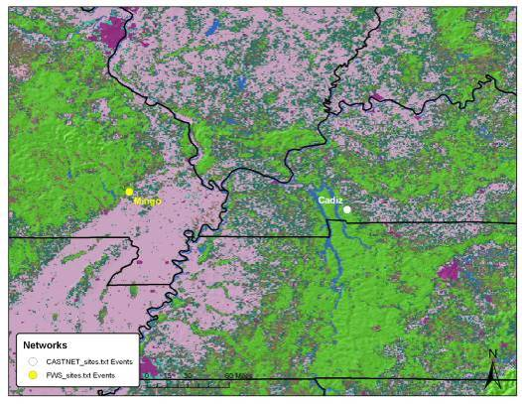

Ambient air

Ambient air concentration levels of particle-associated ammonium, nitrate, sulfate and gas-phase sulfur dioxide and nitric acid for Cadiz, KY during the 2000-2004 period, are presented in Table 5.

Table 5 Descriptive statistics (in μg/m³) of atmospheric particulate ammonium, nitrate, sulfate and, sulfur dioxide and nitric acid in Cadiz KY for 2000-2004 periods
 | Mean | Minimum | Maximum | Std Deviation
Aerosol
Ammonium (NH₄⁺) | 1.7 | 0.4 | 4.5 | 0.7
Nitrate (NO₃⁻) | 1.2 | 0.1 | 6.5 | 1.2
Sulfate (SO₄²⁻) | 4.5 | 1.2 | 13.1 | 2.4
Gas Phase
Sulfur dioxide (SO₂) | 5.9 | 0.7 | 24.7 | 3.5
Nitric Acid (HNO₃) | 2.1 | 0.6 | 5.1 | 0.8

Figure 10 Mean annual concentrations of particulate ammonium (NH4), nitrate (NO3) and sulfate (SO4) and gaseous nitric acid (HNO3) and sulfur dioxide (SO2)

As shown in Figure 10 concentrations of particulate components (ammonium, nitrate and sulfate) decreased from 2000 to 2003, while a slight increase is observed for 2004. A similar profile but with upward trends in atmospheric concentrations for sulfur dioxide is plotted.

Figure 11 Mean quarterly concentrations of particulate ammonium (NH4), nitrate (NO3) and sulfate (SO4) and gaseous nitric acid (HNO3) and sulfur dioxide (SO2)
On a seasonal basis, slightly higher concentrations during the 2nd (April-June) and 3rd (July-September) for sulfate are measured. An opposite profile is drawn for nitrate, sulfur dioxide and nitric acid, with higher concentration being measured during winter.

Figure 12 Scatter plot of NH4 nanoequivalents per m³ vs. the sum of NO₃ and SO₄ nano-equivalents per m³

Figure 12 shows the relationship between the sum of sulfate and nitrate vs. ammonium (in n-equivalents/m³). The green line indicates that both nitrate and sulfate are fully neutralized by ammonium in the forms of ammonium nitrate and ammonium sulfate. The slope of the regression indicates that ammonium concentrations are able to neutralize approximately 93% of nitrate and sulfate, which indicates that the predominant chemical components are (NH₄)HSO₄, NH₄NO₃ and (NH₄)₂SO₄, and minor amounts of H₂SO₄ and HNO₃ if any.

Table 6 shows the inter-annual and seasonal variation of the relationships between ammonium, and nitrate and sulfate. No significant variability is computed from 2002 to 2004. Neutralization by ammonia appears to be significant throughout the year, while minor amounts of sulfate and nitrate is present in free form (as acids).

Table 6 Annual and quarterly variation of regression coefficients of atmospheric NH4 (as dependent variable) and the sum of NO3 and SO4 (as independent variable).

Year | 2000 | 2001 | 2002 | 2003 | 2004
Slope | 0.84 | 0.83 | 0.82 | 0.91 | 0.87
Intercept | -0.2 | 0.0 | -0.6 | -11.8 | -6.3
R | 0.98 | 0.97 | 0.98 | 0.98 | 0.98
Quarter | 1st | 2nd | 3rd | 4th
Slope | 1.02 | 0.87 | 0.80 | 0.92
Intercept | -16.3 | -7.7 | 1.0 | -9.7
R | 0.99 | 0.95 | 0.99 | 0.98

Dry Deposition

Concentrations and total deposition of particle-associated ammonium, nitrate, sulfate and gas-phase sulfur dioxide and nitric acid, and total nitrogen and sulfur for Cadiz, KY during the 2000-2004 period, are presented in Concentrations and total deposition of particle-associated ammonium, nitrate, sulfate and gas-phase sulfur dioxide and nitric acid, and total nitrogen and sulfur for Cadiz, KY during the 2000-2004 period, are presented in Concentrations and total deposition of particle-associated ammonium, nitrate, sulfate and gas-phase sulfur dioxide and nitric acid, and total nitrogen and sulfur for Cadiz, KY during the 2000-2004 period, are presented in Concentrations and total deposition of particle-associated ammonium, nitrate, sulfate and gas-phase sulfur dioxide and nitric acid, and total nitrogen and sulfur for Cadiz, KY during the 2000-2004 period, are presented in . . . .

Table 7 Descriptive statistics (g/ha) of dry deposition of ammonium, nitrate, sulfate and, sulfur dioxide and nitric acid in Cadiz, KY for 2000-2004 periods and total nitrogen and sulfur deposition (kg/ha) for the entire period

 | Mean | Minimum | Maximum | Std Deviation | Total deposition
Aerosol
Ammonium (NH₄⁺) | 12 | 3 | 32 | 6 | 2.1
Nitrate (NO₃⁻) | 8 | 0 | 46 | 8 | 0.4
Sulfate (SO₄²⁻) | 32 | 5 | 98 | 19 | 19.4
Gas Phase
Sulfur dioxide (SO₂) | 167 | 15 | 736 | 106 | 2.5
Nitric Acid (HNO₃) | 168 | 25 | 371 | 60 | 8.7
Total Nitrogen |  |  |  |  | 11.2
Total Sulfur |  |  |  |  | 21.9

Figure 13 Annual dry deposition of ammonium (NH4), nitrate (NO3), sulfate (SO4), nitric acid (HNO3) and sulfur dioxide (SO2).
As shown in Figure 13, annual dry deposition of particulate ammonium, nitrate and sulfate followed a downward trend from 2000 to 2003 and a slight increase during 2004, which is consistent with their atmospheric concentrations. On the other hand, while SO2 and HNO3 dry deposition was significantly reduced in 2001, deposited amounts increased progressively from 2002 to 2004.

Figure 14 Quarterly dry deposition of ammonium (NH4), nitrate (NO3), sulfate (SO4), nitric acid (HNO3) and sulfur dioxide (SO2).
On a seasonal basis, dry deposition follows a similar trend as compared to atmospheric concentrations with highest contributions of particle-associated ammonium and sulfate during the warm period (2rd -3rd quarter) and significant input of SO₂ and nitrate during the cold period (1st and 4th quarters)

Figure 15 Total nitrogen and sulfur dry deposition at Cadiz during 2000-2004
The total amount of nitrogen and sulfur deposited in Cadiz, KY, ranged approximately from 2.0 kg/ha to 3.0 kg/ha and from 4.0 kg/ha up to 5.2 kg/ha, respectively. A clear inter-annual pattern is observed for both elements with comparables amounts of dry deposition in 2000 and 2004, providing evidence of an increasing trend during the last two years.

Candor, North Carolina

Candor North Carolina is used as a surrogate CASTNET site for FWS Cape Romain site in South Carolina. Figure 16 shows the locations of both sites.

Figure 16 Location of CASTNET Candor and FWS Cape Romain sites.
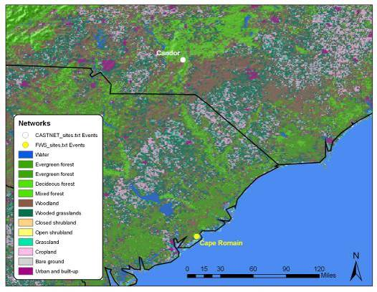

Ambient air

Ambient air concentration levels of particle-associated ammonium, nitrate, sulfate and gas-phase sulfur dioxide and nitric acid for Candor, NC during the 2000-2004 period, are presented in Table 8.

Table 8 Descriptive statistics (in μg/m³) of atmospheric particulate ammonium, nitrate, sulfate and, sulfur dioxide and nitric acid in Candor NC for 2000-2004 periods
 | Mean | Minimum | Maximum | Std Deviation
Aerosol
Ammonium (NH₄⁺) | 1.6 | 0.3 | 6.1 | 0.7
Nitrate (NO₃⁻) | 0.7 | 0.0 | 1.5 | 0.6
Sulfate (SO₄²⁻) | 4.5 | 1.2 | 13.5 | 2.1
Gas Phase
Sulfur dioxide (SO₂) | 4.7 | 0.5 | 21.4 | 3.0
Nitric Acid (HNO₃) | 1.9 | 0.5 | 4.4 | 0.7

Figure 17 Mean annual concentrations of particulate ammonium (NH4), nitrate (NO3) and sulfate (SO4) and gaseous nitric acid (HNO3) and sulfur dioxide (SO2)

As shown in Figure 17, concentrations of particulate components (ammonium, nitrate and sulfate) decreased from 2000 to 2003, while a slight increase is observed for 2004. A similar profile is plotted for atmospheric concentrations of sulfur dioxide and nitric acid.

Figure 18 Mean quarterly concentrations of particulate ammonium (NH4), nitrate (NO3) and sulfate (SO4) and gaseous nitric acid (HNO3) and sulfur dioxide (SO2)
On a seasonal basis, slightly higher concentrations during the 2nd (April-June) and 3rd (July-September) for ammonium are measured. The differences are more pronounced for sulfate, while an opposite profile is drawn for sulfur dioxide, nitric acid and nitrate, with higher concentration being measured during winter.

Figure 19 Scatter plot of NH4 nanoequivalents per m3 vs. the sum of NO₃ and SO₄ nano-equivalents per m³
Figure 19 shows the relationship between the sum of sulfate and nitrate vs. ammonium (in n-equivalents/m³). The green line indicates that both nitrate and sulfate are fully neutralized by ammonium in the forms of ammonium nitrate and ammonium sulfate. The slope of the regression indicates that ammonium concentrations are able to neutralize approximately 93% of nitrate and sulfate, which indicates that the predominant chemical components are (NH₄)HSO₄, NH₄NO₃ and (NH₄)₂SO₄, and minor amounts of H₂SO₄ and HNO₃ if any.

Table 9 shows the inteannual and seasonal variation of the relationships between ammonium, and nitrate and sulfate. No significant variability is computed from 2002 to 2004. Neutralization by ammonia appears to be more significant during the 2nd and 3rd quarter.

Table 9 Annual and quarterly variation of regression coefficients of atmospheric NH4 (as dependent variable) and the sum of NO3 and SO4 (as independent variable).

Year | 2000 | 2001 | 2002 | 2003 | 2004
Slope | 0.88 | 0.85 | 0.82 | 0.86 | 1.10
Intercept | -3.4 | -2.0 | 2.9 | -1.7 | -26.55
R | 0.97 | 0.98 | 0.97 | 0.97 | 0.96
Quarter | 1st | 2nd | 3rd | 4th
Slope | 0.89 | 0.86 | 1.02 | 0.94
Intercept | -1.9 | -5.7 | -23.1 | -6.8
R | 0.95 | 0.91 | 0.96 | 0.97

Dry Deposition

Deposition rates and total deposition of particle-associated ammonium, nitrate, sulfate and gas-phase sulfur dioxide and nitric acid, and total nitrogen and sulfur for Candor NC during the 2000-2004 period, are presented in Table 10.

Table 10 Descriptive statistics (g/ha) of dry deposition of ammonium, nitrate, sulfate and, sulfur dioxide and nitric acid in Candor NC for 2000-2004 periods and total nitrogen and sulfur deposition (kg/ha) for the entire period
 | Mean | Minimum | Maximum | Std Deviation | Total deposition
Aerosol
Ammonium (NH₄⁺) | 13 | 1 | 176 | 12 | 2.5
Nitrate (NO₃⁻) | 5 | 0 | 26 | 4 | 0.3
Sulfate (SO₄²⁻) | 36 | 4 | 389 | 30 | 3.0
Gas Phase
Sulfur dioxide (SO₂) | 67 | 14 | 207 | 32 | 8.6
Nitric Acid (HNO₃) | 155 | 42 | 505 | 69 | 8.8
Total Nitrogen |  |  |  |  | 11.5
Total Sulfur |  |  |  |  | 11.6

Figure 20 Annual dry deposition of ammonium (NH4), nitrate (NO3), sulfate (SO4), nitric acid (HNO3) and sulfur dioxide (SO2).
As shown in Figure 20, annual dry deposition of ammonium (NH4), nitrate (NO3), sulfate (SO4), nitric acid (HNO3) and sulfur dioxide (SO2) the amounts of particulate ammonium, nitrate and sulfate followed a downward trend from 2000 to 2003 and a slight increase during 2004, which is consistent with their atmospheric concentrations. On the other hand, dry deposition rates of SO2 and HNO3 fluctuated during 2000-2004.but indicated a rather downward trend.

Figure 21 Quarterly dry deposition of ammonium (NH4), nitrate (NO3), sulfate (SO4), nitric acid (HNO3) and sulfur dioxide (SO2).
On a seasonal basis, dry deposition follows a similar trend as compared to atmospheric concentrations with highest contributions of particle-associated ammonium and sulfate including nitric acid during the warm period (2rd -3rd quarter) and significant input of SO₂ and nitrate during the cold period (1st and 4th quarters)

Figure 22 Total nitrogen and sulfur dry deposition at Candor during 2000-2004
The total amount of nitrogen and sulfur deposited in Candor, ranged approximately from 2.0 kg/ha to 2.5 kg/ha and from 2.2 kg/ha up to 2.7 kg/ha, respectively. A clear inter-annual pattern is observed for both elements with a decreasing trend of dry deposition during the last years.

Cherokee Nation, Oklahoma

Cherokee Nation in Oklahoma is used as a surrogate CASTNET site for FWS Wichita Mountain site in Oklahoma. Figure 23 shows the locations of both sites.

Figure 23 Location of CASTNET Cherokee Nation and FWS Wichita Mountain sites.
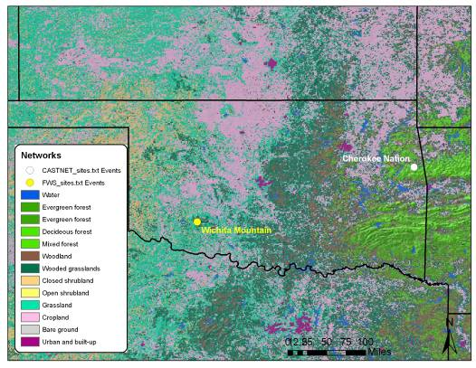

Ambient air

Ambient air concentration levels of particle-associated ammonium, nitrate, sulfate and gas-phase sulfur dioxide and nitric acid for Cherokee Nation, OK during the 2000-2004 period, are presented in Table 11. Ambient air and dry deposition measurements are available from 2002 to 2004.

Table 11 Descriptive statistics (in μg/m³) of atmospheric particulate ammonium, nitrate, sulfate and, sulfur dioxide and nitric acid in Cherokee Nation OK for 2000-2004 periods
 | Mean | Minimum | Maximum | Std Deviation
Aerosol
Ammonium (NH₄⁺) | 1.3 | 0.5 | 3.9 | 0.6
Nitrate (NO₃⁻) | 1.5 | 0.0 | 7.4 | 1.5
Sulfate (SO₄²⁻) | 3.3 | 0.8 | 10.8 | 1.6
Gas Phase0
Sulfur dioxide (SO₂) | 1.7 | 0.3 | 4.7 | 0.9
Nitric Acid (HNO₃) | 1.4 | 0.3 | 4.2 | 0.5

Figure 24 Mean annual concentrations of particulate ammonium (NH4), nitrate (NO3) and sulfate (SO4) and gaseous nitric acid (HNO3) and sulfur dioxide (SO2)

As shown in Figure 24, concentrations of ammonium, sulfate and nitric acid decreased from 2002 to 2004. On the other hand, nitrate and sulfur dioxide concentrations increased progressively.

Figure 25 Mean quarterly concentrations of particulate ammonium (NH4), nitrate (NO3) and sulfate (SO4) and gaseous nitric acid (HNO3) and sulfur dioxide (SO2)
On a seasonal basis, slightly higher concentrations during the 2nd (April-June) and 3rd (July-September) for sulfate and nitric acid are measured. An opposite profile is drawn for sulfur dioxide, nitric acid and particulate ammonium and nitrate, with higher concentration being measured during winter.

Figure 26 Scatter plot of NH4 nanoequivalents per m3 vs. the sum of NO₃ and SO₄ nano-equivalents per m³
Figure 26 shows the relationship between the sum of sulfate and nitrate vs. ammonium (in n-equivalents/m³). The green line indicates that both nitrate and sulfate are fully neutralized by ammonium in the forms of ammonium nitrate and ammonium sulfate. The slope of the regression indicates that ammonium concentrations are able to neutralize approximately 93% of nitrate and sulfate, which indicates that the predominant chemical components are (NH₄)HSO₄, NH₄NO₃ and (NH₄)₂SO₄, and minor amounts of H₂SO₄ and HNO₃ if any.

Table 12 shows the inter-annual and seasonal variation of the relationships between ammonium, and nitrate and sulfate. No significant variability is computed from 2002 to 2004. Neutralization by ammonia appears to be significant throughout the year although a rathe low slope is computed for spring during the 2nd and 3rd quarter.

Table 12 Annual and quarterly variation of regression coefficients of atmospheric NH4 (as dependent variable) and the sum of NO3 and SO4 (as independent variable).

Year | 2000 | 2001 | 2002 | 2003 | 2004
Slope |  |  | 0.94 | 0.96 | 0.97
Intercept |  |  | -13.5 | -14.3 | -8.3
R |  |  | 0.98 | 0.94 | 0.85
Quarter | 1st | 2nd | 3rd | 4th
Slope | 1.05 | 0.58 | 1.00 | 0.88
Intercept | -18.3 | 12.7 | -22.5 | -5.9
R | 0.97 | 0.73 | 0.95 | 0.94

Dry Deposition

Deposition rates and total deposition of particle-associated ammonium, nitrate, sulfate and gas-phase sulfur dioxide and nitric acid, and total nitrogen and sulfur for Cherokee Nation OK during the 2000-2004 period, are presented in Table 13.

Table 13 Descriptive statistics (g/ha) of dry deposition of ammonium, nitrate, sulfate and, sulfur dioxide and nitric acid in Cherokee Nation OK for 2000-2004 periods and total nitrogen and sulfur deposition (kg/ha) for the entire period

 | Mean | Minimum | Maximum | Std Deviation | Total deposition
Aerosol
Ammonium (NH₄⁺) | 10 | 2 | 33 | 6 | 1.1
Nitrate (NO₃⁻) | 11 | 0 | 69 | 11 | 0.3
Sulfate (SO₄²⁻) | 27 | 5 | 79 | 16 | 1.2
Gas Phase
Sulfur dioxide (SO₂) | 28 | 8 | 86 | 13 | 1.9
Nitric Acid (HNO₃) | 128 | 36 | 408 | 61 | 3.7
Total Nitrogen |  |  |  |  | 5.2
Total Sulfur |  |  |  |  | 3.1

Figure 27 Annual dry deposition of ammonium (NH4), nitrate (NO3), sulfate (SO4), nitric acid (HNO3) and sulfur dioxide (SO2).
As shown in Figure 20, the amounts of all sulfur- and nitrogen–compounds fluctuated from 2002 to 2004 following an upward trend.

Figure 28 Quarterly dry deposition of ammonium (NH4), nitrate (NO3), sulfate (SO4), nitric acid (HNO3) and sulfur dioxide (SO2).
On a seasonal basis, dry deposition follows a similar trend as compared to atmospheric concentrations with highest contributions of particle-associated ammonium and sulfate including nitric acid during the warm period (2rd -3rd quarter) and significant input of SO₂ and nitrate during the cold period (1st and 4th quarters)

Figure 29 Total nitrogen and sulfur dry deposition at Cherokee Nation during 2000-2004
The total amount of nitrogen and sulfur deposited in Cherokee Nation OK, ranged approximately from 1.5 kg/ha to 2.0 kg/ha and from 0.7 kg/ha up to 1.2 kg/ha, respectively. A clear inter-annual pattern is observed for both elements with an increasing trend during the last years.

Georgia Station, Georgia

Georgia Station in Georgia is used as a surrogate CASTNET site for FWS Wolf Island in Georgia. Figure 37 shows the locations of both sites.

Figure 30 Location of CASTNET Georgia Station and FWS Wolf Island sites.
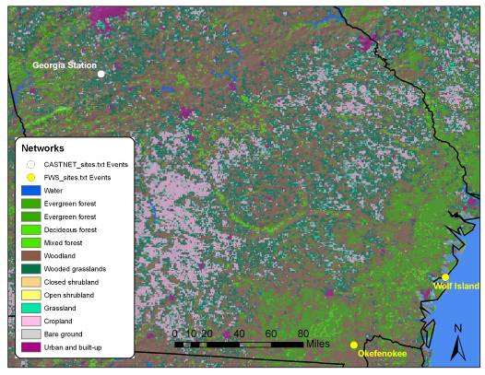

Ambient air

Ambient air concentration levels of particle-asociated ammonium, nitrate, sulfate and gas-phase sulfur dioxide and nitric acid for Georgia Station during the 2000-2004 period, are presented in Table 14.

Table 14 Descriptive statistics (in μg/m³) of atmospheric particulate ammonium, nitrate, sulfate and, sulfur dioxide and nitric acid in Georgia Station for 2000-2004 periods
 | Mean | Minimum | Maximum | Std Deviation
Aerosol
Ammonium (NH₄⁺) | 1.4 | 0.4 | 4.4 | 0.6
Nitrate (NO₃⁻) | 0.4 | 0.0 | 1.9 | 0.4
Sulfate (SO₄²⁻) | 4.4 | 1.4 | 14.2 | 2.3
Gas Phase
Sulfur dioxide (SO₂) | 5.0 | 0.4 | 24.2 | 3.1
Nitric Acid (HNO₃) | 1.9 | 0.5 | 4.7 | 0.7

Figure 31 Mean annual concentrations of particulate ammonium (NH4), nitrate (NO3) and sulfate (SO4) and gaseous nitric acid (HNO3) and sulfur dioxide (SO2)

As shown in Figure 31, concentrations of all components did not vary since 2000, while for most of them concentrations are increased in 2004.

Figure 32 Mean quarterly concentrations of particulate ammonium (NH4), nitrate (NO3) and sulfate (SO4) and gaseous nitric acid (HNO3) and sulfur dioxide (SO2)
On a seasonal basis, slightly higher concentrations during the 2nd (April-June) and 3rd (July-September) for sulfate and amoonium are measured. An opposite profile is drawn for sulfur dioxide, nitric acid and particulate nitrate, with higher concentration being measured during winter.

Figure 33 Scatter plot of NH4 nanoequivalents per m³ vs. the sum of NO₃ and SO₄ nano-equivalents per m³
Figure 33 shows the relationship between the sum of sulfate and nitrate vs. ammonium (in n-equivalents/m³). The green line indicates that both nitrate and sulfate are fully neutralized by ammonium in the forms of ammonium nitrate and ammonium sulfate. The slope of the regression indicates that ammonium concentrations are able to neutralize approximately 75% of nitrate and sulfate, which indicates that the predominant chemical components are (NH₄)HSO₄, NH₄NO₃ and (NH₄)₂SO₄, and minor amounts of H₂SO₄ and HNO₃.

Table 15 shows the inter-annual and seasonal variation of the relationships between ammonium, and nitrate and sulfate. No significant variability is computed from 2002 to 2004. Neutralization by ammonia appears to be significant throughout the year although a rather low slope is computed for spring during the 2nd and 3rd quarter.

Table 15 Annual and quarterly variation of regression coefficients of atmospheric NH4 (as dependent variable) and the sum of NO3 and SO4 (as independent variable).

Year | 2000 | 2001 | 2002 | 2003 | 2004
Slope | 0.82 | 0.70 | 0.73 | 0.70 | 0.70
Intercept | -1.9 | 4.8 | 3.7 | 6.2 | 5.1
R | 0.97 | 0.95 | 0.95 | 0.96 | 0.96
Quarter | 1st | 2nd | 3rd | 4th
Slope | 0.75 | 0.69 | 0.71 | 0.86
Intercept | 4.5 | 2.5 | 4.2 | -3.7
R | 0.88 | 0.91 | 0.97 | 0.98

Dry Deposition

Deposition rates and total deposition of particle-associated ammonium, nitrate, sulfate and gas-phase sulfur dioxide and nitric acid, and total nitrogen and sulfur for Georgia Station during the 2000-2004 period, are presented in Table 16.

Table 16 Descriptive statistics (g/ha) of dry deposition of ammonium, nitrate, sulfate and, sulfur dioxide and nitric acid in Georgia Station for 2000-2004 periods and total nitrogen and sulfur deposition (kg/ha) for the entire period

 | Mean | Minimum | Maximum | Std Deviation | Total deposition
Aerosol
Ammonium (NH₄⁺) | 10 | 3 | 35 | 5 | 1.8
Nitrate (NO₃⁻) | 4 | 0 | 22 | 3 | 0.2
Sulfate (SO₄²⁻) | 33 | 10 | 116 | 20 | 2.6
Gas Phase
Sulfur dioxide (SO₂) | 119 | 15 | 603 | 84 | 13.7
Nitric Acid (HNO₃) | 172 | 54 | 416 | 64 | 8.8
Total Nitrogen |  |  |  |  | 10.8
Total Sulfur |  |  |  |  | 16.2

Figure 34 Annual dry deposition of ammonium (NH4), nitrate (NO3), sulfate (SO4), nitric acid (HNO3) and sulfur dioxide (SO2).
As shown in Figure 34, the amounts of all compounds did not vary significantly from 2000 to 2004 with significantly lower concentrations during 2003.The annual variation indicates a rather increasing trend for all components.

Figure 35 Quarterly dry deposition of ammonium (NH4), nitrate (NO3), sulfate (SO4), nitric acid (HNO3) and sulfur dioxide (SO2).
On a seasonal basis, dry deposition follows a similar trend as compared to atmospheric concentrations with highest contributions of particle-associated ammonium and sulfate including nitric acid during the warm period (2rd -3rd quarter) and significant input of SO₂ and nitrate during the cold period (1st and 4th quarters)

Figure 36 Total nitrogen and sulfur dry deposition at Georgia Station during 2000-2004
The total amount of nitrogen and sulfur deposited in Georgia Station, ranged approximately from 1.2 kg/ha to 2.7 kg/ha and from 2.2 kg/ha up to 3.9 kg/ha, respectively. Statistically insignificant trends are observed for both elements primarily due to the low deposition during 2003.

Howland, Maine

Howland in Maine is used as a surrogate CASTNET site for FWS Moosehorn in Maine. Figure 37 shows the locations of both sites.

Figure 37 Location of CASTNET Howland and FWS Moosehorn sites.
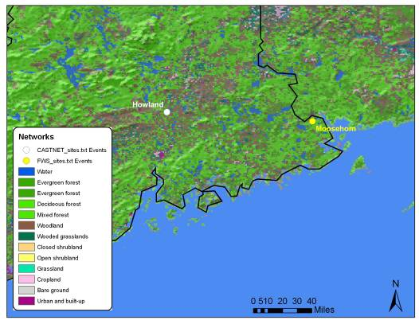

Ambient air

Ambient air concentration levels of particle-asociated ammonium, nitrate, sulfate and gas-phase sulfur dioxide and nitric acid for Howland during the 2000-2004 period, are presented in Table 17.

Table 17 Descriptive statistics (in μg/m³) of atmospheric particulate ammonium, nitrate, sulfate and, sulfur dioxide and nitric acid in Howland for 2000-2004 periods
 | Mean | Minimum | Maximum | Std Deviation
Aerosol
Ammonium (NH₄⁺) | 0.5 | 0.1 | 2.3 | 0.3
Nitrate (NO₃⁻) | 0.2 | 0.0 | 2.7 | 0.3
Sulfate (SO₄²⁻) | 1.7 | 0.3 | 8.5 | 1.0
Gas Phase
Sulfur dioxide (SO₂) | 1.3 | 0.2 | 5.9 | 1.0
Nitric Acid (HNO₃) | 0.6 | 0.1 | 2.1 | 0.3

Figure 38 Mean annual concentrations of particulate ammonium (NH4), nitrate (NO3) and sulfate (SO4) and gaseous nitric acid (HNO3) and sulfur dioxide (SO2)

As shown in Figure 38, concentrations of ammonium, sulfate and sulfur dioxide increase during 2001 followed by decreasing concentrations from 2002 to 2004. Nitrate concentrations increased with comparable levels for 2000 and 2004, while nitric acid increased progressively from 2000 to 2002 followed by a decreasing trend to 2004.

Figure 39 Mean quarterly concentrations of particulate ammonium (NH4), nitrate (NO3) and sulfate (SO4) and gaseous nitric acid (HNO3) and sulfur dioxide (SO2)
On a seasonal basis, slightly higher concentrations during the 2nd (April-June) and 3rd (July-September) for sulfate and amoonium are measured. An opposite profile is drawn for sulfur dioxide, nitric acid and particulate nitrate, with higher concentration being measured during winter.

Figure 40 Scatter plot of NH4 nanoequivalents per m³ vs. the sum of NO₃ and SO₄ nano-equivalents per m³
Figure 40 shows the relationship between the sum of sulfate and nitrate vs. ammonium (in n-equivalents/m³). The green line indicates that both nitrate and sulfate are fully neutralized by ammonium in the forms of ammonium nitrate and ammonium sulfate. The slope of the regression indicates that ammonium concentrations are able to neutralize approximately 68% of nitrate and sulfate, which indicates that the predominant chemical components are (NH₄)HSO₄, H₂SO₄ and HNO₃. and considerable amounts of NH₄NO₃ and (NH₄)₂SO₄,

Table 18 shows the inter-annual and seasonal variation of the relationships between ammonium, and nitrate and sulfate. No significant variability is computed from 2002 to 2004. Neutralization by ammonia appears to be significant throughout the year although a rather low slope is computed for spring during the 2nd and 3rd quarter.

Table 18 Annual and quarterly variation of regression coefficients of atmospheric NH4 (as dependent variable) and the sum of NO3 and SO4 (as independent variable).

Year | 2000 | 2001 | 2002 | 2003 | 2004
Slope | 0.59 | 0.75 | 0.70 | 0.72 | 0.57
Intercept | 5.1 | 0.8 | 1.5 | 0.4 | 4.5
R | 0.82 | 0.97 | 0.96 | 0.97 | 0.88
Quarter | 1st | 2nd | 3rd | 4th
Slope | 0.58 | 0.72 | 0.68 | 0.64
Intercept | 2.7 | 1.1 | 4.3 | 2.9
R | 0.87 | 0.96 | 0.97 | 0.86

Dry Deposition

Deposition rates and total deposition of particle-associated ammonium, nitrate, sulfate and gas-phase sulfur dioxide and nitric acid, and total nitrogen and sulfur for Howland during the 2000-2004 period, are presented in Table 19.

Table 19 Descriptive statistics (g/ha) of dry deposition of ammonium, nitrate, sulfate and, sulfur dioxide and nitric acid in Howland for 2000-2004 periods and total nitrogen and sulfur deposition (kg/ha) for the entire period

 | Mean | Minimum | Maximum | Std Deviation | Total deposition
Aerosol
Ammonium (NH₄⁺) | 4 | 1 | 21 | 3 | 0.7
Nitrate (NO₃⁻) | 2 | 3 | 38 | 3 | 0.1
Sulfate (SO₄²⁻) | 13 | 2 | 77 | 10 | 1.0
Gas Phase
Sulfur dioxide (SO₂) | 22 | 4 | 90 | 15 | 2.6
Nitric Acid (HNO₃) | 55 | 5 | 206 | 33 | 4.3
Total Nitrogen |  |  |  |  | 5.1
Total Sulfur |  |  |  |  | 3.6

Figure 41 Annual dry deposition of ammonium (NH4), nitrate (NO3), sulfate (SO4), nitric acid (HNO3) and sulfur dioxide (SO2).

As shown in Figure 41, for all components, lower depositions are estimated during 2003. Overall, an upward trend is observed for ammonium, sulfate and nitric acid, while no significant changes are estimated for nitrate and sulfur dioxide followed a decreasing trend.

Figure 42 Quarterly dry deposition of ammonium (NH4), nitrate (NO3), sulfate (SO4), nitric acid (HNO3) and sulfur dioxide (SO2).
On a seasonal basis, dry deposition follows a similar trend as compared to atmospheric concentrations with highest contributions of particle-associated ammonium and sulfate including nitric acid during the warm period (2rd -3rd quarter) and significant input of SO₂ and nitrate during the cold period (1st and 4th quarters)

Figure 43 Total nitrogen and sulfur dry deposition at Howland during 2000-2004
The total amount of nitrogen and sulfur deposited in Howland, ranged approximately from 0.5 kg/ha to 0.9 kg/ha and from 0.5 kg/ha up to 0.8 kg/ha, respectively. While deposition of sulfur and nitrogen increased during 2000-2002, a downward pattern is observed during tha last two years.

Hoxeyville, Michigan

Hoxeyville in Michingan is used as a surrogate CASTNET site for FWS Seney in Michingan. Figure 44 shows the locations of both sites.

Figure 44 Location of CASTNET Hoxeyville and FWS Seney sites.
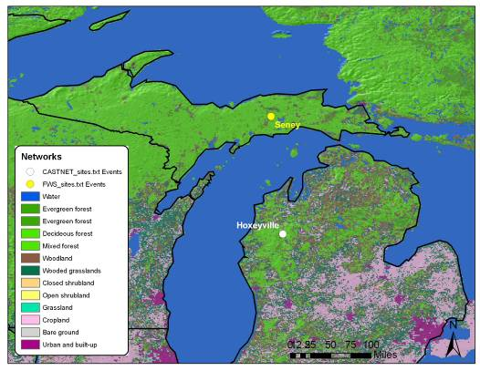

Ambient air

Ambient air concentration levels of particle-asociated ammonium, nitrate, sulfate and gas-phase sulfur dioxide and nitric acid for Hoxeyville during the 2000-2004 period, are presented in Table 20.

Table 20 Descriptive statistics (in μg/m³) of atmospheric particulate ammonium, nitrate, sulfate and, sulfur dioxide and nitric acid in Hoxeyville for 2000-2004 periods
 | Mean | Minimum | Maximum | Std Deviation
Aerosol
Ammonium (NH₄⁺) | 1.0 | 0. | 3.8 | 0.6
Nitrate (NO₃⁻) | 1.0 | 0.0 | 6.6 | 1.2
Sulfate (SO₄²⁻) | 2.5 | 0.5 | 11.4 | 1.7
Gas Phase
Sulfur dioxide (SO₂) | 2.4 | 0.2 | 9.4 | 1.6
Nitric Acid (HNO₃) | 1.1 | 0.2 | 3.4 | 0.6

Figure 45 Mean annual concentrations of particulate ammonium (NH4), nitrate (NO3) and sulfate (SO4) and gaseous nitric acid (HNO3) and sulfur dioxide (SO2)

As shown in Figure 45, concentrations of ammonium, sulfate and sulfur dioxide increase during 2001 followed by decreasing concentrations from 2002 to 2004..

Figure 46 Mean quarterly concentrations of particulate ammonium (NH4), nitrate (NO3) and sulfate (SO4) and gaseous nitric acid (HNO3) and sulfur dioxide (SO2)
On a seasonal basis, slightly higher concentrations during the 2nd (April-June) and 3rd (July-September) for sulfate and ammonium are measured. An opposite profile is drawn for sulfur dioxide, nitric acid and particulate nitrate, with higher concentration being measured during winter.

Figure 47 Scatter plot of NH4 nanoequivalents per m³ vs. the sum of NO₃ and SO₄ nano-equivalents per m³
Figure 47 shows the relationship between the sum of sulfate and nitrate vs. ammonium (in n-equivalents/m³). The green line indicates that both nitrate and sulfate are fully neutralized by ammonium in the forms of ammonium nitrate and ammonium sulfate. The slope of the regression indicates that ammonium concentrations are able to neutralize approximately 85% of nitrate and sulfate, which indicates that the predominant chemical components are (NH₄)HSO₄, NH₄NO₃ and (NH₄)₂SO₄ and minor amounts of H₂SO₄ and HNO₃,

Table 21 shows the inter-annual and seasonal variation of the relationships between ammonium, and nitrate and sulfate. No significant variability is computed from 2002 to 2004. Neutralization by ammonia appears to be significant throughout the year although a rather low slope is computed for spring during the 2nd and 3rd quarter.

Table 21 Annual and quarterly variation of regression coefficients of atmospheric NH4 (as dependent variable) and the sum of NO3 and SO4 (as independent variable).

Year | 2000 | 2001 | 2002 | 2003 | 2004
Slope | 0.94 | 0.90 | 0.84 | 0.84 | 0.84
Intercept | -3.5 | -2.5 | 0.1 | -0.8 | -1.4
R | 0.95 | 0.99 | 0.98 | 0.99 | 0.98
Quarter | 1st | 2nd | 3rd | 4th
Slope | 0.95 | 0.81 | 0.81 | 0.91
Intercept | -6.3 | 0.6 | 0.6 | -4.0
R | 0.99 | 0.98 | 0.99 | 0.98

Dry Deposition

Deposition rates and total deposition of particle-associated ammonium, nitrate, sulfate and gas-phase sulfur dioxide and nitric acid, and total nitrogen and sulfur for Hoxeyville during the 2000-2004 period, are presented in Table 22.

Table 22 Descriptive statistics (g/ha) of dry deposition of ammonium, nitrate, sulfate and, sulfur dioxide and nitric acid in Hoxeyville for 2000-2004 periods and total nitrogen and sulfur deposition (kg/ha) for the entire period

 | Mean | Minimum | Maximum | Std Deviation | Total deposition
Aerosol
Ammonium (NH₄⁺) | 6 | 0 | 26 | 4 | 1.0
Nitrate (NO₃⁻) | 5 | 0 | 34 | 5 | 0.2
Sulfate (SO₄²⁻) | 16 | 0 | 80 | 14 | 1.1
Gas Phase
Sulfur dioxide (SO₂) | 28 | 1 | 39 | 17 | 3.1
Nitric Acid (HNO₃) | 84 | 1 | 278 | 53 | 6.1
Total Nitrogen |  |  |  |  | 7.3
Total Sulfur |  |  |  |  | 4.2

Figure 48 Annual dry deposition of ammonium (NH4), nitrate (NO3), sulfate (SO4), nitric acid (HNO3) and sulfur dioxide (SO2).

As shown in Figure 48, for all components, a rather downward trend was observed for 2001-2004 period.

Figure 49 Quarterly dry deposition of ammonium (NH4), nitrate (NO3), sulfate (SO4), nitric acid (HNO3) and sulfur dioxide (SO2).
On a seasonal basis, dry deposition follows a similar trend as compared to atmospheric concentrations with highest contributions of particle-associated ammonium and sulfate including nitric acid during the warm period (2rd -3rd quarter) and significant input of SO₂ and nitrate during the cold period (1st and 4th quarters)

Figure 50 Total nitrogen and sulfur dry deposition at Hoxeyville during 2000-2004
The total amount of nitrogen and sulfur deposited in Hoxeyville, ranged approximately from 0.1 kg/ha to 1.4 kg/ha and from 0.2 kg/ha up to 1.1 kg/ha, respectively. With the exception of 2000, a downward pattern is observed for both elements during the last years.

Indian River Lagoon, Florida

Indian River Lagoon in Florida is used as a surrogate CASTNET site for FWS Chassahowitzka in Florida. Figure 51 shows the locations of both sites.

Figure 51 Location of CASTNET Indian River Lagoon and FWS Chassahowitzka sites.
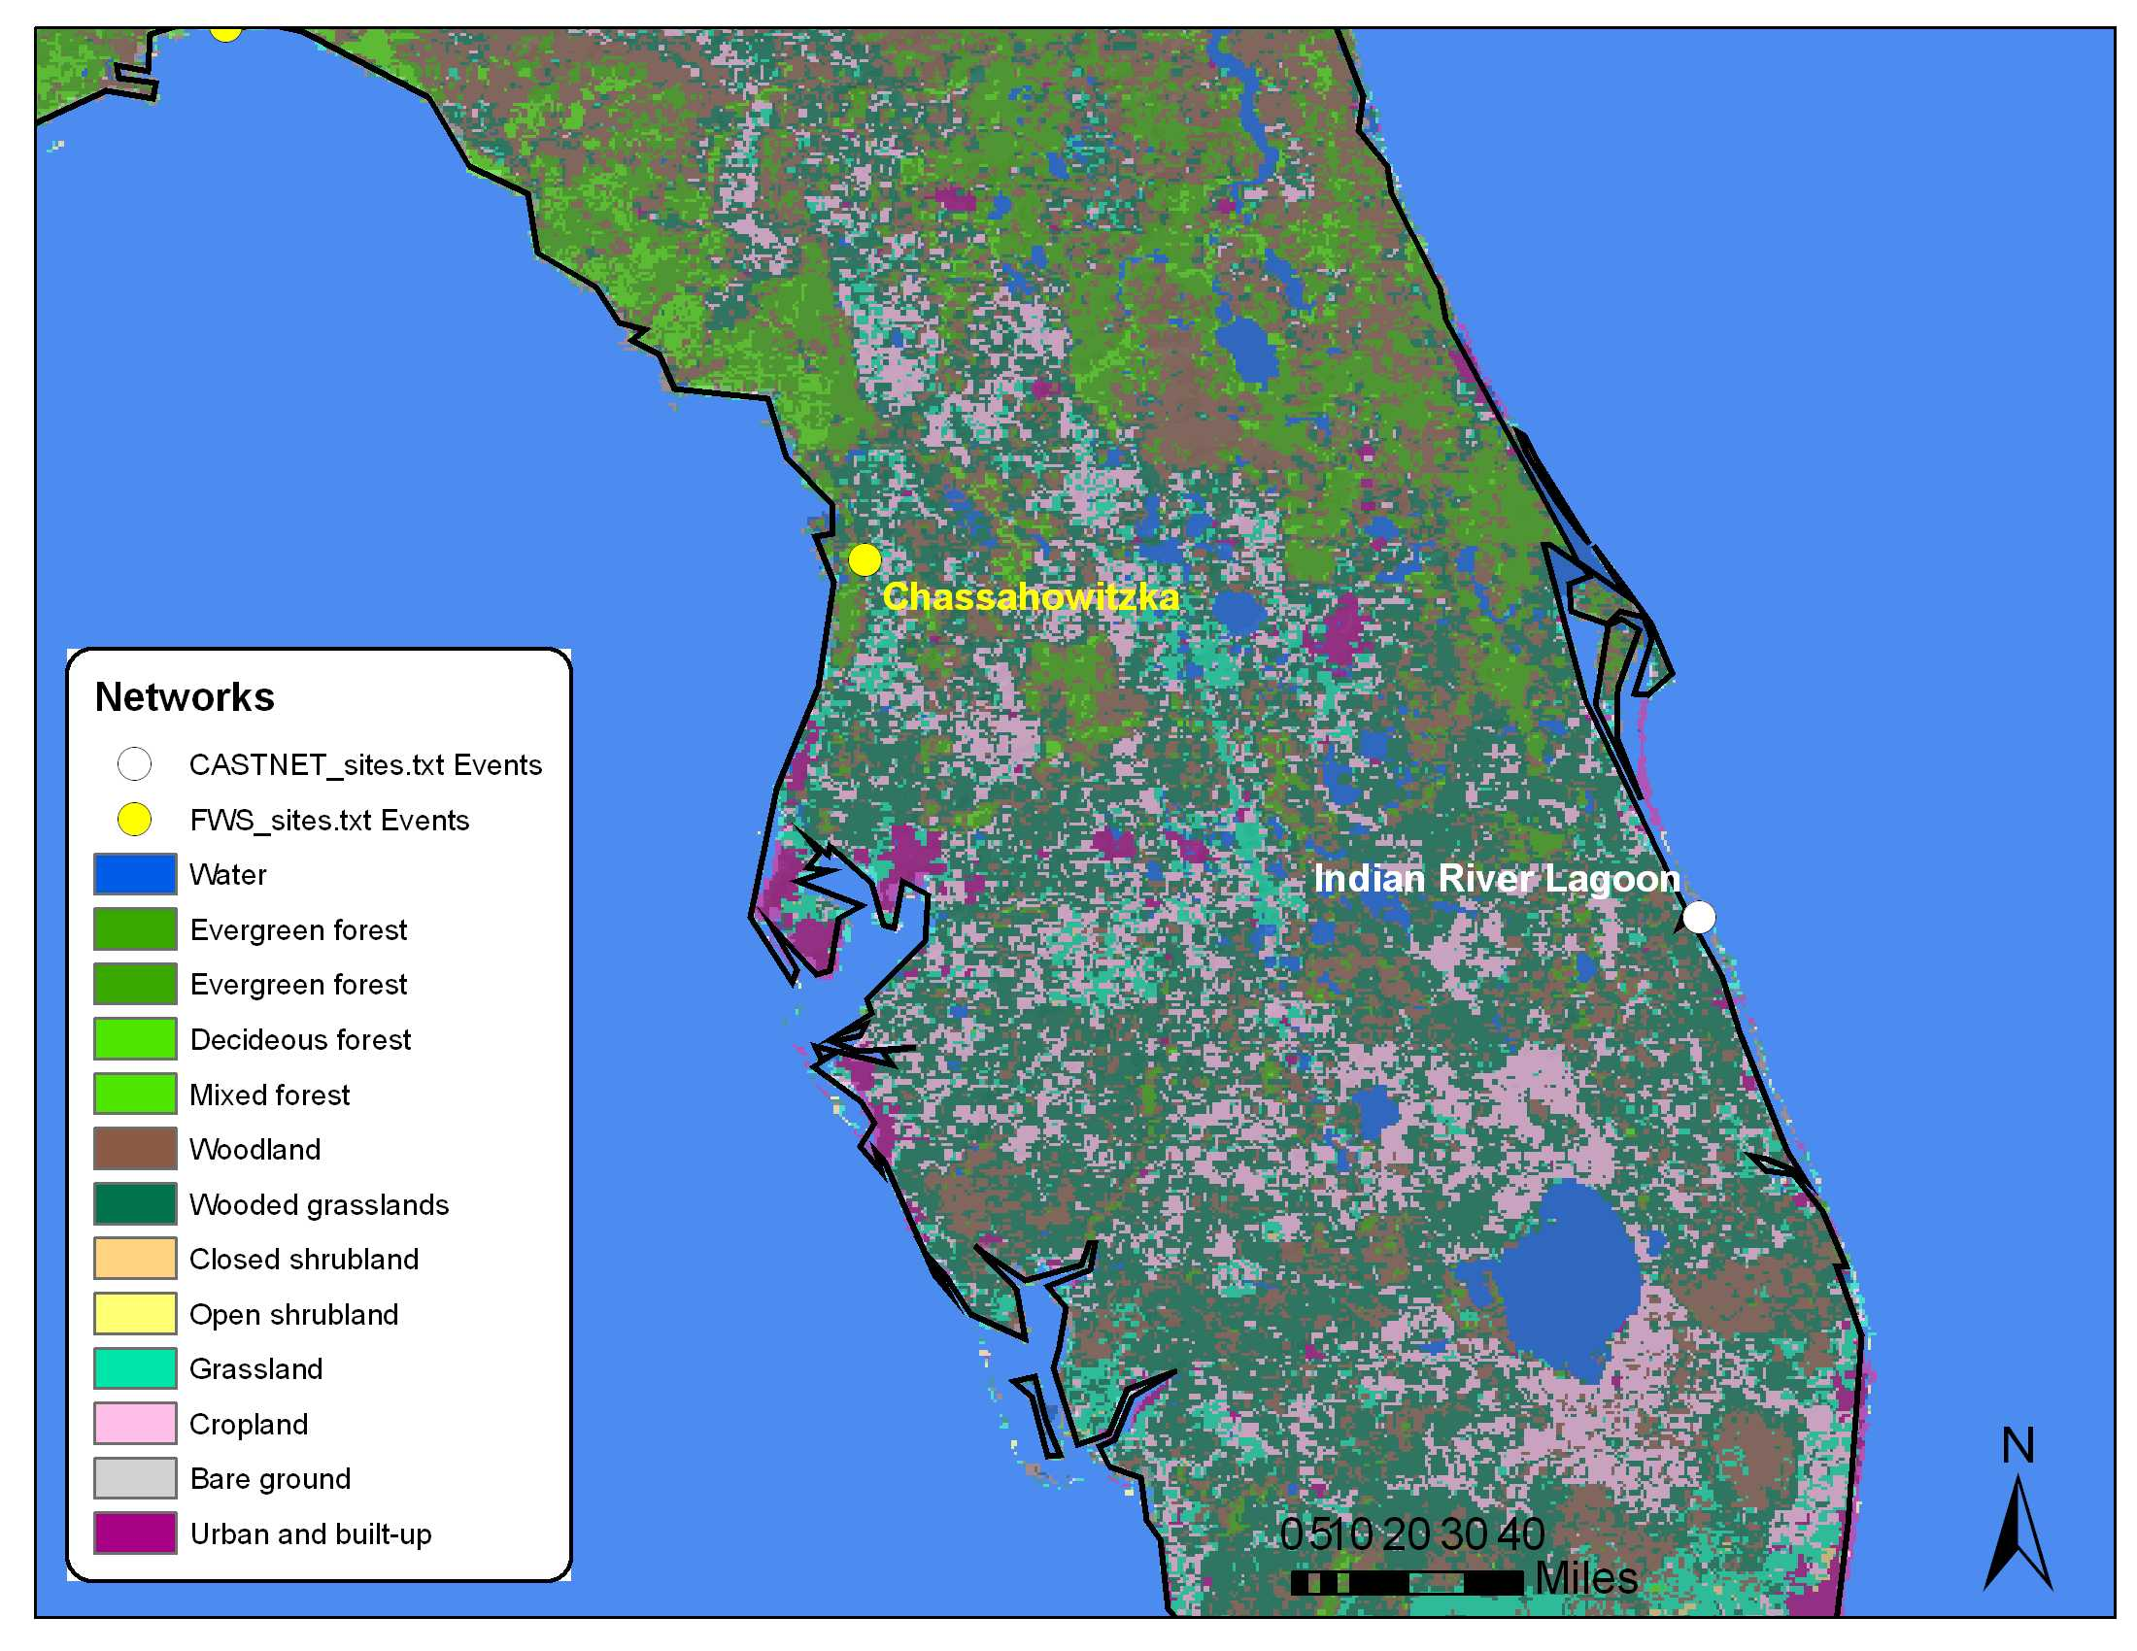

Ambient air

Ambient air concentration levels of particle-asociated ammonium, nitrate, sulfate and gas-phase sulfur dioxide and nitric acid for Indian River Lagoon during the 2000-2004 period, are presented in Table 23. Measurements of ambient concentration and dry deposition started in 2001.

Table 23 Descriptive statistics (in μg/m³) of atmospheric particulate ammonium, nitrate, sulfate and, sulfur dioxide and nitric acid in Indian River Lagoon for 2000-2004 periods
 | Mean | Minimum | Maximum | Std Deviation
Aerosol
Ammonium (NH₄⁺) | 0.6 | 0.2 | 1.8 | 0.3
Nitrate (NO₃⁻) | 2.0 | 0.7 | 4.0 | 0.7
Sulfate (SO₄²⁻) | 3.3 | 1.4 | 6.8 | 1.1
Gas Phase
Sulfur dioxide (SO₂) | 1.9 | 0.3 | 9.6 | 1.3
Nitric Acid (HNO₃) | 0.6 | 0.1 | 2.2 | 0.5

Figure 52 Mean annual concentrations of particulate ammonium (NH4), nitrate (NO3) and sulfate (SO4) and gaseous nitric acid (HNO3) and sulfur dioxide (SO2)

As shown in Figure 52, concentrations of ammonium, sulfate and sulfur dioxide increase from 2001 to 2004, while concentration of gases varied substantially.

Figure 53 Mean quarterly concentrations of particulate ammonium (NH4), nitrate (NO3) and sulfate (SO4) and gaseous nitric acid (HNO3) and sulfur dioxide (SO2)
On a seasonal basis, slightly higher concentrations for almost all components are measured during winter and fall.

Figure 54 Scatter plot of NH4 nanoequivalents per m³ vs. the sum of NO₃ and SO₄ nano-equivalents per m³
Figure 54 shows the relationship between the sum of sulfate and nitrate vs. ammonium (in n-equivalents/m³). The green line indicates that both nitrate and sulfate are fully neutralized by ammonium in the forms of ammonium nitrate and ammonium sulfate. The slope of the regression indicates that ammonium concentrations are able to neutralize approximately 40% of nitrate and sulfate, which indicates that the predominant chemical components are H₂SO₄ HNO₃ and (NH₄)HSO₄, and minor amounts of NH₄NO₃ (NH₄)₂SO_{4.}

Table 24 shows the inter-annual and seasonal variation of the relationships between ammonium, and nitrate and sulfate. No significant variability is computed from 2002 to 2004. Neutralization by ammonia appears to be insignificant throughout the year and for different seasons.

Table 24 Annual and quarterly variation of regression coefficients of atmospheric NH4 (as dependent variable) and the sum of NO3 and SO4 (as independent variable).

Year | 2000 | 2001 | 2002 | 2003 | 2004
Slope |  | 0.42 | 0.40 | 0.40 | 0.40
Intercept |  | -8.2 | -4.8 | -6.3 | -2.6
R |  | 0.86 | 0.86 | 0.77 | 0.90
Quarter | 1st | 2nd | 3rd | 4th
Slope | 0.46 | 0.46 | 0.41 | 0.38
Intercept | -16.3 | -9.3 | -2.7 | -5.4
R | 0.81 | 0.85 | 0.89 | 0.89

Dry Deposition

Deposition rates and total deposition of particle-associated ammonium, nitrate, sulfate and gas-phase sulfur dioxide and nitric acid, and total nitrogen and sulfur for Indian River Lagoon during the 2000-2004 period, are presented in Table 25.

Table 25 Descriptive statistics (g/ha) of dry deposition of ammonium, nitrate, sulfate and, sulfur dioxide and nitric acid in Indian River Lagoon for 2000-2004 periods and total nitrogen and sulfur deposition (kg/ha) for the entire period

 | Mean | Minimum | Maximum | Std Deviation | Total deposition
Aerosol
Ammonium (NH₄⁺) | 3 | 0 | 10 | 2 | 0.4
Nitrate (NO₃⁻) | 9 | 0 | 28 | 4 | 0.3
Sulfate (SO₄²⁻) | 15 | 2 | 39 | 7 | 0.9
Gas Phase
Sulfur dioxide (SO₂) | 22 | 2 | 120 | 15 | 1.9
Nitric Acid (HNO₃) | 30 | 2 | 108 | 24 | 1.7
Total Nitrogen |  |  |  |  | 2.5
Total Sulfur |  |  |  |  | 2.7

Figure 55 Annual dry deposition of ammonium (NH4), nitrate (NO3), sulfate (SO4), nitric acid (HNO3) and sulfur dioxide (SO2).

As shown in Figure 55, for all components, a rather downward trend was observed for 2001-2003 period followed by a slight decrease of dry deposition for 2004.

Figure 56 Quarterly dry deposition of ammonium (NH4), nitrate (NO3), sulfate (SO4), nitric acid (HNO3) and sulfur dioxide (SO2).
On a seasonal basis, dry deposition follows a similar trend as compared to atmospheric concentrations with slightly higher concentrations for almost all components being measured during winter and fall.

Figure 57 Total nitrogen and sulfur dry deposition at Indian River Lagoon during 2000-2004
The total amount of nitrogen and sulfur deposited in Indian River Lagoon, ranged approximately from 0.2 kg/ha to 0.6 kg/ha and from 0.4 kg/ha up to 0.9 kg/ha, respectively. Dry deposition increased from 2001 to 2003, while a significant decrease is observed for sulfur in 2004.

Sumatra, Florida

Sumatra in Florida is used as a surrogate CASTNET site for three FWS sites, namely Breton, Louisiana, St. Marks in Florida and Okefenokee in Georgia. Figure 58 shows the locations of both sites.

Figure 58 Location of CASTNET Sumatra and FWS Breton, St.Marks and Okefenokee sites.
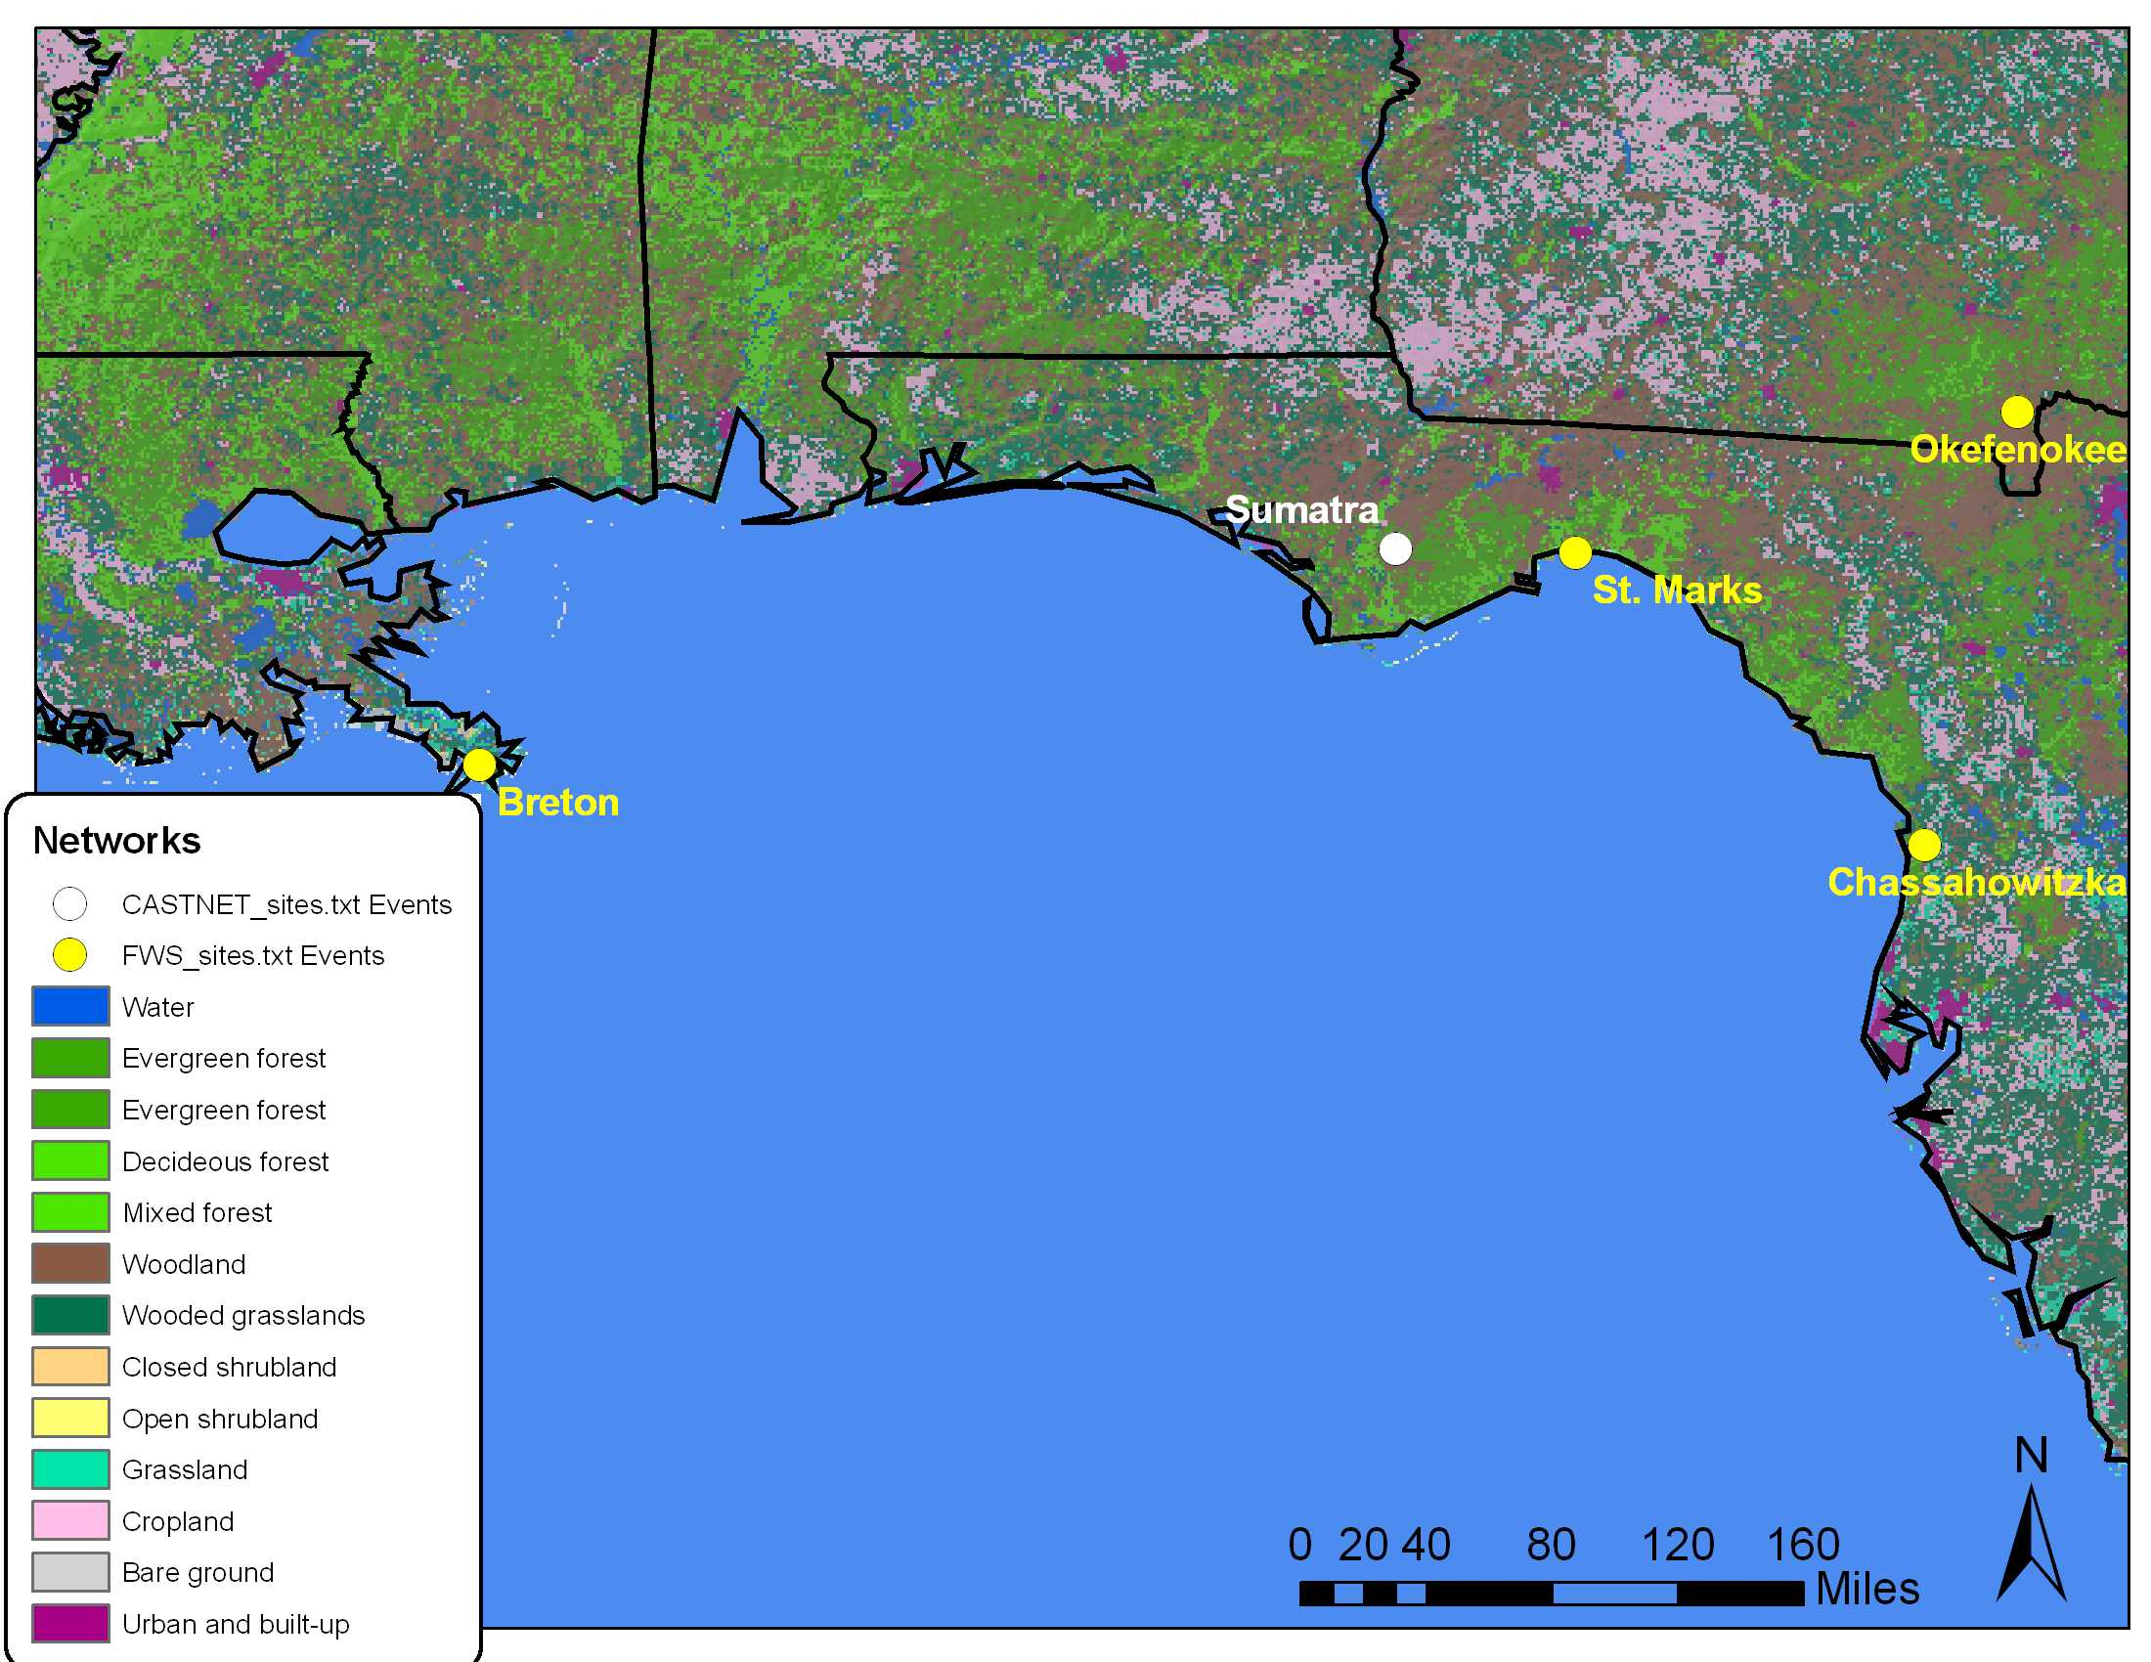

Ambient air

Ambient air concentration levels of particle-asociated ammonium, nitrate, sulfate and gas-phase sulfur dioxide and nitric acid for Sumatra during the 2000-2004 period, are presented in Table 26.

Table 26 Descriptive statistics (in μg/m³) of atmospheric particulate ammonium, nitrate, sulfate and, sulfur dioxide and nitric acid in Sumatra for 2000-2004 periods
 | Mean | Minimum | Maximum | Std Deviation
Aerosol
Ammonium (NH₄⁺) | 0.8 | 0.1 | 2.9 | 0.4
Nitrate (NO₃⁻) | 0.4 | 0.1 | 1.5 | 0.3
Sulfate (SO₄²⁻) | 3.4 | 0.5 | 11.8 | 1.7
Gas Phase
Sulfur dioxide (SO₂) | 1.4 | 0.1 | 4.3 | 0.8
Nitric Acid (HNO₃) | 0.9 | 0.1 | 2.3 | 0.4

Figure 59 Mean annual concentrations of particulate ammonium (NH4), nitrate (NO3) and sulfate (SO4) and gaseous nitric acid (HNO3) and sulfur dioxide (SO2)

As shown in Figure 59 concentrations of all components followed an increasing trend from 2001 to 2004.

Figure 60 Mean quarterly concentrations of particulate ammonium (NH4), nitrate (NO3) and sulfate (SO4) and gaseous nitric acid (HNO3) and sulfur dioxide (SO2)
On a seasonal basis, slightly higher concentrations during the 2nd (April-June) and 3rd (July-September) for sulfate and ammonium are measured. An opposite profile is drawn for sulfur dioxide, nitric acid and particulate nitrate, with higher concentration being measured during winter
Figure 61 Scatter plot of NH4 nanoequivalents per m³ vs. the sum of NO₃ and SO₄ nano-equivalents per m³
Figure 61 shows the relationship between the sum of sulfate and nitrate vs. ammonium (in n-equivalents/m³). The green line indicates that both nitrate and sulfate are fully neutralized by ammonium in the forms of ammonium nitrate and ammonium sulfate. The slope of the regression indicates that ammonium concentrations are able to neutralize approximately 60% of nitrate and sulfate, which indicates that the predominant chemical components are H₂SO₄ HNO₃ and (NH₄)HSO₄, and minor amounts of NH₄NO₃ (NH₄)₂SO_{4.}

Table 27 shows the inter-annual and seasonal variation of the relationships between ammonium, and nitrate and sulfate. No significant variability is computed from 2000 to 2004. Neutralization by ammonia appears to be moderately significant throughout the year and for different seasons.

Table 27 Annual and quarterly variation of regression coefficients of atmospheric NH4 (as dependent variable) and the sum of NO3 and SO4 (as independent variable).

Year | 2000 | 2001 | 2002 | 2003 | 2004
Slope | 0.60 | 0.49 | 0.45 | 0.65 | 0.66
Intercept | -4.3 | 3.5 | 7.0 | -8.8 | -10.9
R | 0.90 | 0.78 | 0.72 | 0.90 | 0.92
Quarter | 1st | 2nd | 3rd | 4th
Slope | 0.52 | 0.54 | 0.62 | 0.64
Intercept | 4.3 | -5.9 | -5.8 | -4.3
R | 0.67 | 0.80 | 0.97 | 0.90

Dry Deposition

Deposition rates and total deposition of particle-associated ammonium, nitrate, sulfate and gas-phase sulfur dioxide and nitric acid, and total nitrogen and sulfur for Sumatra during the 2000-2004 period, are presented in Table 28.

Table 28 Descriptive statistics (g/ha) of dry deposition of ammonium, nitrate, sulfate and, sulfur dioxide and nitric acid in Sumatra for 2000-2004 periods and total nitrogen and sulfur deposition (kg/ha) for the entire period

 | Mean | Minimum | Maximum | Std Deviation | Total deposition
Aerosol
Ammonium (NH₄⁺) | 5 | 0 | 19 | 3 | 0.9
Nitrate (NO₃⁻) | 3 | 0 | 15 | 3 | 0.2
Sulfate (SO₄²⁻) | 23 | 1 | 68 | 13 | 1.9
Gas Phase
Sulfur dioxide (SO₂) | 21 | 3 | 67 | 12 | 2.5
Nitric Acid (HNO₃) | 69 | 4 | 202 | 36 | 5.7
Total Nitrogen |  |  |  |  | 6.7
Total Sulfur |  |  |  |  | 4.4

Figure 62 Annual dry deposition of ammonium (NH4), nitrate (NO3), sulfate (SO4), nitric acid (HNO3) and sulfur dioxide (SO2).

As shown in Figure 62, for all components, a rather downward trend was observed for 2001-2003 period followed by a slight decrease of dry deposition for 2004.

Figure 63 Quarterly dry deposition of ammonium (NH4), nitrate (NO3), sulfate (SO4), nitric acid (HNO3) and sulfur dioxide (SO2).
On a seasonal basis, slightly higher deposition rates during the 2nd (April-June) and 3rd (July-September) for sulfate and ammonium are measured. An opposite profile is drawn for sulfur dioxide, nitric acid and particulate nitrate, with higher deposition being measured during winter

Figure 64 Total nitrogen and sulfur dry deposition at Sumatra during 2000-2004
The total amount of nitrogen and sulfur deposited in Sumatra, ranged approximately from 0.9 kg/ha to 1.2 kg/ha and from 0.8 kg/ha up to 1.0 kg/ha, respectively. Dry deposition decreased from 2000 to 2003 for both elements,

Washington Crossing, New Jersey

Washington Crossing in New Jersey is used as a surrogate CASTNET site for FWS Brigantine New Jersey. Figure 65 shows the locations of both sites.

Figure 65 Location of CASTNET Sumatra and FWS Breton, St.Marks and Okefenokee sites.
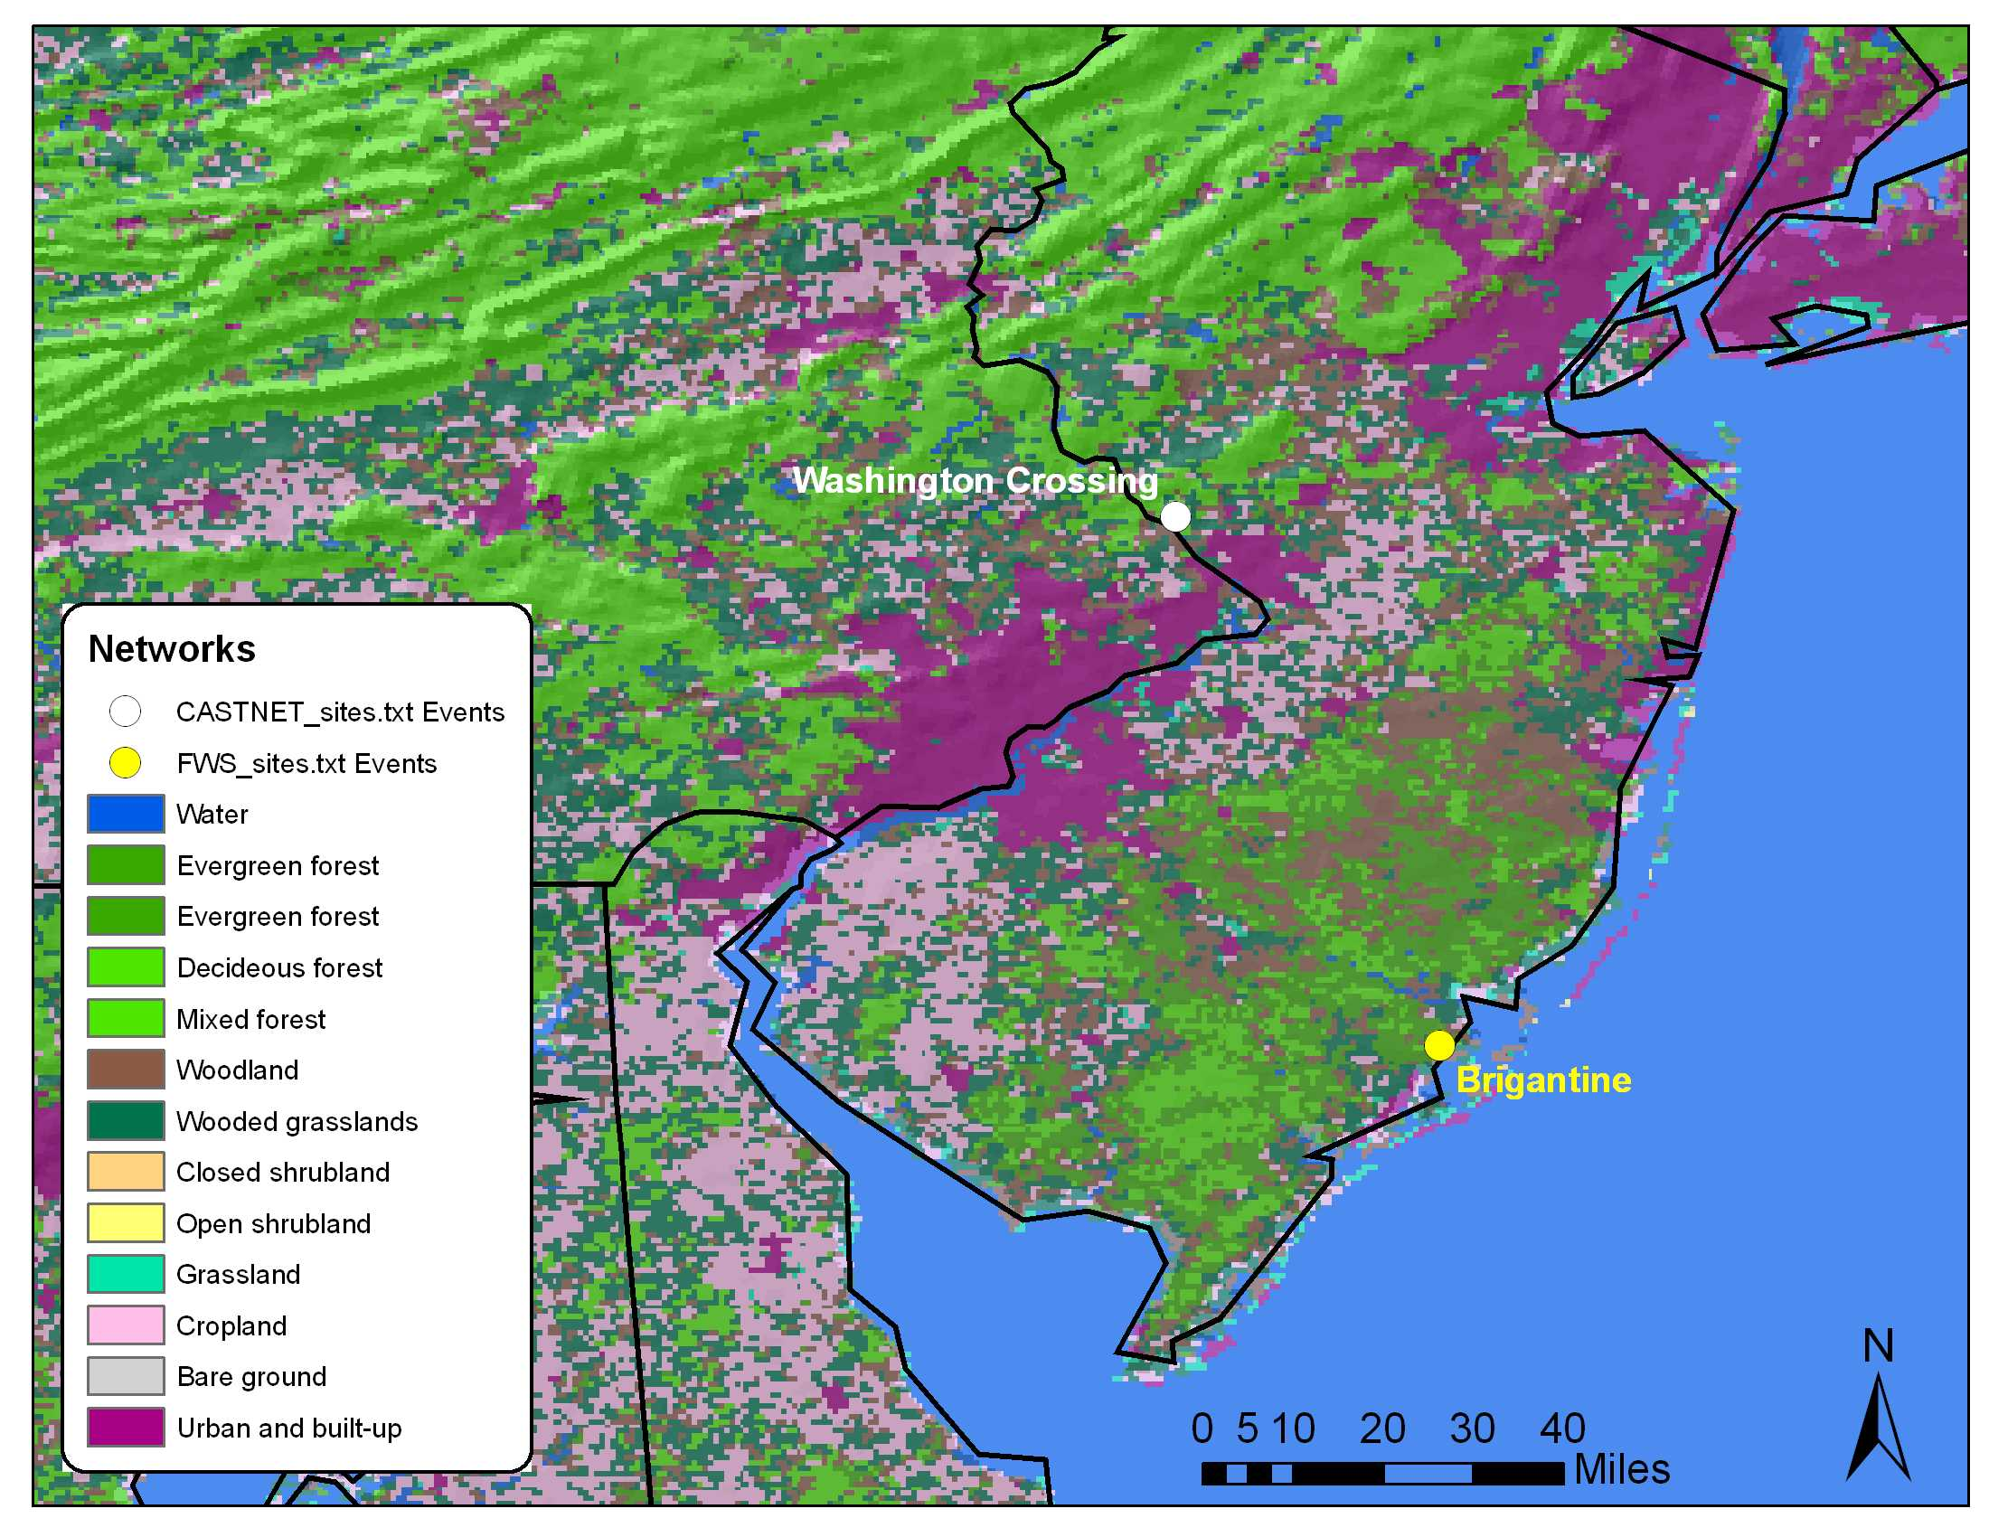

Ambient air

Ambient air concentration levels of particle-asociated ammonium, nitrate, sulfate and gas-phase sulfur dioxide and nitric acid for Washington Crossing during the 2000-2004 period, are presented in Table 29.

Table 29 Descriptive statistics (in μg/m³) of atmospheric particulate ammonium, nitrate, sulfate and, sulfur dioxide and nitric acid in Washington Crossing for 2000-2004 periods
 | Mean | Minimum | Maximum | Std Deviation
Aerosol
Ammonium (NH₄⁺) | 1.6 | 0.3 | 4.6 | 0.7
Nitrate (NO₃⁻) | 1.2 | 0.1 | 5.9 | 1.1
Sulfate (SO₄²⁻) | 4.3 | 0.9 | 13.4 | 2.2
Gas Phase
Sulfur dioxide (SO₂) | 8.3 | 1.4 | 31.1 | 5.4
Nitric Acid (HNO₃) | 2.5 | 0.5 | 5.9 | 1.1

Figure 66 Mean annual concentrations of particulate ammonium (NH4), nitrate (NO3) and sulfate (SO4) and gaseous nitric acid (HNO3) and sulfur dioxide (SO2)

As shown in Figure 66 concentrations of all components fluctuated for different years with no clear trends for the monitoring period.

Figure 67 Mean quarterly concentrations of particulate ammonium (NH4), nitrate (NO3) and sulfate (SO4) and gaseous nitric acid (HNO3) and sulfur dioxide (SO2)
On a seasonal basis, slightly higher concentrations during the 2nd (April-June) and 3rd (July-September) for sulfate and ammonium are measured. An opposite profile is drawn for sulfur dioxide, nitric acid and particulate nitrate, with higher concentration being measured during winter
Figure 68 Scatter plot of NH4 nanoequivalents per m³ vs. the sum of NO₃ and SO₄ nano-equivalents per m³
Figure 61 shows the relationship between the sum of sulfate and nitrate vs. ammonium (in n-equivalents/m³). The green line indicates that both nitrate and sulfate are fully neutralized by ammonium in the forms of ammonium nitrate and ammonium sulfate. The slope of the regression indicates that ammonium concentrations are able to neutralize approximately 88% of nitrate and sulfate, which indicates that the predominant chemical components are (NH₄)HSO₄, NH₄NO₃ (NH₄)₂SO₄ and minor amounts of. H₂SO₄ and HNO₃

Table 30 shows the inter-annual and seasonal variation of the relationships between ammonium, and nitrate and sulfate. No significant variability is computed from 2000 to 2004. Neutralization by ammonia appears to be significant throughout the year and for different seasons.

Table 30 Annual and quarterly variation of regression coefficients of atmospheric NH4 (as dependent variable) and the sum of NO3 and SO4 (as independent variable).

Year | 2000 | 2001 | 2002 | 2003 | 2004
Slope | 0.85 | 0.86 | 0.84 | 0.96 | 0.89
Intercept | -4.8 | -4.3 | -4.2 | -19.9 | -12.8
R | 0.96 | 0.98 | 0.96 | 0.96 | 0.97
Quarter | 1st | 2nd | 3rd | 4th
Slope | 0.88 | 0.92 | 0.90 | 0.82
Intercept | -8.8 | -14.2 | -13.1 | -2.4
R | 0.94 | 0.6 | 0.98 | 0.94

Dry Deposition

Deposition rates and total deposition of particle-associated ammonium, nitrate, sulfate and gas-phase sulfur dioxide and nitric acid, and total nitrogen and sulfur for Washington Crossing during the 2000-2004 period, are presented in Table 31.

Table 31 Descriptive statistics (g/ha) of dry deposition of ammonium, nitrate, sulfate and, sulfur dioxide and nitric acid in Washington Crossing for 2000-2004 periods and total nitrogen and sulfur deposition (kg/ha) for the entire period

 | Mean | Minimum | Maximum | Std Deviation | Total deposition
Aerosol
Ammonium (NH₄⁺) | 11 | 2 | 37 | 6 | 1.9
Nitrate (NO₃⁻) | 9 | 0 | 41 | 8 | 0.5
Sulfate (SO₄²⁻) | 31 | 4 | 112 | 19 | 2.2
Gas Phase
Sulfur dioxide (SO₂) | 215 | 29 | 708 | 134 | 23.7
Nitric Acid (HNO₃) | 202 | 26 | 591 | 118 | 14.8
Total Nitrogen |  |  |  |  | 17.1
Total Sulfur |  |  |  |  | 25.9

Figure 69 Annual dry deposition of ammonium (NH4), nitrate (NO3), sulfate (SO4), nitric acid (HNO3) and sulfur dioxide (SO2).

As shown in Figure 69, for all components, a strong increasing trend is observed for 2001-2003 period followed by a slight decrease of dry deposition for 2004.

Figure 70 Quarterly dry deposition of ammonium (NH4), nitrate (NO3), sulfate (SO4), nitric acid (HNO3) and sulfur dioxide (SO2).
On a seasonal basis, slightly higher deposition rates during the 2nd (April-June) and 3rd (July-September) for sulfate and ammonium and nitric acid are measured. An opposite profile is drawn for sulfur dioxide and particulate nitrate, with higher deposition being measured during winter

Figure 71 Total nitrogen and sulfur dry deposition at Washington Crosiing during 2000-2004
Figure 72
The total amount of nitrogen and sulfur deposited in Washington Crossing, ranged approximately from 1.0 kg/ha to 3.4 kg/ha and from 3.8 kg/ha up to 6.2 kg/ha, respectively. Dry deposition decreased from 2000 to 2004 for both elements,

