Conceptual Model - Causes of Haze in Chassahowtizka Wilderness Area (CHAS1)

Regional sulfate is likely responsible for most of the haze in the Chassahowtizka Wilderness Area. Organics from combustion sources in Southern Georgia, Western Alabama, and Northern Florida are also a significant contributors to haze in the region, especially during the winter time.

As shown in Figure 1, Chassahowtizka Wilderness Area is located in west central Florida on the Gulf coast approximately 50 miles north of Tampa-St. Petersburg and 70 miles west of Orlando. The wilderness is nestled within the 31,000 acre Chassahowitzka National Wildlife Refuge. The wilderness area consists of approximately 23,360 acres of salt water bays, estuaries and brackish marshes. The IMPROVE site is located at a maintenance facility, 4 miles south of the town Homossassa Springs, FL, and 1/4 mile west of the Chassahowitzka National Wildlife Reserve maintenance facility. The IMPROVE site is located at an elevation of 4.3 m MSL. Based on all the valid aerosol measurements during 2000-2002 in CHAS1, the average PM_{2.5} mass concentration measured at CHAS1 during 2000 to 2002 is 9.3 µg/m³. The average total light extinction coefficient (B_{ext}) is 84.8 Mm⁻¹ (Visual Range ~ 54 Km; Deciview ~ 21). The average contributions of the major aerosol components to Chassahowitzka haze are particulate sulfate 55.0%, nitrate 6.5%, organic matter (OMC) 14.2%, elemental carbon (light absorbing carbon, LAC) 5.8%, fine soil 0.9%, sea salt 0.6%, and coarse mass (CM) 4.1%.

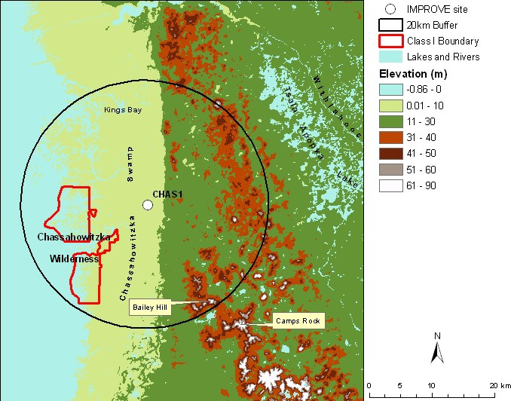
Figure 1. Terrain and land features surrounding the Chassahowitzka Wilderness Area
Sulfate is the largest aerosol contributor to light extinction during the 20% worst days, with a contribution of ~ 64%. OMC also contributes about 16% to light extinction during the 20% worst visibility days. Figure 2 suggests that the highest occurrence of the 20% worst days happened in February, in which ~ 32% of the sampling days are the 20% haziest days at Chassahowitzka. As shown in Figure 3, in the 20% worst visibility days, sulfate is the largest aerosol contributor to haze with a contribution from ~50% in the winter to over 70% in the summer. OMC also contributes significantly to light extinction during the 20% worst days especially during the winter time (~25-30% in the winter). Figure 4 indicates that during the 20% best days, air usually comes from southeast; while during the 20% worst haze days, air most frequently comes from the northwest.
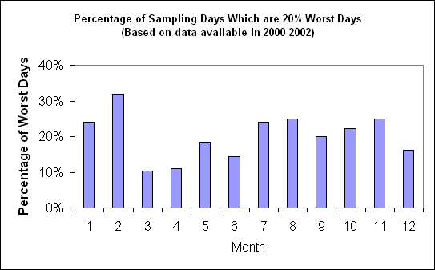
Figure 2. Percentage of sampling days that are 20% worst days in each month (Based on data available in 2000-2004)
Based on the PMF receptor modeling, seven source factors are identified for CHAS1. Figure 5 illustrates the contribution of each PMF resolved source factor to PM_{2.5} mass at the site. Sulfate-rich secondary aerosol is the biggest contributor to PM_{2.5} mass, with a contribution of 40%. Biomass burning and coal combustion contributes about 16% and 14% to PM_{2.5}, respectively. Difference maps of the PMF factor score weighted and un-weighted residence times (Figure 6) suggest that secondary sulfate mostly comes from regional sources close to the site. Southern Georgia, Western Alabama and Northern Florida are the major source areas for combustion sources including biomass burning, coal combustion and mobile emissions.
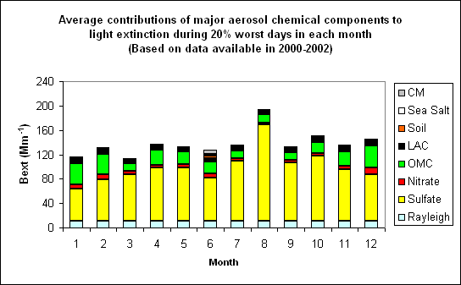 Figure 3. Average contributions of major aerosol chemical components to light extinction during 20% worst days in each month (Based on data available in 2001-2004)
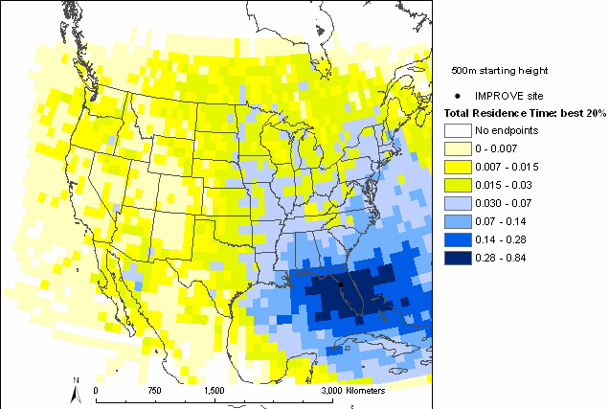 | 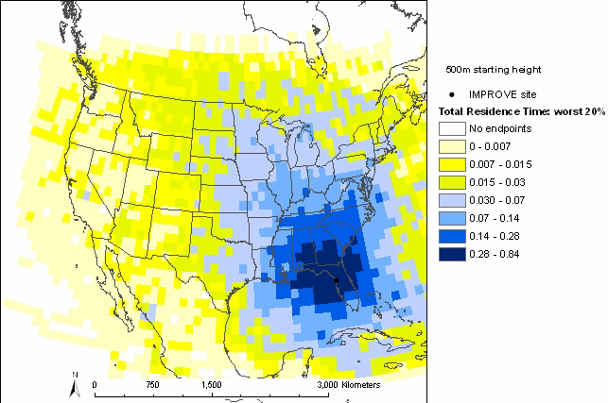
Figure 4. Normalized residence time for 20% best (left) and 20% worst (right) days (based on data from 2001-2004, air mostly transported from the blue area under the given sampling days)

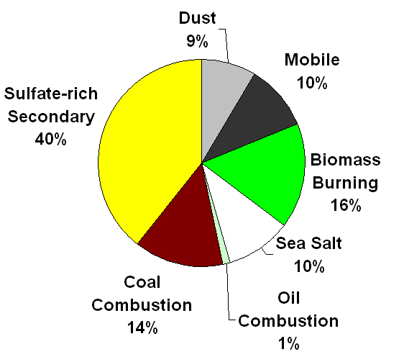
Figure 5. Average contributions of PMF resolved source factors to PM2.5 mass concentration.

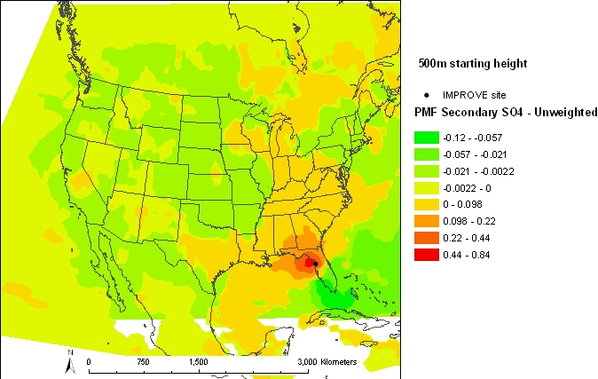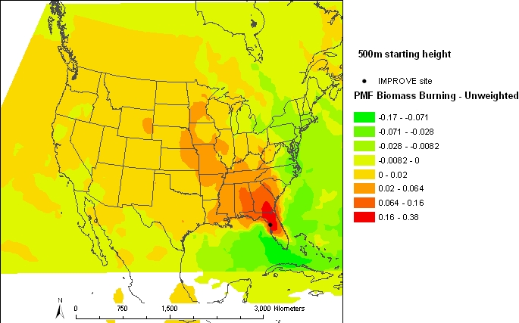

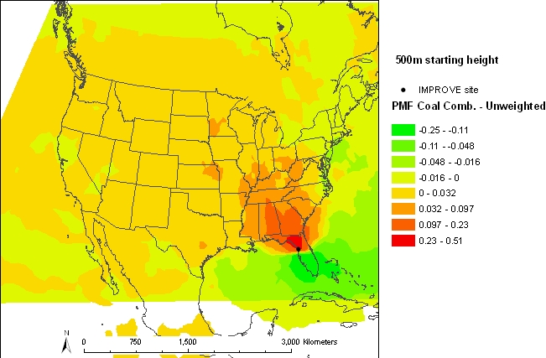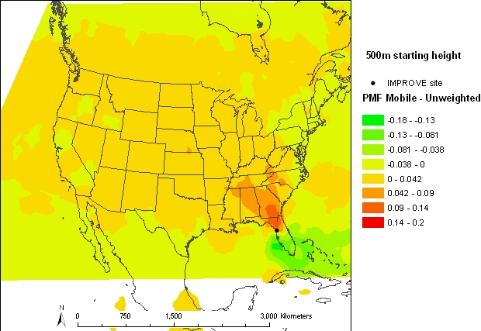

Figure 6. Difference maps of the PMF source factor (Sulfate-rich secondary source factor on the top left, biomass burning source factor on the top right, coal combustion source factor on the bottom left, mobile source factor on the bottom right) weighted and un-weighted residence times.

