Conceptual Model - Causes of Haze in St. Marks Wilderness Area (SAMA1)

Regional sulfate and sulfate transported from the eastern United States are the major causes of haze in the St. Marks Wilderness Area. Organics from regional biomass burning also contributes significantly to the haze in the region.

As shown in Figure 1, the St. Marks Wilderness Area is located at the eastern edge of the Florida Panhandle on the Gulf coast approximately 25 miles south of Tallahassee. The wilderness is part of the 68,931 acre St. Marks National Wildlife Refuge. The wilderness area consists of approximately 17,745 acres of salt water bays, estuaries and brackish marshes. The wilderness is divided into two units: the St. Marks unit to the east and a smaller unit to the west near the Ochlockonee Bay. The IMPROVE site is located in a forest clearing 3 miles south of the visitor center at the refuge near highway 59. The IMPROVE site is located at an elevation of 8 m MSL. Based on all the valid aerosol measurements during 2002-2004 in SAMA1, the average PM_{2.5} mass concentration is 9.2 µg/m³. The average total light extinction coefficient (B_{ext}) is 82.4 Mm⁻¹ (Visual Range ~ 58 Km; Deciview ~ 20). The average contributions of the major aerosol components to St. Marks haze are particulate sulfate 58.7%, nitrate 4.7%, organic matter (OMC) 14.5%, elemental carbon (light absorbing carbon, LAC) 4.2%, fine soil 0.8%, sea salt 0.7%, and coarse mass (CM) 3.0%.

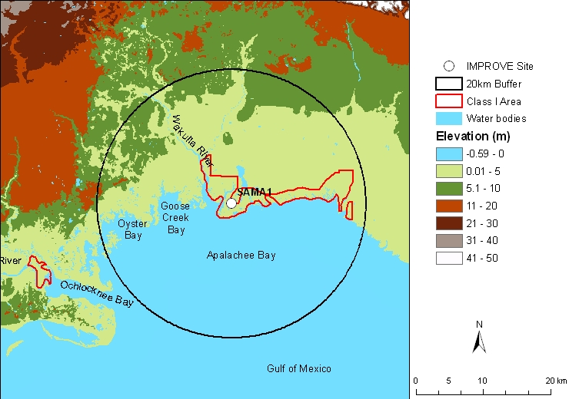
Figure 1. Terrain and land features surrounding the St. Marks Wilderness Area

Sulfate is the largest aerosol contributor to light extinction during the 20% worst days, with a contribution of ~ 65%. OMC also contributes about 18% to light extinction during the 20% worst visibility days. Figure 2 suggests that the highest occurrence of the 20% worst days happened in October, in which ~ 38% of the sampling days are the 20% haziest days at St. Marks. October has the highest frequency of flow from the northeast. As shown in Figure 3, in the 20% worst visibility days, sulfate is the largest aerosol contributor to haze with a contribution of ~40% in the winter to ~80% in the summer and fall. OMC contributes about 30% in the winter and spring (January to May) during the 20% worst days. Figure 4 indicates that during the 20% best days, air usually comes from south of the site; while during the 20% worst haze days, air usually comes from north of the site.
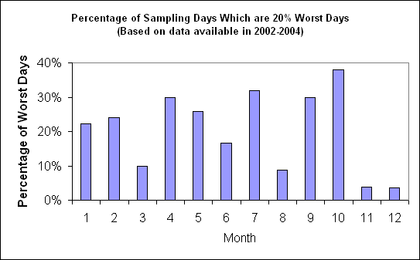
Figure 2. Percentage of sampling days that are 20% worst days in each month
Based on the PMF receptor modeling, six source factors are identified for SAMA1. Figure 5 illustrates the contribution of each PMF resolved source factor to PM_{2.5} mass at the site. Sulfate-rich secondary aerosol is the biggest contributor to PM_{2.5} mass, with a contribution of ~47%, followed by biomass burning smoke (26%). Difference maps of the PMF factor score weighted and un-weighted residence times (Figure 6) suggest that secondary sulfate mainly transports from the eastern U.S., while smoke is mostly from biomass burning close-by (Southern Georgia and Alabama).
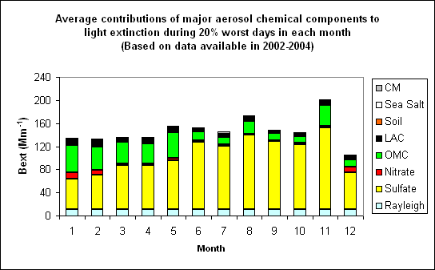 Figure 3. Average contributions of major aerosol chemical components to light extinction during 20% worst days in each month
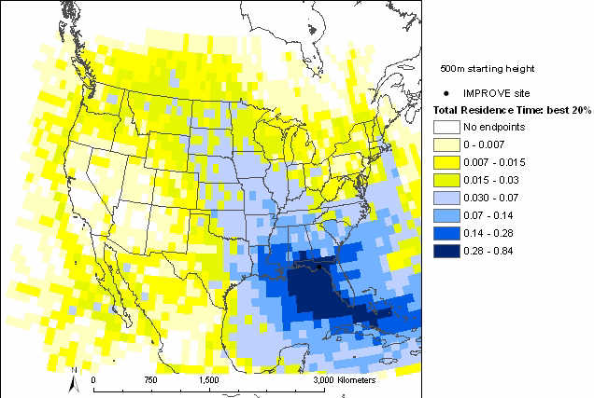 | 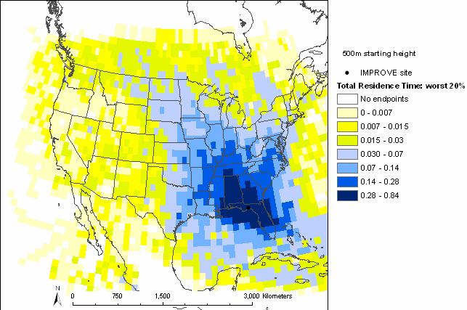
Figure 4. Normalized residence time for 20% best (left) and 20% worst (right) days (air mostly transported from the blue area under the given sampling days)

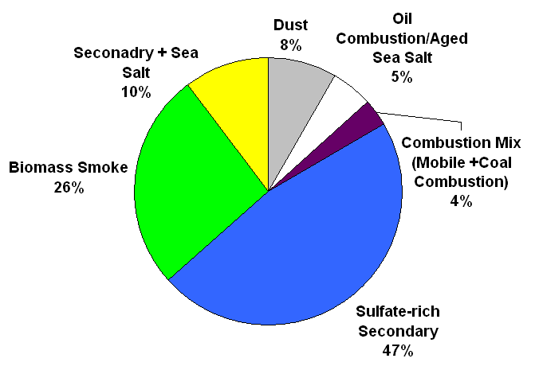
Figure 5. Average contributions of PMF resolved source factors to PM2.5 mass concentration.

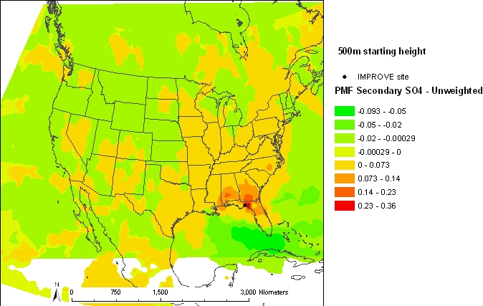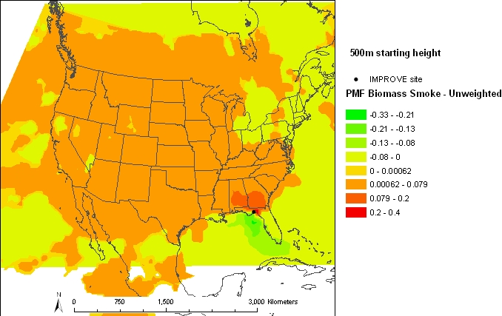

Figure 6. Difference maps of the PMF source factor (sulfate-rich secondary source factor on the left, and biomass smoke source factor on the right) weighted and un-weighted residence times.

