Conceptual Model - Causes of Haze in Okefenokee Wilderness Area (OKEF1)

Regional sulfate and sulfate transported from the eastern United States are the major causes of haze in the Okefenokee Wilderness Area. Organics from biomass burning in the southeastern U.S., especially in the state of Georgia also contributes significantly to regional haze in the Okefenokee Wilderness Area.

As shown in Figure 1, Okefenokee Wilderness Area is located in the southeastern corner of Georgia bordering Florida. The wilderness is approximately 20 miles northeast of Jacksonville, Florida. The wilderness is part of the 396,009 acre Okefenokee National Wildlife Refuge. The wilderness area consists of 343,850 acres of islands, lakes, cypress forests, scrub-shrub areas, and open wet “prairies”. The IMPROVE site is located in a grass covered cleared area near the refuge headquarters. The nearest highway is highway 121, 3.3 miles to the east. The IMPROVE site is located at an elevation of 48 m MSL. Based on all the valid aerosol measurements during 2000-2004 in OKEF1, the average PM_{2.5} mass concentration is 9.3 µg/m³. The average total light extinction coefficient (B_{ext}) is 88.6 Mm⁻¹ (Visual Range ~ 55 Km; Deciview ~ 21). The average contributions of the major aerosol components to Okefenokee haze are particulate sulfate 56.4%, nitrate 5.4%, organic matter (OMC) 16.8%, elemental carbon (light absorbing carbon, LAC) 4.3%, fine soil 0.8%, sea salt 0.7%, and coarse mass (CM) 3.2%.

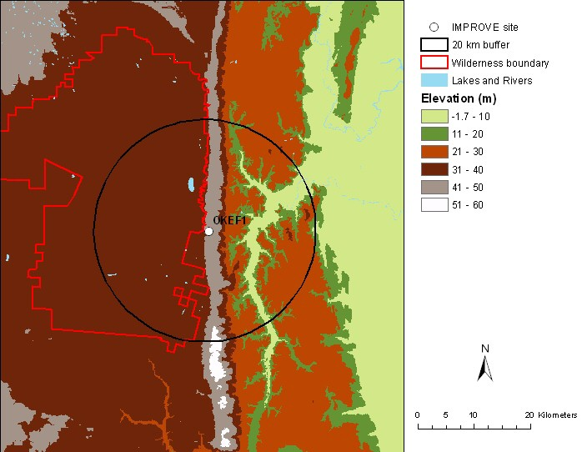
Figure 1. Terrain and land features surrounding the Okefenokee Wilderness Area

Sulfate is the largest aerosol contributor to light extinction during the 20% worst days, with a contribution of ~ 65%. OMC also contributes about 19% to light extinction during the 20% worst visibility days with greatest contribution in the spring. Figure 2 suggests that the highest occurrence of the 20% worst days happened in May, July, and October, in which over 30% of the sampling days are the 20% haziest days at Okefenokee. As shown in Figure 3, in the 20% worst visibility days, sulfate is the largest aerosol contributor to haze throughout the year. Figure 4 indicates that during the 20% best days, air usually comes from south of the site; while during the 20% worst haze days, air usually comes from north of the site.
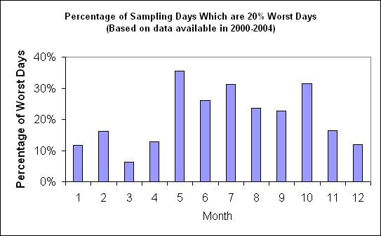
Figure 2. Percentage of sampling days that are 20% worst days in each month
Based on the PMF receptor modeling, six source factors are identified for OKEF1. Figure 5 illustrates the contribution of each PMF resolved source factor to PM_{2.5} mass at the site. Sulfate-rich secondary aerosol is the biggest contributor to PM_{2.5} mass, with a contribution of ~49%, followed by biomass burning emissions (34%). Difference maps of the PMF factor score weighted and un-weighted residence times (Figure 6) suggest that secondary sulfate mainly transports from the eastern U.S., while biomass smoke is mostly from the southeastern US, especially the state of Georgia.
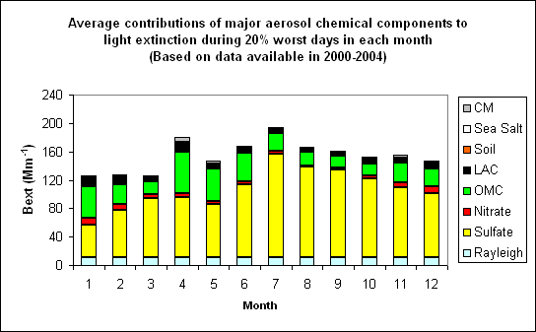 Figure 3. Average contributions of major aerosol chemical components to light extinction during 20% worst days in each month
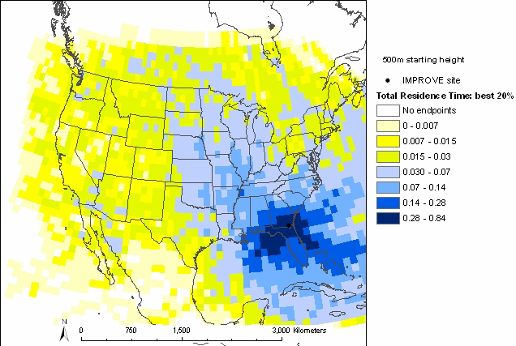 | 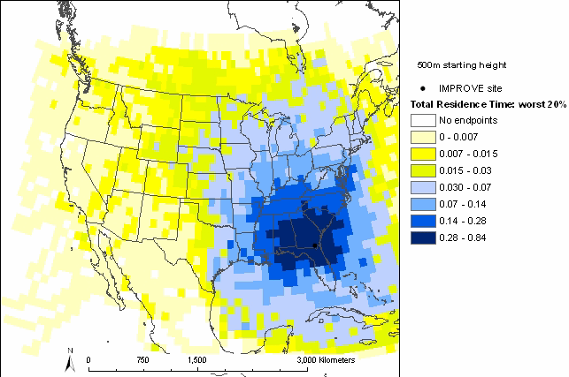
Figure 4. Normalized residence time for 20% best (left) and 20% worst (right) days (air mostly transported from the blue area under the given sampling days)

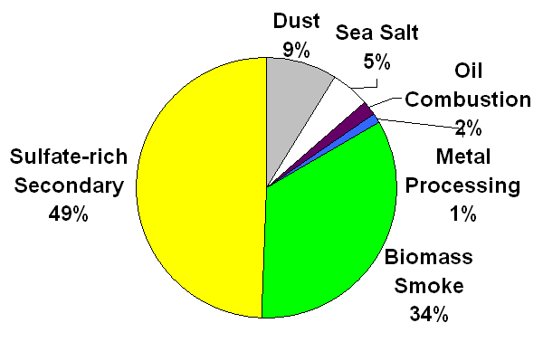
Figure 5. Average contributions of PMF resolved source factors to PM2.5 mass concentration.

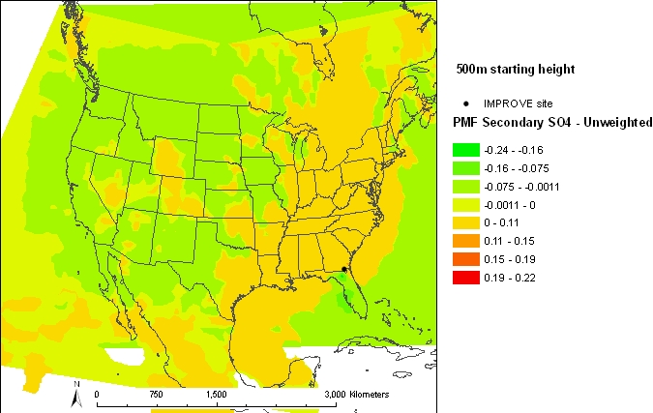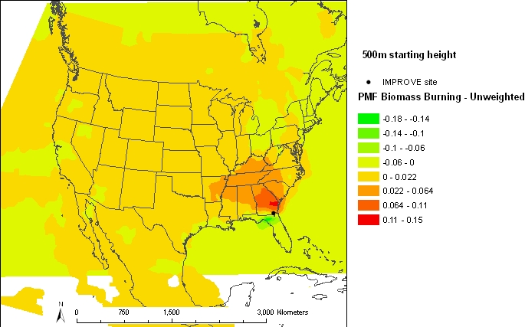

Figure 6. Difference maps of the PMF source factor (sulfate-rich secondary source factor on the left, biomass smoke source factor on the right) weighted and un-weighted residence times.

