Conceptual Model - Causes of Haze in Moosehorn Wilderness Area (MOOS1)

Secondary sulfate from the northeastern U.S. during the summer time is responsible for most of the worst visibility days in the Moosehorn Wilderness Area.

As shown in Figure 1, Moosehorn Wilderness Area is located near the Canada/US border in northeast Maine. The wilderness is approximately 130 miles northeast of Augusta, Maine and 60 miles west of St. John, New Brunswick, Canada. The wilderness is divided into two parts; the 4,719 acre Baring Division and the 2,782 acre Edmunds Division to the south. The wilderness area consists of streams, lakes, forests, shorelines, bogs and marshes. The IMPROVE site is located in a small cleared area surrounded by forests near McConvey Road, about 1 mi northeast of refuge headquarters at the Baring Division. The nearest highway is US Highway 1, 1.8 miles to the west. The IMPROVE site is located at an elevation of 78 m MSL. Based on all the valid aerosol measurements during 2000-2004 in MOOS1, the average PM_{2.5} mass concentration is 5.0 µg/m³. The average total light extinction coefficient (B_{ext}) is 48.8 Mm⁻¹ (Visual Range ~ 108 Km; Deciview ~ 14). The average contributions of the major aerosol components to Moosehorn haze are particulate sulfate 45.7%, nitrate 6.5%, organic matter (OMC) 13.1%, elemental carbon (light absorbing carbon, LAC) 5.0%, fine soil 0.5%, sea salt 1.4%, and coarse mass (CM) 3.2%.
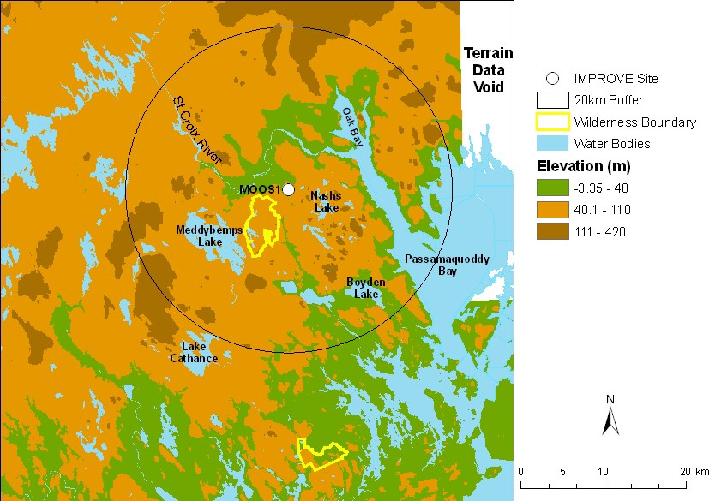
Figure 1. Terrain and land features surrounding the Moosehorn Wilderness Area

Sulfate is the largest aerosol contributor to light extinction during the 20% worst days, with a contribution of ~ 61%. Figure 2 suggests that the highest occurrence of the 20% worst days happened in July, in which ~ 45% of the sampling days are the 20% haziest days at Moosehorn. As shown in Figure 3, in the 20% worst visibility days, sulfate is the largest aerosol contributor to haze, with a contribution from ~40% in the winter to ~70% in the summer. Figure 4 indicates that during the 20% best days, air usually comes from north of the site; while during the 20% worst haze days, air usually comes from southwest of the site.
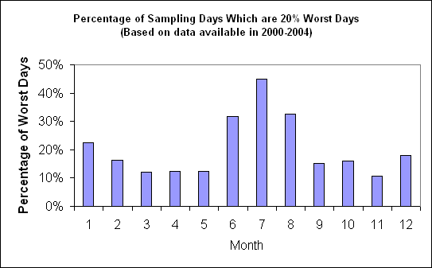
Figure 2. Percentage of sampling days that are 20% worst days in each month
Based on the PMF receptor modeling, six source factors are identified for MOOS1. Figure 5 illustrates the contribution of each PMF resolved source factor to PM_{2.5} mass at the site. Sulfate-rich secondary aerosol is the biggest contributor to PM_{2.5} mass, with a contribution of ~58%. Difference maps of the PMF factor score weighted and un-weighted residence times (Figure 6) suggest that secondary sulfate mainly transports from southwest of the site (i.e. northeastern U.S.). Oil combustion and biomass burning each contributes ~10% to PM_{2.5}, and their major source regions are in the northeastern U.S. and southeastern Canada, respectively.
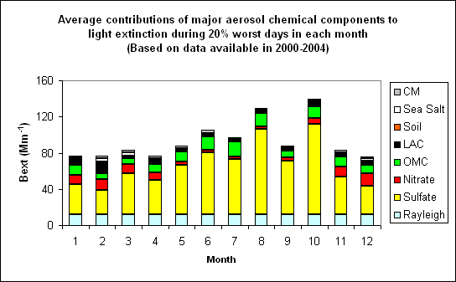 Figure 3. Average contributions of major aerosol chemical components to light extinction during 20% worst days in each month
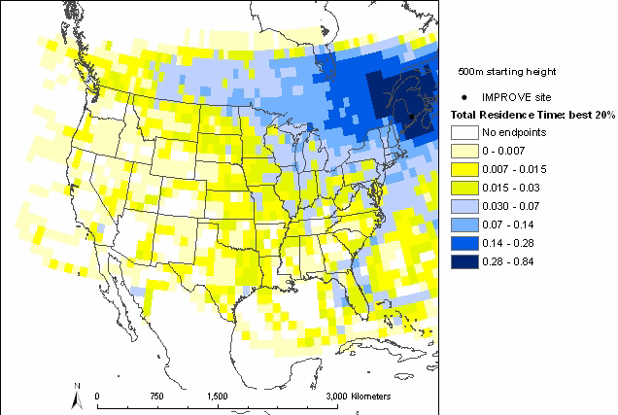 | 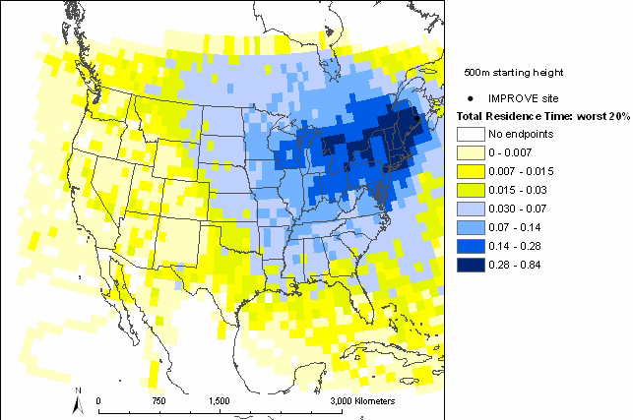
Figure 4. Normalized residence time for 20% best (left) and 20% worst (right) days (air mostly transported from the blue area under the given sampling days)

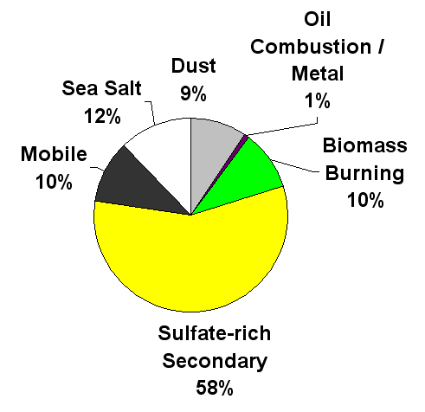
Figure 5. Average contributions of PMF resolved source factors to PM2.5 mass concentration.

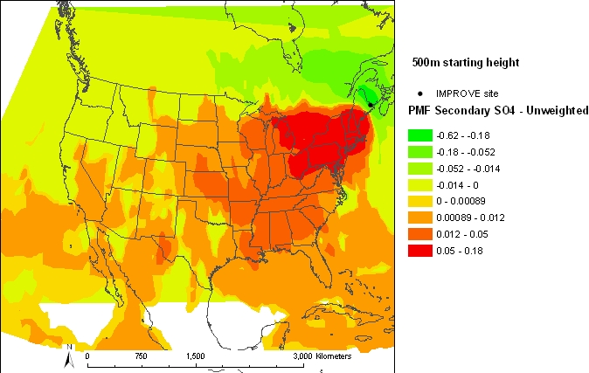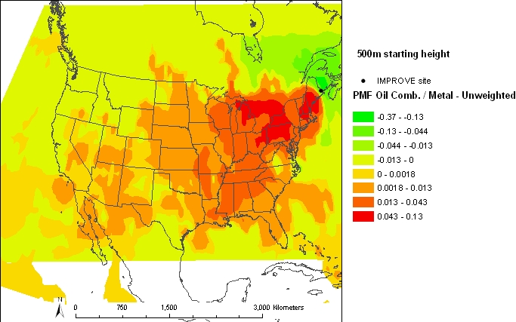

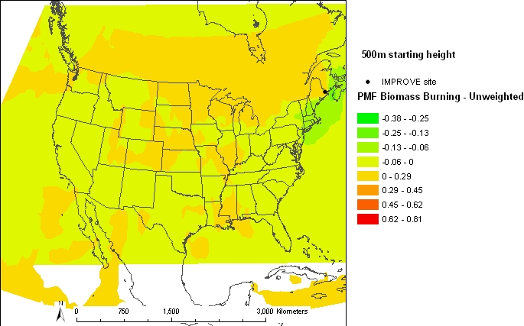

Figure 6. Difference maps of the PMF source factor (sulfate-rich secondary source factor on the top left, oil combustion source factor on the top right, biomass burning source factor on the bottom left) weighted and un-weighted residence times.

