Conceptual Model - Causes of Haze in Seney Wilderness Area (SENE1)

Regional sulfate and sulfate transported from the eastern United States are the major causes of haze in the Seney Wilderness Area during the warm seasons. Secondary nitrate from the central U.S. is responsible for most of the haze in the cold seasons.

As shown in Figure 1, Seney Wilderness Area is located in Michigan's Upper Peninsula. The IMPROVE site is located at an elevation of 78 m MSL. Based on all the valid aerosol measurements during 2000-2004 in SENE1, the average PM_{2.5} mass concentration is 5.0 µg/m³. The average total light extinction coefficient (B_{ext}) is 51.6 Mm⁻¹ (Visual Range ~ 122 Km; Deciview ~ 14). The average contributions of the major aerosol components to Seney haze are particulate sulfate 42.0%, nitrate 16.2%, organic matter (OMC) 11.8%, elemental carbon (light absorbing carbon, LAC) 3.7%, fine soil 0.5%, sea salt 0.2%, and coarse mass (CM) 2.3%.

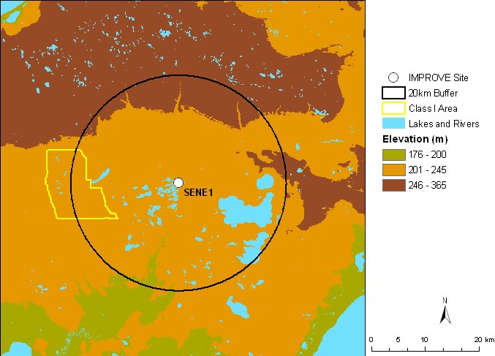
Figure 1. Terrain and land features surrounding the Seney Wilderness Area

Sulfate is the largest aerosol contributor to light extinction during the 20% worst days, with a contribution of ~ 51%. Nitrate also contributes about 23% to light extinction during the 20% worst visibility days. Figure 2 suggests that the highest occurrence of the 20% worst days happened in the summer from June to August, in which ~ 30% of the sampling days are the 20% haziest days at Seney. As shown in Figure 3, in the 20% worst visibility days, sulfate is the largest aerosol contributor to haze during the warm months (with a contribution of more than 60% from April to September), while nitrate is the largest contributor during the cold months (with a contribution of ~ 40 - 70% during January to March and November to December). Figure 4 indicates that during the 20% best days, air usually comes from north of the site; while during the 20% worst haze days, air usually comes from south of the site.
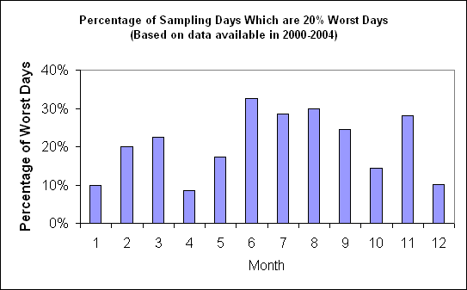
Figure 2. Percentage of sampling days that are 20% worst days in each month
Based on the PMF receptor modeling, eight source factors are identified for SENE1. Figure 5 illustrates the contribution of each PMF resolved source factor to PM_{2.5} mass at the site. Sulfate-rich secondary aerosol is the biggest contributor to PM_{2.5} mass, with a contribution of ~43%, followed by biomass burning smoke (20%), and nitrate-rich secondary (14%). Difference maps of the PMF factor score weighted and un-weighted residence times (Figure 6) suggest that secondary sulfate mainly transports from Midwest states. while smoke is mostly from biomass burning close-by and secondary nitrate is mostly from the central U.S.
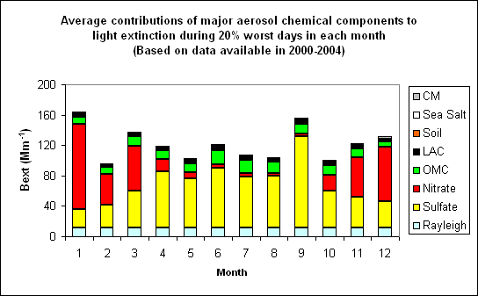 Figure 3. Average contributions of major aerosol chemical components to light extinction during 20% worst days in each month
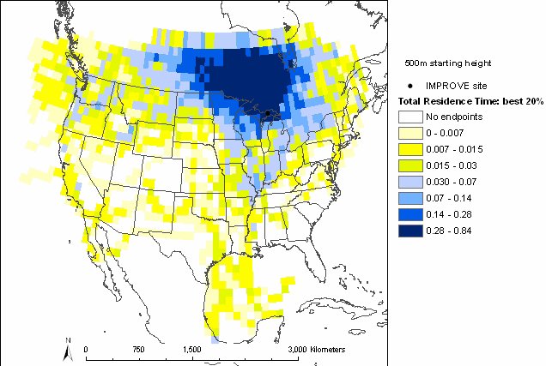 | 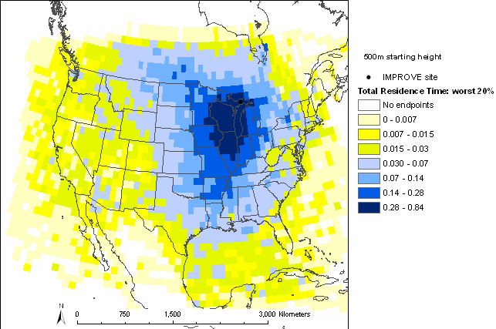
Figure 4. Normalized residence time for 20% best (left) and 20% worst (right) days (air mostly transported from the blue area under the given sampling days)

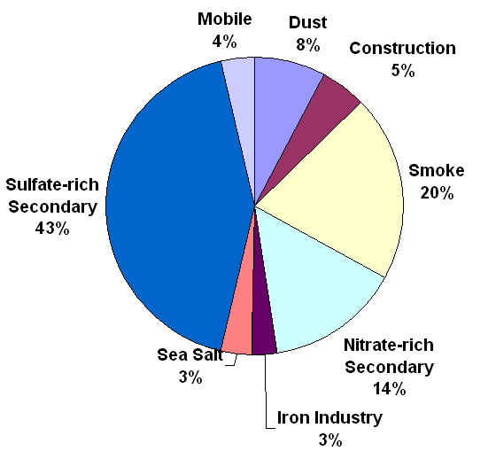
Figure 5. Average contributions of PMF resolved source factors to PM2.5 mass concentration.

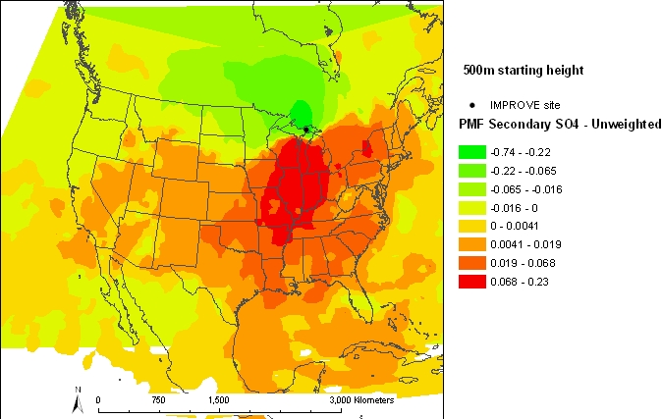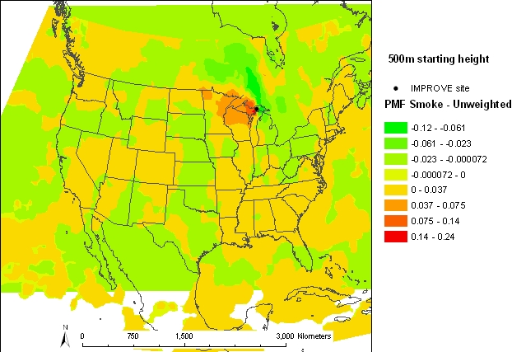

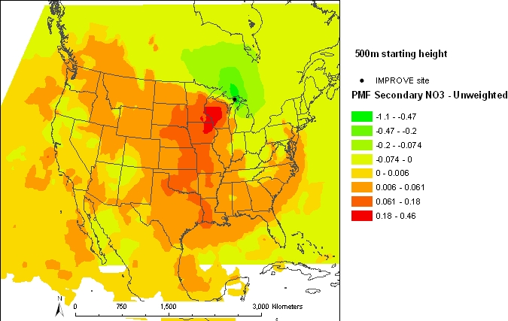

Figure 6. Difference maps of the PMF source factor (sulfate-rich secondary source factor on the top left, biomass smoke source factor on the top right, and nitrate-rich secondary on the bottom left) weighted and un-weighted residence times.

