Conceptual Model - Causes of Haze in Brigantine Wilderness Area (BRIG1)

Sulfate from southwest of the site and the stagnation meteorology conditions during the summer are most likely responsible for the regional haze in the Brigantine Wilderness Area. Mobile emissions from the surrounding major metropolitan areas may also contribute significantly to the regional haze.

As shown in Figure 1, Brigantine Wilderness Area is located in the east coast of New Jersey with one area bordering the Great Bay and an eastern portion on an island facing the Atlantic Ocean. The wilderness is approximately 6 miles north of Atlantic City, NJ. The wilderness is part of the 56,600 acre Edwin B. Forsythe National Wildlife Refuge. The wilderness area consists of 6,600 acres of lakes, forests, and wetlands. The IMPROVE site is located in a grass covered cleared area near the refuge headquarters. The nearest highway is US Highway 9, 0.75 miles to the west. The IMPROVE site is located at an elevation of 5 m MSL. Based on all the valid aerosol measurements during 2000-2004 in BRIG1, the average PM2.5 mass concentration measured at BRIG1 during 2000 to 2004 is 10.4 µg/m³. The average total light extinction coefficient (B_{ext}) is 96.7 Mm⁻¹ (Visual Range ~ 56 Km; Deciview ~ 21). The average contributions of the major aerosol components to Brigantine haze are particulate sulfate 53.7%, nitrate 11.1%, organic matter (OMC) 11.5%, elemental carbon (light absorbing carbon, LAC) 4.6%, fine soil 0.5%, sea salt 1.4%, and coarse mass (CM) 4.7%.

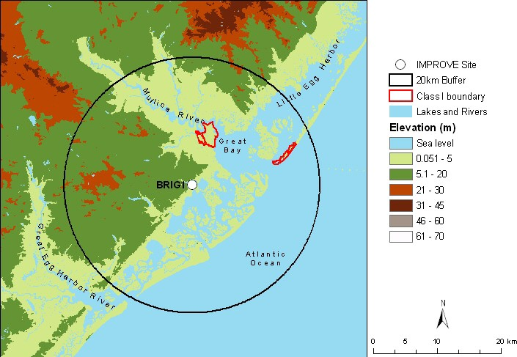
Figure 1. Terrain and land features surrounding the Brigantine Wilderness Area
Sulfate is the largest aerosol contributor to light extinction during the 20% worst days, with a contribution of ~ 66%. Figure 2 suggests that the highest occurrence of the 20% worst days happened in June and July, in which ~ 40-50% of the sampling days are the 20% haziest days at Brigantine. As shown in Figure 3, in the 20% worst visibility days, sulfate is the largest aerosol contributor to haze except in January, during which nitrate is the largest aerosol contributor to haze. Figure 4 indicates that the air transport patterns are quite different for 20% best and 20% worst days. During the 20% best days, air usually comes from north to northwest of the site. While during the 20% worst haze days, air most frequently comes from west to southwest, which are also the dominant air transport patterns for summer time at the site. It has more residence time relatively nearby the site, indicating lighter winds during the 20% worst visibility days.
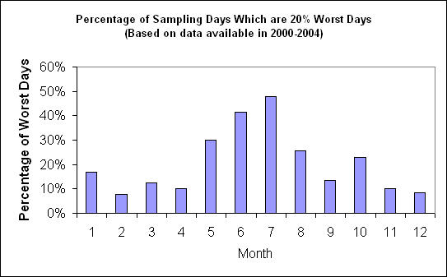
Figure 2. Percentage of sampling days that are 20% worst days in each month (Based on data available in 2000-2004)
Based on the PMF receptor modeling, seven source factors are identified for BRIG1. Figure 5 illustrates the contribution of each PMF resolved source factor to PM_{2.5} mass at the site. Sulfate-rich secondary aerosol is the biggest contributor, followed by mobile emissions which include gasoline and diesel combustion emissions. Difference maps of the PMF factor score weighted and un-weighted residence times (Figure 6) suggest that secondary sulfate mostly comes from southwest of the site. Gasoline emissions are mostly from southwest of the site, while diesel emissions are mostly from north to northwest of the site. Brigantine Wilderness area is located about 10 km north of Atlantic City, 50 km southeast of Philadelphia, and 100 km south of New York City. Mobile emissions from these major urban areas may have significant impact on regional haze at Brigantine.

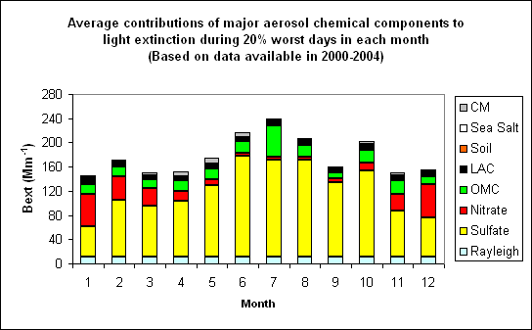 Figure 3. Average contributions of major aerosol chemical components to light extinction during 20% worst days in each month (Based on data available in 2001-2004)
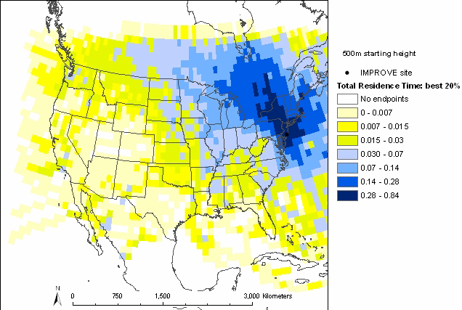 | 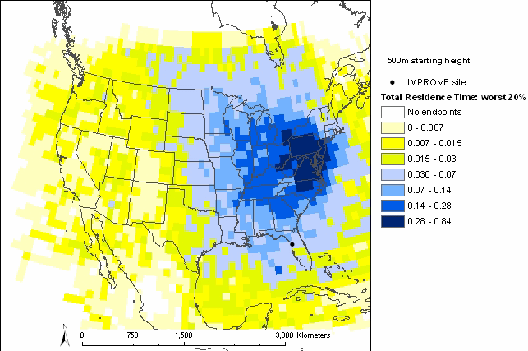
Figure 4. Normalized residence time for 20% best (left) and 20% worst (right) days (based on data from 2001-2004, air mostly transported from the blue area under the given sampling days)

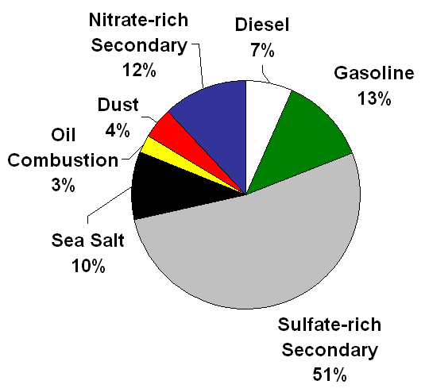
Figure 5. Average contributions of PMF resolved source factors to PM2.5 mass concentration.

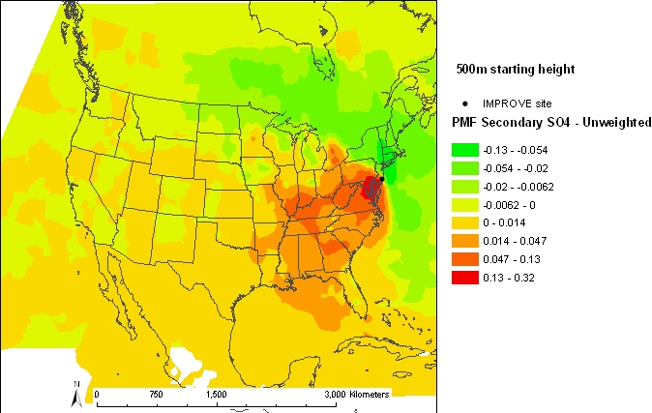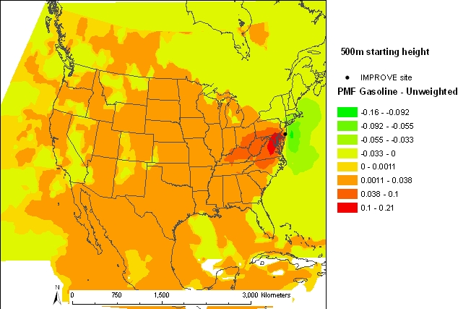

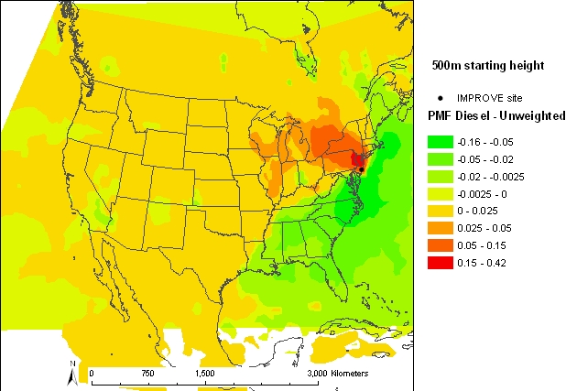

Figure 6. Difference maps of the PMF source factor (Sulfate-rich secondary source factor on the top left, gasoline source factor on the top right, diesel source factor on the bottom left) weighted and un-weighted residence times.

