Conceptual Model - Causes of Haze in Swanquarter Wilderness Area (SWAN1)

Secondary sulfate from the southeastern U.S. is the major cause of haze in the Swanquarter Wilderness Area.

As shown in Figure 1, The Swanquarter Wilderness Area is located on the east coast facing Pamlico Sound in North Carolina's inner banks region. The Hatteras barrier islands shelter the area from the Atlantic Ocean. The wilderness is approximately 40 miles northeast of the city of New Bern and 52 east of Greenville, NC. The wilderness is part of the 16,411 acre Swanquarter National Wildlife Refuge. The wildlife refuge consists of approximately 80 percent brackish marshes and 20 percent forested wetlands. The IMPROVE site is located in a marsh approximately 1 mile from the Mattamuskeet NWR entrance to the north of Swanquarter NWR. The aerosol monitor is approximately 4 miles to the north of the Swanquarter wilderness boundary and 1000 feet from Lake Mattamuskeet. The nearest road is highway 94, 1000 feet miles to the west. The IMPROVE site is located at an elevation of -3.7 m MSL. Based on valid aerosol measurements during 2001-2004 in SAMA1, the average PM_{2.5} mass concentration is 8.0 µg/m³. The average total light extinction coefficient (B_{ext}) is 68.4 Mm⁻¹ (Visual Range ~ 72 Km; Deciview ~ 18). The average contributions of the major aerosol components to Swanquarter haze are particulate sulfate 56.2%, nitrate 6.1%, organic matter (OMC) 10.0%, elemental carbon (light absorbing carbon, LAC) 3.2%, fine soil 1.4%, sea salt 1.1%, and coarse mass (CM) 4.4%.

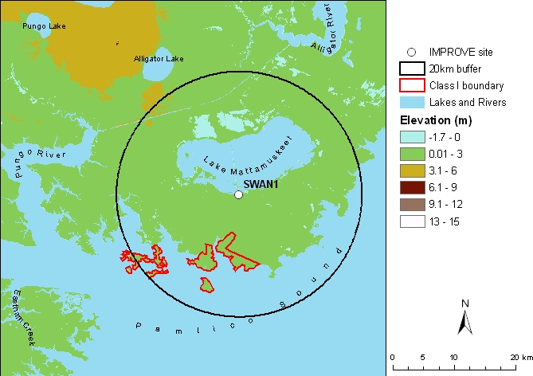
Figure 1. Terrain and land features surrounding the Swanquarter Wilderness Area

Sulfate is the largest aerosol contributor to light extinction during the 20% worst days, with a contribution of ~ 68%. Figure 2 shows that the highest occurrence of the 20% worst days happened in July, in which ~54% of the sampling days are 20% haziest days at Swanquarter. Flow is predominantly from the southwest in July. As shown in Figure 3, on the 20% worst visibility days, sulfate is the largest aerosol contributor to haze with a contribution from ~40% in the winter to over 70% in the summer and early fall. Figure 4 indicates that during the 20% best days, air usually comes from east of the site (i.e. from the ocean); while during the 20% worst haze days, air usually comes from west of the site (especially from the southeastern U.S.).
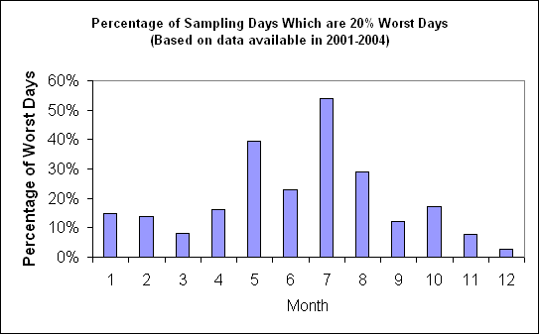
Figure 2. Percentage of sampling days that are 20% worst days in each month
Based on the PMF receptor modeling, seven source factors are identified for SWAN1. Figure 5 illustrates the contribution of each PMF resolved source factor to PM_{2.5} mass at the site. Sulfate-rich secondary aerosol is the biggest contributor to PM_{2.5} mass, with a contribution of ~52%. Difference map of the PMF sulfate-rich secondary source factor score weighted and un-weighted residence times (Figure 6) suggests that secondary sulfate mainly transports from the southeastern U.S.
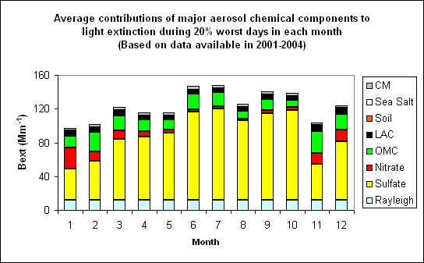 Figure 3. Average contributions of major aerosol chemical components to light extinction during 20% worst days in each month
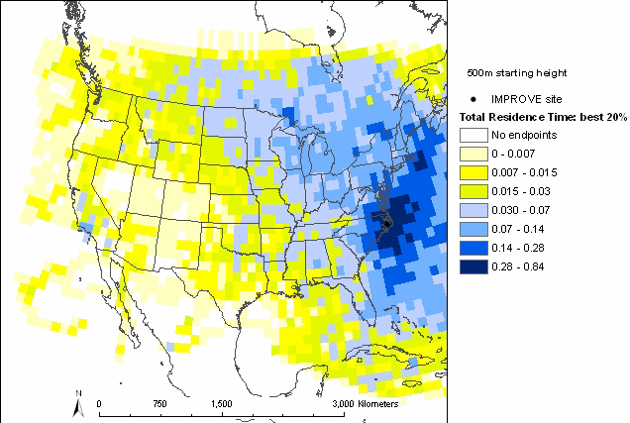 | 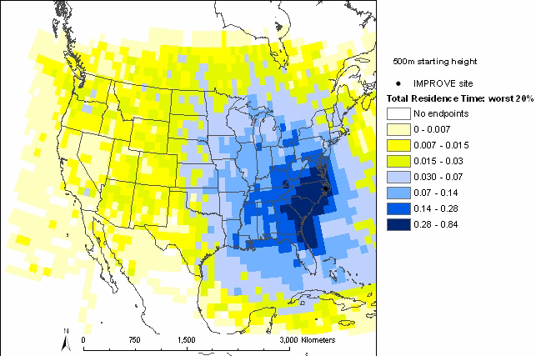
Figure 4. Normalized residence time for 20% best (left) and 20% worst (right) days (air mostly transported from the blue area under the given sampling days)

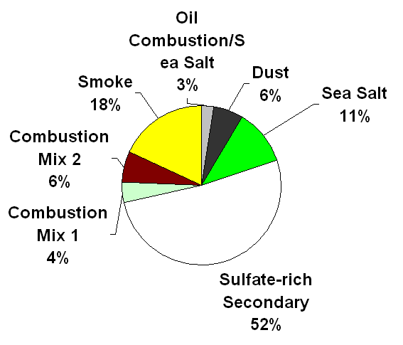
Figure 5. Average contributions of PMF resolved source factors to PM2.5 mass concentration.

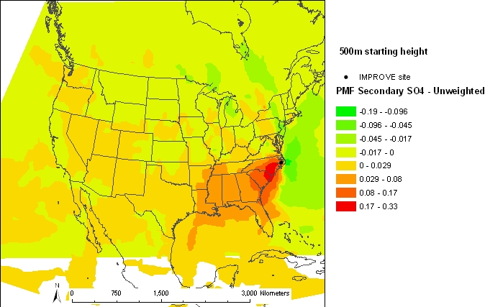

Figure 6. Difference maps of the PMF sulfate-rich secondary source factor weighted and un-weighted residence times.

